Policy Brief
2019—EDUF 3026
Purpose
Policies shape our world at all levels of activity, from the global, through to our individual experiences within it. Given the all-pervasive role of policy in the fields of education and international development for citizens—including students, parents, principals and, of course, teachers—this assessment asks you to select, think critically about and communicate the significance of a particular policy issue. You do not need to focus solely on one national, government policy document, but, rather, write about a policy issue. The policy issue may relate to an area of education in a particular location or to a specific program by an organization (see examples). As noted above, and as we discuss in the unit, policy is active at multiple levels - discursively, geographically, and in governance structures. Please check with us if you are uncertain about your choice of a policy issue. In general, the more focus, the better.
‘Policy briefs’ are intended to be accessible, concise summaries that are prepared for busy, high-level leaders in various fields; the aim is to name the issue and explain its context and significance. Part of this process includes distilling salient contextual dimensions (e.g., geographical, historical, political), and presenting the various factors, views, possibilities, and/or anticipated outcomes or solutions in relation to the issue. This task requires you to write a policy brief about an education topic of recent significance that relates to themes of international development and poverty that we discuss in EDUF3026.

Process
- Based on materials and organisations that we have been considering, or from your own interest, identify a topic of recent significance. In addition to the readings and learning materials in the unit, external organisation websites and broader news outlets are useful places to start.

- Begin to gather materials. As you read, write down initial thoughts, feelings, or connections to the themes in EDUF3026. Why is this issue significant now? Has it appeared in the news, or as an issue of concern elsewhere, previously? If it is an ongoing issue, what has changed to make it more significant, or of renewed interest, recently?

- Consider the various possible perspectives about your selected topic/policy area. Consider the actors and voices representing the issue; what and who they privilege, and in which political spaces is the chosen policy topic predominantly located (NGO, government, organization, or some combination).

- Conduct some additional research, using academic sources, government releases, supporting documents, media reports, and other resources to explore the supporting and detracting arguments relating to the policy/topic. Some sources may include existing analyses of your topic, and it is important to draw/build on them, but do not copy or summarise their work.

- Using the research you have done, write a 2-4 page (1500-word) critical profile, or ‘brief’, about the policy issue which:
  - Demonstrates an understanding of the social/historical/political contexts in which the issue emerged and is situated;
  - Identifies the current significance, problem, and/or recent developments relating to the issue;
  - Critically analyses and assesses the issue in relation to at least 1-2 points of difference and/or inequity in education and international development (i.e., please focus on 1-2 key areas, such as, for example, gender or literacy);
  - Uses evidence from relevant professional literature, media, and peer-reviewed articles, to support articulation and analysis of the issue; and
  - Uses relevant theories/concepts/issues/debates in the analysis.
The broader aim is to succinctly show your understanding of the issue or topic itself, of policy actors and processes, and potential consequences, through critical analysis and thinking, and clear writing.

- By 11:59pm on 18 October, 2019, submit your paper of 1500 words (+/-10%) through Turnitin on Canvas, and include on the first page the Student IDs (SIDs), the name of the course, the name of your tutorial leader, and the day and time of your tutorial.

- Please name the electronic file in the following manner:
Tutor Surname--Tutorial Day--Tutorial Time—(SID)
For example: Labib--Tuesday--9am--(3726823)

Formatting
- Please include a creative and meaningful title that indicates to the reader the focus of your analysis (i.e., do not merely name it 'Policy Brief').

- Introduce the paper by describing the focus of your analysis and the main point(s) you are making in your brief.

- Include a number of clearly headed sub-sections, which succinctly convey and develop your analysis of the issues. Then, provide evidence/support for this assessment through the use of relevant resources (i.e., citations and quotes from the policy itself, other associated documents, academic articles, etc.).
As noted above, these should include:
  - Clear description of the policy issue
  - Explanation of why the issue is significant
  - Some context about the issue (economic, historical, political)
  - Multiple perspectives on the issue
  - Possible consequences or implications related to the policy issue

- Conclude the paper with a clear statement that highlights the key points of your analysis, and raises further questions for future policies and/or analysis of the issue.

- Utilise in-text referencing throughout the brief, and include a reference list in APA form either at the end of the policy brief or as footnotes. See APA formatting guide through the University of Sydney Library page or Purdue Owl Online. Cite a minimum of 5 sources to pass the assessment.

Some Resources to Explore
- Development organisation and government websites (Save the Children, World Bank, IMF, UNESCO, DFAT, DFID, USAID, SIDA, Australia Human Rights Commission, etc.)

- Academic journal articles reporting on education and international development, sometimes referred to as ‘educational development’. Search keywords in library databases.

- Related policy bodies or institutes

- News reports, media commentary, etc.

Appendix A: Policy Brief Considerations

ORGANIZATION AND DESIGN

Because policymakers are extremely busy, policy briefs should be laid out and organized in a clear and easy-to-read manner. Thus, policy briefs typically have a heading with a title and a clear description of the policy issue. Notice how the policy brief below clearly displays the policy issue—“Proving Preschool Education for All 4-Year-Olds”—in large, bolded words that are easy to read.

The organization and design also notes the date of the policy brief and the organization that produced it.

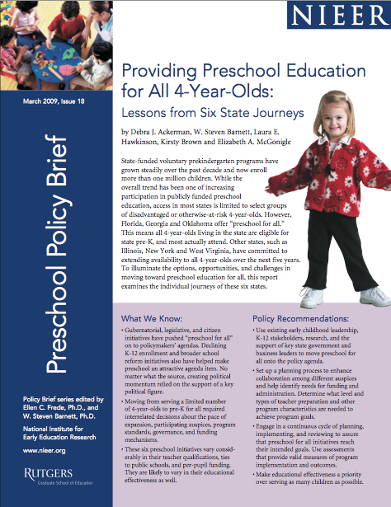

HIGHLIHGHTING TEXT

In order to increase the impact of a policy brief, it is recommended to highlight the most important findings. Therefore, policy briefs often emphasize the key findings or issues by using text in bold, italics, or CAPITAL LETTERS. Bullet points and outlines can also be used to guide the policymaker to the most important findings and recommendations. The excerpt below from a policy brief in Tanzania highlights important findings from a research study on youth and wellbeing by using bullet points and bolded text.

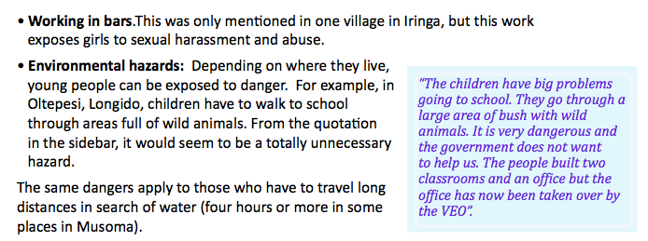

This excerpt also shows an example of a text-box that includes a ‘juicy’ or insightful quote that illustrates and further elaborates on the findings. The text-box is set apart from the body text and contains the actual quote from a participant in the study. It also uses a different coloured text as well as quotation marks to note that this is unique data from the study.
GRAPHICS AND TABLES
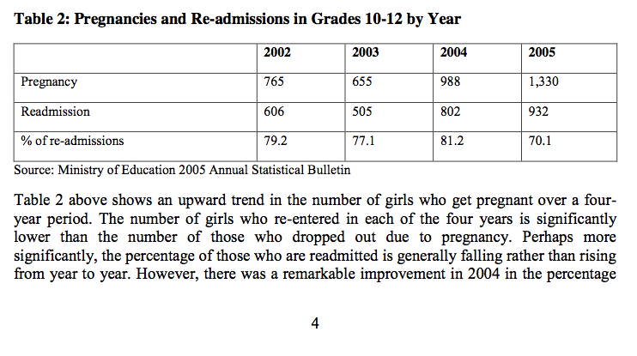
Policy briefs should display meaningful and powerful data that supports the policy recommendations in clear, easy-to-read graphics and tables. This example to the left comes from a document about the policy concerning the re-entry for girls who desire to return to school after giving birth (Mwansa, 2011). Notice how the author uses a table to illustrate the policy issue. The author also cites the source of the data and provides a very short description of what the table indicates.
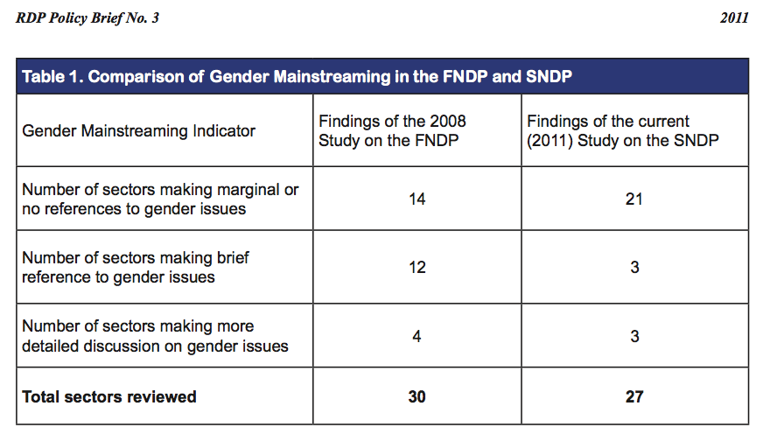
To the right is another example of a table from a policy brief created by the Monitoring and Evaluation Department of the Ministry of Finance and Planning, Government of the Republic of Zambia (2011). This table highlights statements made in existing policies rather than displaying data, which is another approach that could be used in a policy brief.

Policy Brief Rubric

 | High Distinction | Distinction | Credit | Pass | Fail
Engagement with Policy and Social, Political, & Historical Contexts | 15-13  Thorough and comprehensive grasp of the policy issue, policy implications, and related debates  Exceptional understanding of the social, political, and historical contexts | 12  Strong grasp of the policy issue, policy implications, and related debates  Strong understanding of the social, political, and historical contexts | 11-10  Some grasp of the policy issue, policy implications, and related debates  Moderate understanding of the social, political, and historical contexts | 9-8  Minimal grasp of the policy issue, policy implications, and related debates  Weak understanding of the social, political, and historical contexts | ≤7  Scant or incorrect grasp of the policy issue, policy implications, and related debates  Little to no evidence of understanding of the social, political, and historical contexts
Logic, Argumentation, & External Evidence | 10-9  Argumentation is clear, reasonable and flows logically;  Assessment of policy issue is made in an analytical and persuasive manner;  Shows exceptional ability to synthesize, integrate, and evaluate external knowledge (i.e., sources) | 8  Argumentation is mostly clear, reasonable and flows logically;  Assessment of policy issue is mostly made in an analytical and persuasive manner;  Shows strong ability to synthesize, integrate, and evaluate external knowledge  (i.e., sources) | 7  Argumentation is somewhat clear, reasonable and flows logically;  Assessment of policy issue is made in a somewhat analytical and persuasive manner;  Shows good ability to synthesize, integrate, and evaluate external knowledge  (i.e., sources) | 6-5  Argumentation is mostly unclear, unreasonable and has minimal flow;  Assessment of policy issue contains minimal analysis and persuasion;  Shows mediocre ability to synthesize, integrate, and evaluate external knowledge  (i.e., minimal sources and/or used improperly) | ≤4  Argumentation is illogical, missing, or impossible to follow;  Assessment of policy issue contains little to no analysis (purely descriptive);  Shows little if any ability to synthesize, integrate, and evaluate external knowledge  (i.e., inadequate or improper sources)
Structure, Mechanics, References, & Overall Quality | 15-13  The policy brief is organised according to the tenets of the genre in terms of clarity, presentation of information, sub-headings & layout, possibly with striking creativity or superior polish.  It contains a clear and logical organization, includes strong topic/transition sentences, contains minimal (if any) errors, and adheres to the document standards. | 12  The policy brief is organised according to the tenets of the genre in terms of clarity, presentation of information, sub-headings and layout. It is well-organised, includes topic & transition sentences, contains a couple errors, and/or adheres to most document standards. | 11-10  The policy brief is mostly organised according to the tenets of the genre in terms of clarity, presentation of information, sub-headings and layout. is somewhat organized, uses a few topic & transition sentences, contains several errors, and/or adheres to some document standards. | 9-8  The paper lacks organization and key tents of the policy brief genre, contains minimal topic & transition sentences, contains substantial errors, and/or adheres to few document standards. | ≤7  The document is not organised according to the tenets of the policy brief genre, in terms of clarity, presentation of information, sub-headings and layout. is confusing to read due to limited organization, transition & topic sentences, many errors, and/or issues with document standards.

