C5 Effective policies and recommendations
5.1 Using the "Blue Trade System" as a Trade Strategy for Sustainable Development
The globalization nature of labor issues requires countries to adopt a coordinated and unified “blue trade system”. The system is conducive to the continuous improvement of labor conditions in developing countries, and helps to avoid the establishment of “blue barriers” by developed countries through so-called labor issues. Form a reasonable and fair international trade order. People's awareness of safety, health and environmental protection has gradually increased, and consumers are willing to buy products produced by companies with higher levels of social responsibility at higher prices. Secondly, the labor cost and labor standards of enterprises should be determined according to the level of economic development of the country, and the labor standards should be gradually adjusted to maintain the labor cost and labor standards at a relatively reasonable value under the specific economic development level.
In recent years, China's economy has achieved tremendous development, but the wage level has increased very little. In China's GDP composition, corporate income is much higher than that of workers, indicating that the majority of workers have not fully shared the fruits of economic development. As a developing country, China is opposed to directly linking labor standards with international trade. However, economic development should be synchronized with social development, and the state needs to adjust wage standards in a timely manner. At present, China's labor cost is only one-forty-fiftieth of that of developed countries in the West, and even lower than many backward countries in Southeast Asia (see Table 5).
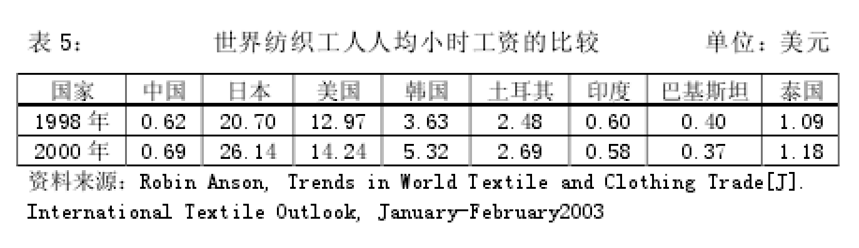
The drawbacks caused by the low cost of export products have become increasingly obvious. The low-cost expansion method that continues to rely on low labor standards cannot guarantee the coordinated development of the Chinese economy for a long time. At the same time, attaching importance to the protection of labor rights and interests is conducive to the sustainable development of enterprises and accelerate the process of internationalization of enterprises. Under the conditions of strict corporate social responsibility standards, enterprises will inevitably improve management efficiency, reduce transaction costs, accelerate technological innovation and transformation, and thus form new competitiveness. In response to the problems of Chinese labor, the government should actively take measures to improve domestic labor conditions, modify and improve relevant labor legislation, and establish more flexible labor standards. At the same time, the relevant supervisory departments should conduct random checks on enterprises according to the relevant industry and industrial labor standards that are currently in place, and impose severe penalties on enterprises that seriously endanger the safety of employees due to the use of child labor, violations of wages and working hours.
5.2 Strengthen the construction of information networks and establish an early warning mechanism for “blue barriers”
Establishing an early warning mechanism is of great significance to the healthy development of China's foreign trade, because international standardization bodies and governments and standardization bodies often revise their technical regulations and standards. If the company's information is not smooth, it cannot follow the changed regulations and standards. Producing products will encounter setbacks when exporting. At the same time, increase the development of the international market, promote the diversification of the export market, and face the "blue barriers" promoted by European and American countries, the government should actively do some promotion work, in addition to let more companies familiar with their rules and establish crisis awareness, In addition to consciously raising labor standards, we should also vigorously explore the market and expand the market share of products.
5.3 Actively participate in international multilateral negotiations through the WTO mechanism
Although the “social terms” have not yet been incorporated into the multilateral system of the WTO, the link between labor issues and trade is an irreversible trend, and future multilateral round negotiations will inevitably involve social clauses. As a member of the WTO, China should work with other member states to clarify and refine its rules of use under the WTO's consultation mechanism. Actively participate in the ILO's discussions on trade and labor standards and economic globalization, and use some relevant provisions and agreements with international organizations to strengthen international exchanges and cooperation to protect the smooth development of China's foreign trade.
5.4 Exploring new ways to attract foreign investment
The main way for China to attract foreign investment is the government's incentive policy, which is to give preferential treatment to foreign investment in industries or regions that the state encourages to reduce equipment tariffs, customs-paid VAT and corporate income tax. Today, with more and more emphasis on corporate social responsibility, the wide implementation of the "blue trade system" is an inevitable trend. Simply relying on low labor costs and preferential policies to maintain competitiveness will not only fail to achieve the goal but will lose competitiveness. Therefore, in order to truly maintain a competitive advantage, it is necessary to improve the investment environment and fundamentally eliminate institutional cost factors.

