Chapter 4: Finding and discussion （5000）

4.1 Status of China's export trade
4.1.1 Import and export trade volume enters a gradual period
After China's accession to the WTO, China's foreign trade environment has been greatly improved, and the volume of import and export trade has continued to grow rapidly. In 2004, China's foreign trade growth rate was as high as 7.35 percent, and the total import and export volume exceeded $1 trillion for the first time, ranking first in the world for the first time. In 2009, the total export volume reached 2.1 trillion dollars, surpassing Germany to become the world's largest exporter. In 2012, the total volume of import and export trade surpassed the United States for the first time and was promoted to become the world's largest trading nation. In the ten years after China's accession to the WTO, China's foreign trade has always maintained a high growth rate. In 2009, due to the financial crisis, China's exports showed negative growth. Since 2012, the external economic environment has been deteriorating. Due to the persistence of the European debt crisis, the slow recovery of the US economy, the spread of global inflationary pressures, and the rise of trade protectionism, China's foreign trade is facing increasingly severe challenges. In recent years, although the total volume of import and export trade has maintained a relatively steady growth, the export growth rate has further slowed down.
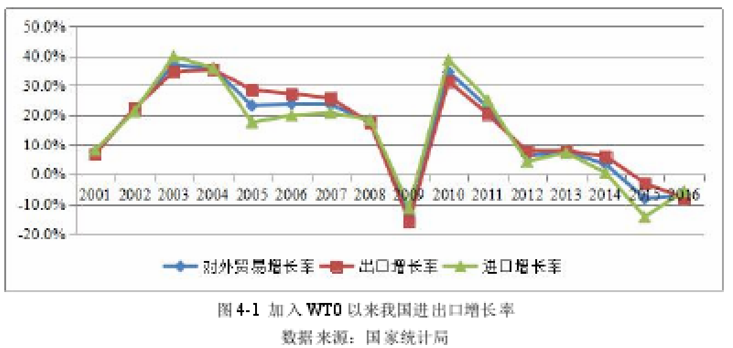

4.1.2 Higher dependence on foreign trade
The degree of dependence on foreign trade reflects the degree to which a country is integrated into the world economy, and it also reflects the dependence of the country's economy on trade. Since 2001, the role of foreign trade in China's economic development has become increasingly prominent. The growth rate of foreign trade is much higher than the growth rate of GDP, and the degree of dependence on foreign trade has also continuously increased. As shown in Figure 4-2, in 1980, China's foreign trade dependence was only 12.5%, and import dependence was slightly higher than export dependence. With the deepening of opening up to the outside world, the rapid development of its labor-intensive industries has stimulated the rapid growth of China's exports. The dependence on foreign trade has continued to rise, and its dependence on exports has continuously increased. In 2006, foreign trade dependence was as high as 65.2%. In recent years, China has been constantly adjusting its economic structure. The economy has shifted from relying mainly on expanding exports to relying on expanding domestic demand. The dependence on foreign trade has declined, but it has remained above 40%, exceeding the world average and far higher than the United States and Japan. Economic powers such as the European Union.
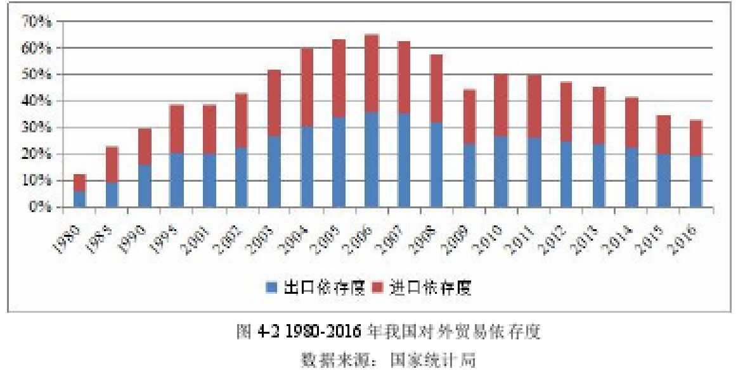
4.1.3 Export products are mainly labor intensive
As a developing country, China has abundant and cheap labor resources. The large-scale export of labor-intensive products not only eases domestic employment pressure, but also makes an indispensable contribution to its economic development. In China's export, labor-intensive products have always occupied a large proportion, especially in traditional labor-intensive products such as clothing, textiles and footwear. China is a big exporter of textiles and clothing in the world, and textiles and clothing account for a large proportion of total foreign trade exports far exceeding the world average. Since 1970, the share of textiles and clothing exports in the world's total exports has been stable at 5%–6%, and the proportion of most developed countries is about 4.5%, slightly lower than the world level, and most developing countries. The proportion is usually around 11%.
In the past 20 years, the structure of China's export products has also quietly changed. Export goods are classified according to SITC and are mainly classified into primary products, industrial manufactured goods and other unclassified commodities. The primary products are mainly divided into five categories: beverages, food, agricultural and mineral raw materials, fuels, animal and vegetable fats and oils. Industrial manufactured products mainly include labor-intensive products such as light textile products, chemicals and related products, machinery and transportation equipment, rubber products mining and metallurgy products and their products, and miscellaneous products. As shown in Figure 4-3, since 1985, the proportion of primary product exports has been declining, and has remained at around 5% in the past 10 years. At the same time, the proportion of exports of industrial manufactured goods has continued to rise, maintaining around 90% in the past 10 years and 92.5% in 2014. It can be seen that at present, China's export industry is mainly concentrated in processing and manufacturing, with low added value of products and strong substitutability of labor. Such products are greatly affected by the blue trade barriers, and this is the main target of the barrier.

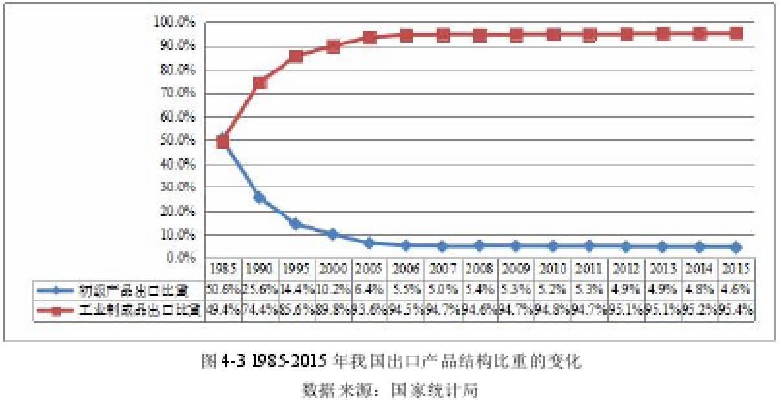
4.1.4 Unbalanced export market structure
At present, China has established economic and trade exchanges with more than 250 countries (regions), but its export market structure is relatively unbalanced. According to the statistics of the National Bureau of Statistics, since the 1990s, the United States, the European Union, Japan, South Korea, and Hong Kong have long occupied the top five of China's export markets, of which most of the exports to Hong Kong are entrepot trade. Although the share of the top five export markets declined slightly, the combined exports of these countries (regions) accounted for more than 55% of China's total exports. Since 2012, the United States has surpassed the EU to become China's largest exporter. In 2015, the proportion of China's total exports to the United States was as high as 18.0%. In international trade, the wider the scope of export markets, the smaller the influence of individual export markets. Conversely, when the import and export markets are mainly concentrated in one or several countries (regions), the influence of these markets is greater. The risk of trade is also greater. The three major economic entities of the United States, Japan and the European Union are China's major export markets. They are the main initiators and supporters of the blue trade barrier. At present, the concentration of export trade is basically coincident with the birthplace of blue trade barriers, which makes the blue trade barriers bring greater negative economic effects to China's foreign trade development.

4.2 Case of the Impact of Blue Barriers on China's Labor-intensive Enterprises
On February 9, 2004, several Walmart suppliers in China were accused by the US Labor Committee and other institutions because the organization believes that there are poor working conditions, deduction of workers' wages, and forced workers to work overtime. In subsequent investigations, the actual wages of workers in these companies were 16.5 cents per hour. This has seriously violated the Chinese Labor Law and the relevant regulations of Dongguan. The legal minimum wage for Dongguan workers should be 450 yuan, while the statutory wages are 8 hours of normal work per day. Once this standard is exceeded, it needs to be paid every hour. 150% of monthly salary. The factory explained that they have no way, because if Walmart finds that the same kind of manufacturers supply cheaper than them, even if the price difference is only a few cents, they will immediately transfer the order to another factory. The measures that the factory can take are only Various methods are used to lower the cost of wages in order to reduce the supply price.
A Walmart spokesperson said that more than 300 factory inspections around the world were done every week to confirm that the supplier's operations were in compliance with the standards set by the countries and the UN. Once they find that the supplier has not complied with local laws or Walmart standards, they will not hesitate to terminate their relationship. In the end, the plastics factory lost its order to Walmart, a major customer, in March 2004 due to a violation of Walmart's principles for its suppliers.
This is a typical trade dispute caused by a violation of the blue clause. The developed countries represented by the United States and the United States believe that the relationship between international trade and labor issues is extremely close, and unfair labor measures adopted by any country will have an unfair competition effect on international trade. Unfair labor measures adopted by developing countries, such as lowering wages, extending working hours, and neglecting the safety of occupational safety and health in the workplace, will greatly reduce the export cost of their goods, and cause export goods of developed countries in the international market. The competitiveness of the developing countries has been greatly reduced, and the advantages enjoyed by developing countries in this situation violate the spirit of international trade liberalization. Developed countries demand that labor standards should be unified, while developing countries believe that the inclusion of labor standards issues in the scope of the World Trade Agreement has certain restrictions on the free negotiation and negotiation between employers and employees, and that the harmonization of labor standards means for developing countries. The increase in labor costs and the competitiveness of developing country products in the international market will be severely weakened. The collision and conflict between developed countries and developing countries in terms of values and economic interests is the essence of the above-mentioned case debate. Developed countries want to achieve the purpose of trade protection through the implementation of labor standards. In order to protect their domestic markets, they impose restrictions on the export of labor-intensive products from developing countries to their countries. From the perspective of trade protection measures in a developed country, blue trade barriers have undoubtedly had a greater impact on Chinese enterprises, especially labor-intensive enterprises. However, this paper believes that this kind of impact is short-lived and can be controlled by certain measures. It is not so much an obstacle to China as it is a challenge. Faced with such challenges, governments, enterprises and industry associations should work together to meet the challenges and greet greater opportunities and longer-term benefits.
4.3 The negative impact of blue trade barriers on the export of labor-intensive industries
4.3.1 Restricting the expansion of export scale
In 2015, China’s total export trade reached US$2,273.5 billion. The three major export markets are US$409.2 billion, EU 355.8 billion and Hong Kong 330.5 billion, accounting for 48.19%. Hong Kong is mainly for entrepot trade, and its final export market is mainly concentrated in developed countries such as Europe and the United States. The United States and the European Union are the main drivers of blue trade barriers. At present, multinational companies in these countries (regions) are actively pursuing the SA8000 standard, and through the new setting of labor standards and corporate social responsibility for China's textile, clothing, footwear, chemicals, toys and other export enterprises, The export of these products to the markets of Europe and the United States has become an indirect barrier to the export of textiles and garments, which has severely restricted the expansion of the overall scale of labor-intensive exports.
The National Bureau of Statistics shows the export volume of labor-intensive products such as textiles and clothing, footwear, furniture and parts, luggage and travel goods, and their proportion of total exports in 2005-2011. It can be seen from the table that the export volume of China's textiles, clothing and footwear continues to increase. The total export value of these typical labor-intensive products increased from US$1656.5 in 2005 to US$3749.6 in 2011, which is an increase from 2005. 126%. However, it should not be overlooked that the proportion of these labor-intensive products in total exports has shown a downward trend: from the proportion of exports in 2005 to 21.7%, to 19.7% in 2011, an average annual decline of 0.3 percentage points. Due to the spread of the global financial crisis in the second half of 2007, the weakening of international market demand, the appreciation of the renminbi, the rising prices of raw materials and the rising labor costs have led to a sharp increase in export cost pressures of some labor-intensive small and medium-sized enterprises, which have caused large losses and seriously affected Export capacity. In the second half of 2008, the Chinese government raised the tax rebate rate for more than 3,000 export commodities three times in a row, mainly in labor-intensive commodities such as textiles and clothing, in order to help domestic enterprises cope with the global financial crisis and the pressure of RMB appreciation. It is undeniable that the upward adjustment of export tax rebates will have a positive impact on SMEs in labor-intensive industries in the short term, but it has not changed the decline of industry benefits and the negative growth of exports in the long run.
TPP regards the basic rights of labor as the core of the agreement. Once the high labor standards in the TPP are reached, it will lead to the transfer of China's labor-intensive products to TPP member countries such as Vietnam and Malaysia, affecting the expansion of its export scale. Since the TPP negotiations in 2010, China's labor-intensive products exported to TPP member countries have been affected to varying degrees. Take China's export growth rate of textiles and raw materials to some TPP countries as an example. As shown in Figure 4-4, in 2011-2016, the annual growth rate of China's textiles and raw materials exported to the United States, Japan, Canada, Australia and other countries showed a general decline. trend. Although the United States has now withdrawn from the TPP, the United States clearly will not give up its other high-standard standards and restrict the export of labor-intensive products from developing countries.
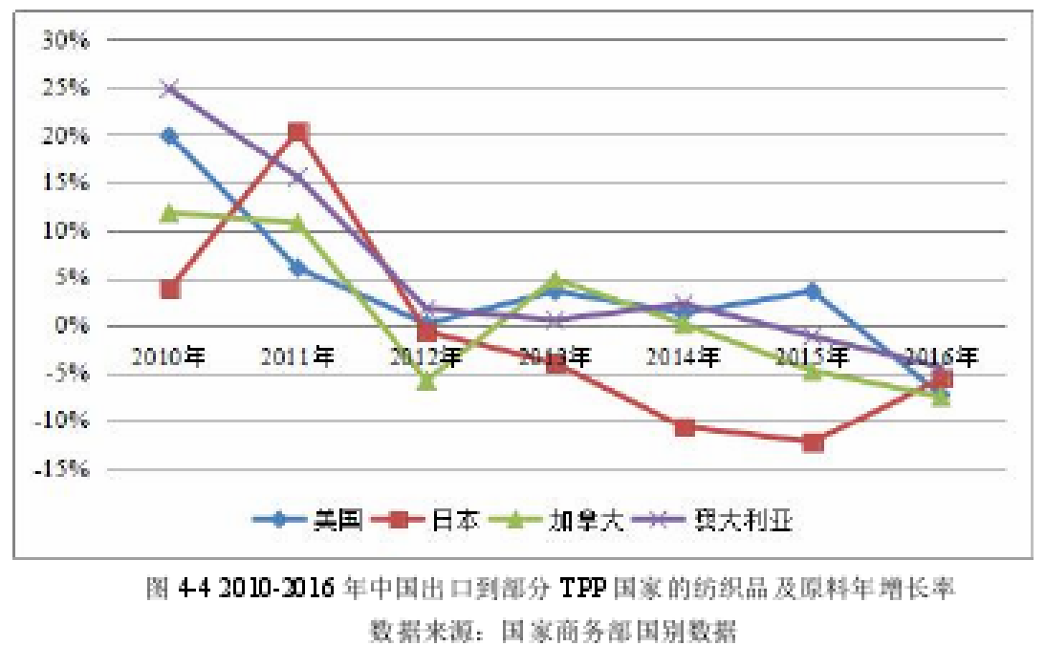
还差一个表 我去找

4.3.2 Reducing the competitiveness of export products
According to the economist David Ricardo's theory of comparative advantage, comparative advantage is a prerequisite for international trade. In international trade, countries should choose to export products with comparative advantages. Therefore, China's exports are mainly labor-intensive products.
At present, most of China's foreign trade processing-oriented enterprises are small and medium-sized enterprises, and there are widespread problems such as low salary and welfare of employees and serious overtime work. Most enterprises are still unable to meet the requirements of labor standards in developed countries. In order to meet these requirements, companies need to invest a lot of manpower, material resources and financial resources. Taking the SA8000 standard as an example, the certification and maintenance of this standard requires companies to pay various fees including application, review, and daily maintenance. These costs can be said to be a small expense for a company. On the one hand, the rising production cost of products will cause enterprises to lose their cost advantages, and will also make other competitive advantages of products greatly reduced or even disappear; on the other hand, in order to make up for the losses caused by the increase in costs, enterprises will certainly increase by increasing the price of products. The cost is transferred to consumers, and most labor-intensive products are characterized by high price elasticity, which is highly substitutable. The increase in prices will greatly reduce the export volume of these products, and the profits of enterprises will decrease, reducing the types of enterprises. The competitiveness of its products in the international market.
The dominant comparative advantage index (RCA) represents the ratio of the proportion of exports of a certain type of products in a country to the proportion of the world's exports of such products. RCA>2.5 means that such products have strong international competitiveness, whereas RCA<0.8 represents The competitiveness is weak. The following is an analysis of the competitiveness of various Chinese export products through changes in RCA. Ren Jiayu (2017) selected four different types of products, and analyzed the negative impact of blue trade barriers on the competitiveness of Chinese export products by measuring the changes in the RCA index of various products from 2000 to 2014. Textile and apparel products are typical labor-intensive products, as shown in Figure 4-5. Since 2000, textile and apparel products RCA>2.5, compared with the other three types of products, clearly have a strong international competitiveness. However, the RCA index of such products has shown a downward trend as a whole, showing that the implementation of blue trade barriers has greatly weakened the comparative advantages of textile and apparel products and reduced the international competitiveness of such products. In addition, mechanical seal products are capital-intensive products with general competitiveness. In recent years, the overall trend has been declining. Organic chemicals are technology-intensive products. Due to technological improvements, their competitiveness has been continuously improved; meat and other resources are intensive. The international competitiveness of the products is weak and declining, and the RCA index approaches zero.
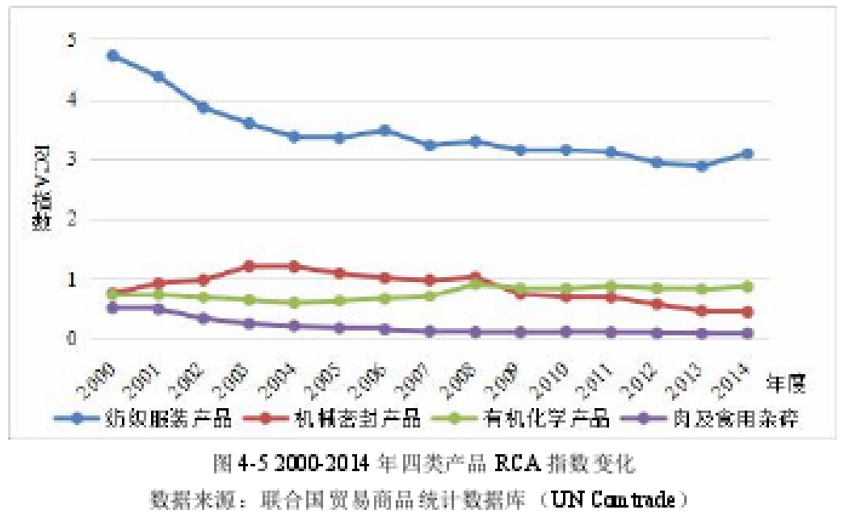

4.3.3 Lead to a surge in trade friction
In 2016, the number of trade frictions in China rose again, with trade remedies reaching 119, up 36.8% year-on-year. There were 91 anti-dumping cases. China has become the country with the largest number of trade frictions in the world for 22 consecutive years. The United States and Europe are the main countries for launching anti-dumping investigations. Trade friction is dominated by anti-dumping, with blue barriers accounting for a large proportion. As shown in Figure 4-6, since 2002, the number of anti-dumping cases in China has shown an increasing trend. Affected by the 2008 financial crisis, the global economy was in a recovery phase in 2009. In order to stimulate the domestic economy and promote international trade, countries have loosened their trade protection. As the world economy slowly stabilized, developed countries began to turn their attention to various new trade barriers. The blue trade barrier is a new trade protection measure adopted by developed countries using labor standards as an excuse to create trade frictions and attempt to restrict the export of products from developing countries. From 2010 to now, the number of anti-dumping cases in China has increased from 44 to 91, and has doubled within six years.
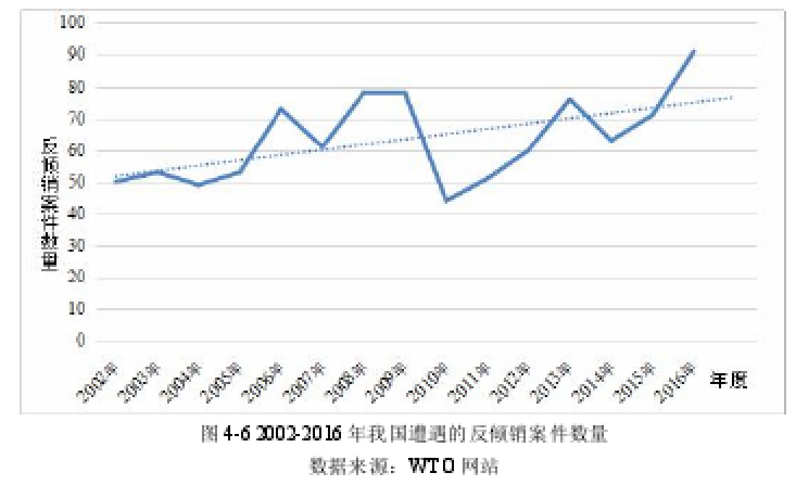
Traditional trade frictions are generally only penalized for a certain batch of goods. The losses suffered by enterprises can be quantified. However, new trade protection measures such as blue trade barriers are directed at enterprises, and if there are non-conformities, they are directly Cancel the order and stop the cooperation. Therefore, blue trade barriers are a heavy blow to labor-intensive industries. For example, in 2005, the European Union imposed an anti-dumping duty of up to 4.9%-49.7% on Chinese vinegar staple fiber. This anti-dumping measure lasted until 2011. However, in December 2013, the European Union launched a countervailing investigation on its vinegar staple fiber and will continue to tax the vinegar staple fiber.
4.3.4 Affecting employment situation and economic and social stability
On the one hand, the enforcement of labor standards such as SA8000 has caused the production enterprises such as textiles and garments to go bankrupt, and a large number of workers are unemployed, which is not conducive to economic and social stability. As a world's most populous country, labor-intensive enterprises have made great contributions to solving the employment problem of the Chinese population. According to statistics, in the general industry, fixed assets investment of 100 million yuan can provide about 932 jobs, while the textile industry and textile and apparel industry can provide 1876 and 4464 jobs respectively.
Since the implementation of the blue trade barrier, many large domestic brands have been forced to increase labor costs in accordance with foreign labor standards. Since the financial crisis in 2008, foreign demand for Chinese textile and apparel industry has become higher and higher. By 2016, the average labor cost has increased by one. More than one. The increase in labor costs in China has caused orders from multinational companies to shift to lower-cost Southeast Asian countries, putting their long-overcapacity textile and garment industry in crisis. 2015 was a concentrated outbreak. Take large and medium-sized textile and garment enterprises as an example. On April 20th, the main supplier of sports brands, Yalun garments, went bankrupt, resulting in more than 2,000 employees unemployed; on May 18, it was once the top 500 private enterprises in Shaoxing. Daxie Wuyang Printing and Dyeing declared bankruptcy and more than 2,000 employees were unemployed; on May 22, the Wiskey womenswear that was funded by Lenovo collapsed, the company had 5,000 employees... The unemployment problem of a large number of workers will be against the Chinese economy, Social stability has an adverse impact (Wang, 2017).
On the other hand, foreign investment is currently concentrated in labor-intensive industries. The increase in labor standards has led to an increase in labor costs, which has reduced the attractiveness of foreign investment and impacted economic and social stability. As can be seen from Figure 4-7, in 2008-2016, the annual growth rate of China's foreign direct investment has shown a downward trend as a whole. Under the influence of the financial crisis, countries have relaxed their investment restrictions in order to develop their own economies. In 2008, the annual growth rate of foreign investment in China was as high as 21.59%. In 2011, the global economy began to pick up. Developed countries used blue barriers to increase labor costs in order to reduce the threat to China's labor-intensive products. Due to the rising labor costs, many investors have shifted their direct investment targets to countries such as Southeast Asia, reducing their establishment of factories, resulting in a slowdown in the growth of foreign direct investment in China, and the investment environment is deteriorating.
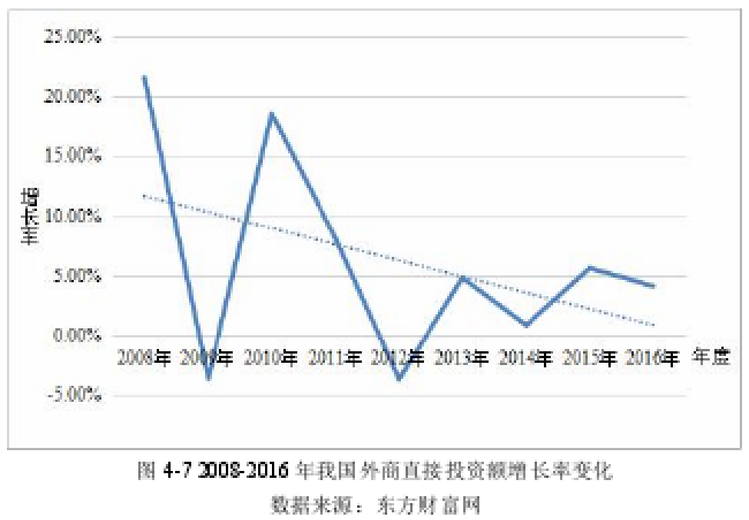

4.4 Positive Impact of Blue Trade Barriers on China's Labor-Intensive Industry Exports
4.4.1 Improve the productivity and quality of export products
Elizabeth Larsen () pointed out: “Employees are difficult to produce quality products under harsh working conditions and working conditions. Long working hours, unsafe working conditions, discriminatory employment policies and injustices Under the long-term influence of unfavorable factors such as salary and treatment, workers will inevitably lead to negative working attitudes, resulting in a decline in product quality." It can be seen that higher production efficiency and product quality must be based on the satisfaction of employees' interests and demands (Zhou, 2004). For a long time, most labor-intensive enterprises in China have paid insufficient attention to the investment in employees' working conditions, salary and other issues, resulting in the international evaluation of related export products is not high. In addition, although China's labor productivity growth rate is fast, with an average annual growth rate of 8.6%, the overall level of labor productivity is still low. In 2016, China's labor productivity was 94,825 yuan/person, a growth rate of 6.4%. As can be seen from Figure 4-8, China's labor productivity has increased continuously from 2000 to 2016, but it is far below the world average, and the labor productivity of the United States far exceeds the world average. According to ILO statistics, in 2016, China's labor productivity only reached 7.8% of the US and 44.6% of the world average.
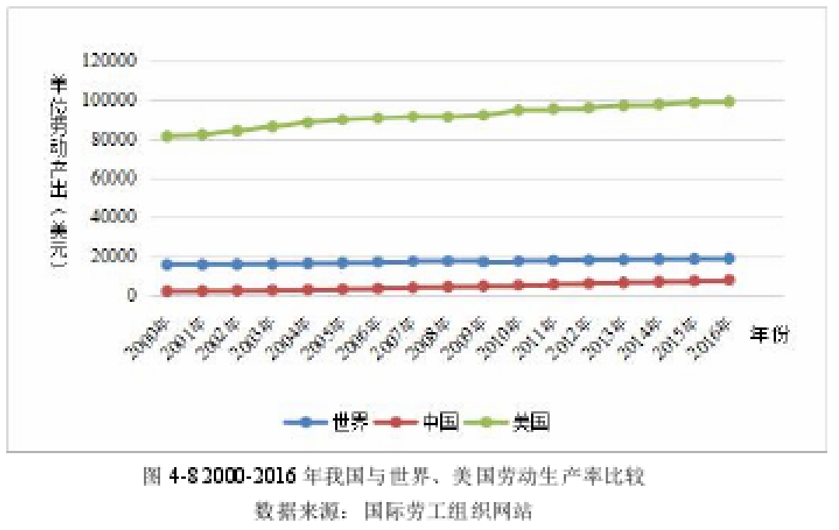
With the gradual implementation of labor standards, the working environment of employees can be improved, the labor rights of employees can be guaranteed, and the company can effectively encourage employees to improve the production efficiency and quality of products to a certain extent. According to a report by New Balance, the work hours of employees have been significantly reduced since New Balance's implementation of the SA8000 standard in China, but the efficiency of production and the quality of products have been greatly improved. It can be seen that although the SA8000 standard certification will lead to an increase in production costs in the short term, in the long run, the implementation of labor standards will help optimize the product quality and production efficiency of enterprises, and the transformation of labor standards such as SA8000 in China's labor-intensive industries. Can play a good role in leverage (Zhu and Huang, 2003).
4.4.2 Promote the adjustment and upgrading of industrial structure
At present, low labor costs are still the comparative advantage of China's exports, but in the long run, the development mode of relying solely on the advantages of cheap labor faces enormous risks. As shown in Figure 4-9, according to research data from Oxford Economics, the gap between China's manufacturing unit labor costs and the United States is getting smaller and smaller than India, Japan and Mexico. On the one hand, China’s labor costs have risen. On the other hand, some developing countries such as India are in the period of reform and economic development, releasing a lot of cheaper labor than China, which has shaken China’s labor advantage to some extent. status.
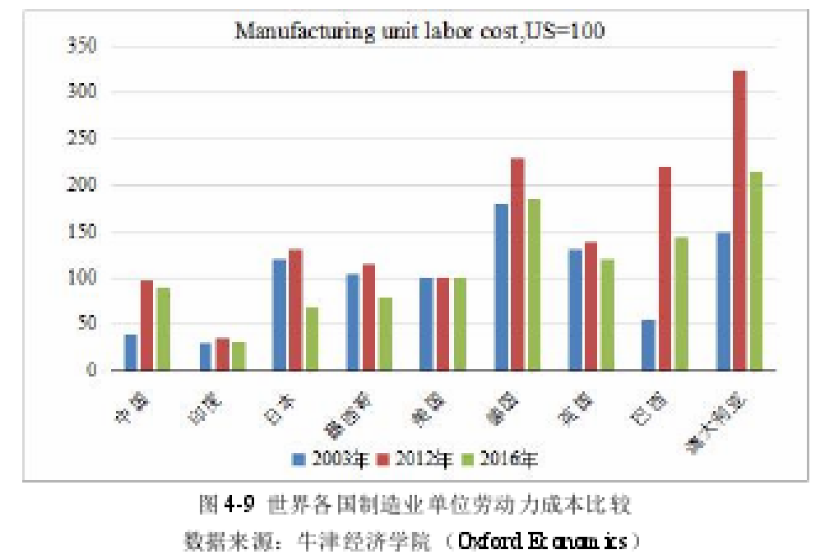

In response to the rising production costs brought about by blue trade barriers, Chinese companies must actively improve production technology, that is, enterprises can achieve a new balance by changing the combination of production factors, especially changing the marginal productivity of labor and capital, and accelerating capital. Marginal productivity growth. Enterprise transformation will drive the adjustment and upgrading of the industrial structure of the entire industry, and promote its industry to gradually transform into technology and capital-intensive, bringing more economic benefits and social benefits.

4.4.2 Enhance the international competitiveness of exporting enterprises
The improvement of labor conditions is conducive to improving the core competitiveness of export enterprises and promoting the healthy development of enterprises. On the one hand, raising labor standards will bring more opportunities for corporate reform and development. The promotion of labor standards can promote a substantial change in the role of workers, truly become the master of production, and enterprises will benefit more from it and create more wealth for the society. Compared with other companies, SA8000-certified companies are equivalent to obtaining market passes for developed countries such as Europe and the United States, which greatly enhances the company's international competitiveness. On the other hand, high labor standards will encourage enterprises to assume social responsibilities, continuously improve working conditions and labor treatment, and the increased production costs will cause some SMEs to face the risk of bankruptcy, and will force another part to survive. Change, improve independent innovation and research and development capabilities, improve production technology, strengthen the standardization of enterprise management, and enable enterprises to transform from cost advantage to capital and technological advantages and improve international competitiveness. Therefore, in the long run, blue trade barriers bring huge opportunities and challenges for China's exports, which is conducive to the adjustment and upgrading of its export industry structure.
4.4.3 Encourage enterprises to abide by laws and regulations, and help protect workers' rights and interests
China has enacted and successively promulgated a series of labor laws, regulations and rules, such as the "Company Law", "Labor Law", "Trade Union Law", "Enterprise Law", "General Principles of Civil Law", etc., which deserves special attention. The Labor Law of the People's Republic of China promulgated on July 5, 1994, which established uniform labor standards and labor market rules in the form of the Basic Law, thus providing legal guidelines for adjusting labor relations. China's first "Labor Contract Law (Draft)" was reviewed and approved at the 19th meeting of the 10th Standing Committee of the National People's Congress on December 26, 2005, adding a legal basis for the protection of workers' rights and interests. Only in accordance with the relevant requirements of the "Labor Law", enterprises can effectively protect the rights and interests of workers and make them become the real masters of enterprises, in order to achieve the purpose of safeguarding the interests of enterprises and promoting the long-term development of enterprises.

