Despite the latest Chinese e-commerce law and Bellamy takeover case, daigou （professional buyer）Jiamin Tang is still optimistic about the future business.

The 24-year-old girl is one of the 150,000 daigou in Australia. She has been a daigou for almost two years and her living costs can be covered by earnings from daigou.

She cooperates with a Chinese store in Chinatown, where she contacts suppliers, contacts customers, packages and arranges shipments, and processes at least 20 orders per day.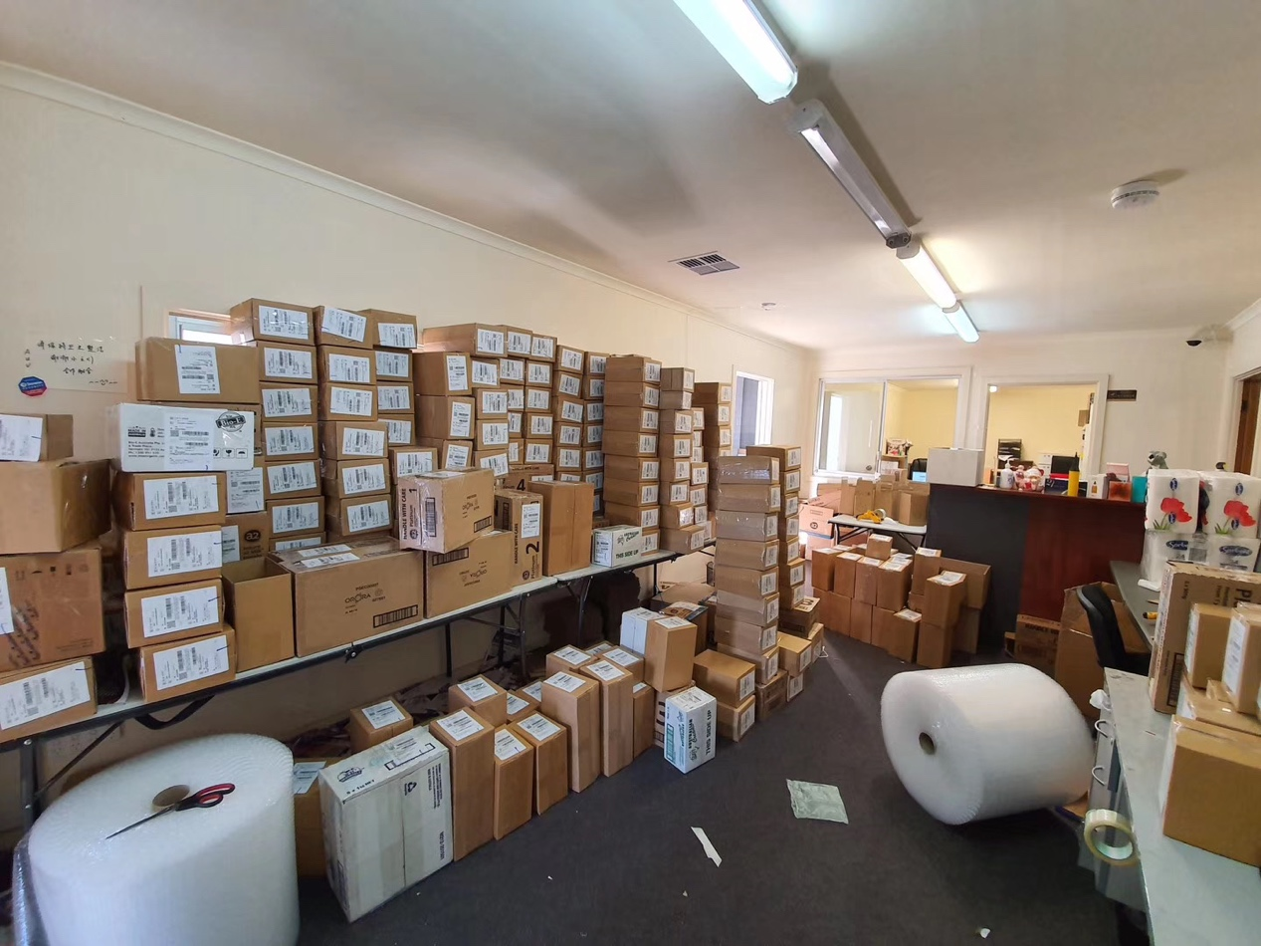
warehouse of a Chinese store

Recently, news about Chinese shoppers rudely purchase the baby formula in the shop has been shown in social media.

"It is just a minority. Actually, daigou have professional business partners, which will not affect the daily needs of local people," Tang explained.

Chinese enthusiasm for Australian baby formula has been going on for many years. Nowadays, the Chinese dairy market policy and the Bellamy takeover case have aroused social concern.

Daigous have to think about whether the future business model needs adjustment because of these changes.
Chinese infant formula VS. Australian infant formula

Due to the Australian government's emphasis on food safety education and strict food control systems, Australian dairy products are well known in the international market.

Since the vicious incident in China's well-known milk powder brand Sanlu in 2008,
Chinese customers have insufficient confidence in the domestic formula.

In order to change this trend, the Chinese government encourages the development of domestic milk powder brands.

On 3 June, 《Domestic Infant Formula Development Plan》was issued and the government established a regular inspection mechanism of dairy product safety.

The plan encourages them to set up foreign-invested companies in China, promote fair competition between Chinese brands and foreign brands, and bring their advanced technology and management experience to China. 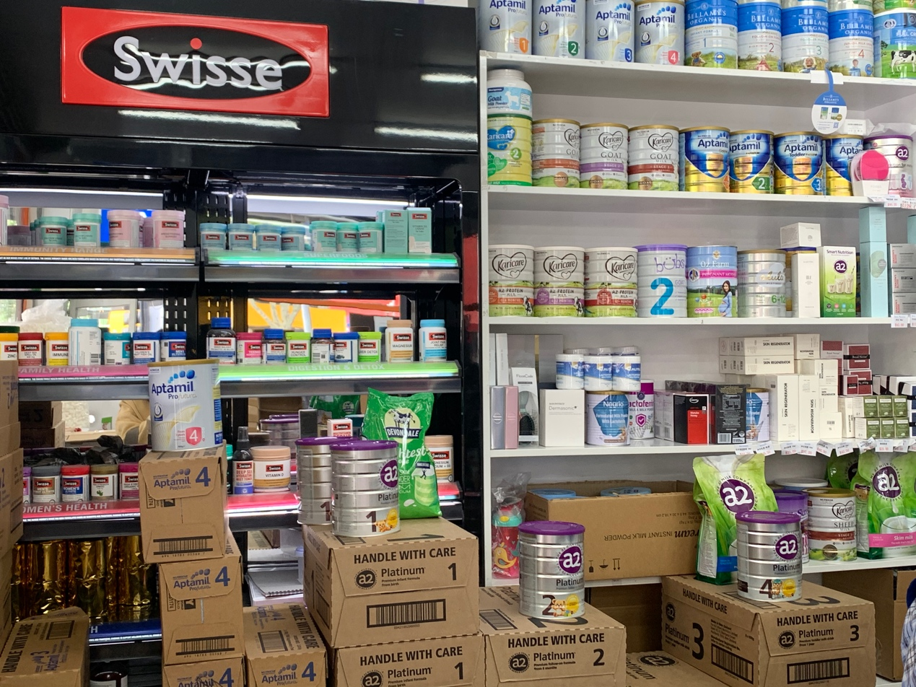
Shelves of a Chinese store in Melbourne

Song Liang, a well-known expert in the Chinese dairy industry, said in a statement that the introduction of this plan demonstrates the Chinese government's determination to change the national stereotype of domestic dairy products through new plans.

According to iiMedia Research 2019, 19.7% of Chinese consumers are more inclined to buy domestic brands, and consumers in economically disadvantaged cities are more confident in domestic baby formula brands. The willingness to purchase is up to 28.1%.

However, the Chinese middle class and upper-class families still prefer imported milk powder brands. The most popular Australian brands are A2 Platinum, Bellamy Organic, Aptamil.

“This competition is very long-lasting and cruel,” Mr.Song told to The Citizen. “This is because foreign-funded infant formula has dominated China for more than 30 years, relying on its brand strength and R&D advantages.”

“Chinese consumers have formed a thinking that the quality of foreign infant formula is better than domestic ones," Mr. Song added.

Therefore, before Chinese dairy brands regain consumers' confidence, Australian dairy brands are still competitive.

Bellamy’s challenges and opportunities

The Chinese market is Bellamy's largest market, accounting for 70% of the company's formula sales.

According to《Administrative Measures Product Formula Registration Young Children Formula Milk Powder》issued by China Food and Drug Administration, by 2019, all products without recipe registration were prohibited from entering.

This has caused a big blow to Bellamy. According to Bellamy’s earnings report, in the first half of FY 2019, Bellamy’s Australian sales were NZ$127.7 million, and the Chinese version of Bellamy’s sales was zero. The Australian version of sales of NZ$152 million, the Chinese version of sales of NZ$18.1 million.

Cooperation with the China Mengniu Dairy Company can solve this problem and create a mutually beneficial and win-win situation.

The acquisition plan was just signed, and Bellamy's share price soared by 55% in a short period of time, from the original $8.34 per share to $12.94.

On the one hand, Mengniu has the opportunity to increase the production of organic milk powder and can further build nutritious food for infants and young children.

Bellamy is an Australian listed company, the performance can be combined with Mengniu to make its revenue higher; at the same time, the Australian market, Mengniu is also easier to enter.

Daigous’ opinions

Daigou Jiaming Tang said,“Although Bellamy is one of the major brands we purchase. most of my customers purchase A2, so this acquisition won't make us worry about the decline in our sales."

“However, it is possible that the bellamy's takeover case will reduce the number of future customers.”

Tang’s worries are reasonable.

For Bellamy, the official opening of the Chinese market has been limited due to the fact that its formula for milk powder has not been applied for registration by the Chinese government.

However, after being taken over by China Mengniu Dairy Company, entering the Chinese market is easier. In other words, Chinese customers may no longer rely on Daigou.

“Whether there is any disadvantage from losing the personalized social capital provided by the daigou will be dependent on the legitimacy status of the Mengniu Group,”said Stuart Orr, a strategic business management professor.

“Of course, the Mengniu Group may also use their ownership to make it more difficult for the daigou to distribute Bellamy's product which may force Chinese consumers to deal with Mengniu,” Mr. Orr said in a statement.

Jiamin Tang said that Bellamy's takeover case may increase the sales of other Australian dairy brands to some extent, which is why she continues to be optimistic about their business future.

“However, the acquisition may have an impact on the development of the Bellamy brand,” Tang said.

“Because of the cooperation with Chinese Mengniu Dairy company, some customers may worry about the decline in the quality of milk products and then purchase other brands.”

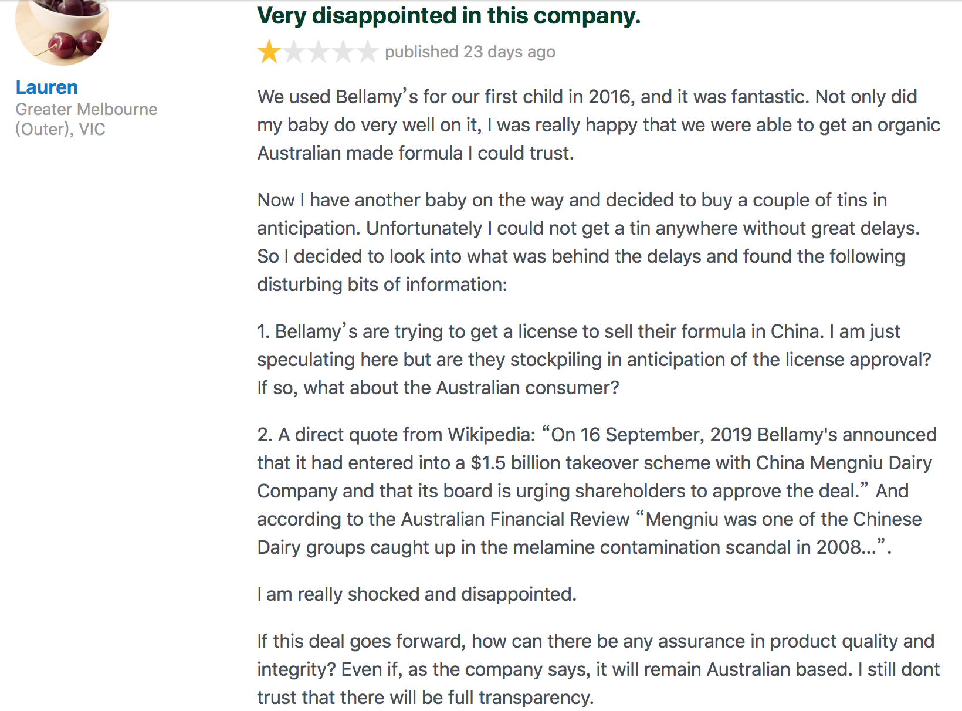
Review of Bellamy Organic. Source: productreview.com.au

In response to similar comments, Mengniu's Chief Executive Officer Lu Minfang said that after the completion of the acquisition, Bellamy's factory and raw material supply will remain in Australia as they are, and only when raw materials are scarce, will they consider importing raw materials overseas to ensure production.

“Having a local presence will add significant credibility if they can indicate that the raw materials are still from Australia.”Mr.Orr said.

