Finc 5001 Major Assignment Part One

Northern Star Resources Limited, an Australian owned global company, generating revenue from gold mining. The company has been mining and exploring gold in Western Australia, Northern Territory and Alaska. It is currently operating Tier-1 world-class projects at Jundee mines, South Kalgoorlie mine, Pogo and Tanimi. Northern Star aims to maximum the total returns to their shareholders, so they acquire high-value, low cost mine to achieve this goal. The company strategies are attracting global investors by meeting the following criterial-maintain gold production from mining operation, improving mining life and constantly having low cost operation. Current stock price of Northern Star is A$11.85.

Here are the graphs of the NST’s share price and ASX200 index below. Although there are some fluctuations, they have a similar upward trend.
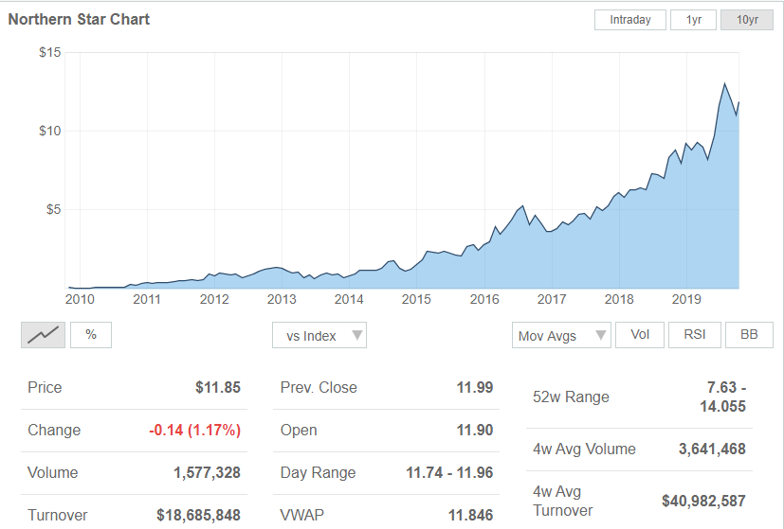
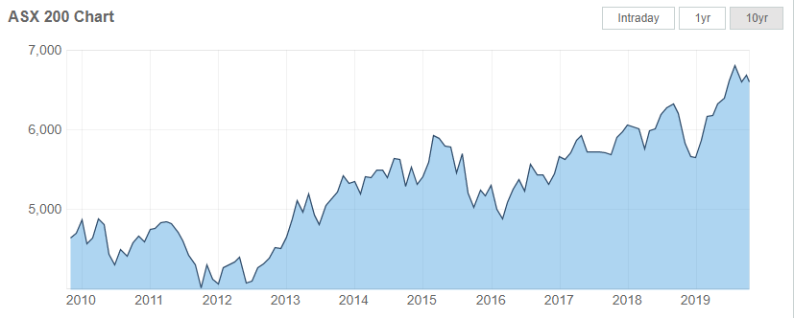

Announcement One: Northern Star Resources Limited acquires the Tier-1 Pogo Gold Mine.
Aug 30th, 2018
NST acquired Pogo project in Alaska for US$260M. The deal would set Northern Star to be the producer from three Tier-1 mines in Tier-1 jurisdictions. Pogo is a world-class project with an 8Moz gold endowment. It produced 3.8Moz at 13.6gpt over the past 12 years at an average rate of 300,000ozpa. NST said Pogo would be managed by the same team with Jundee (an operation had strong performance after bought by Northern Star four years ago), so the development track of Jundee would oversee the Pogo’s future.

During the period of August 28th to September 5th, 2018 when Jundee was acquired, the share price increased from $6.75 to $8.18. The figure can conclude that the market make a positive reaction to this announcement. Moreover, stakeholders of NST believe that this company will perform well after the acquisition of POGO.

Announcement Two: Northern Star Completes Acquisition of Pogo Gold Project
Oct 1st, 2018
On Sept 28th, 2018, Northern Star Resources has completed the acquisition of the Pogo gold project in Alaska and will start receiving financial benefits of Pogo since July 1st, 2018. Since Northern Star is expanding its business into a highly prospective mining location, its total annual production in FY2020 will increase to 800,000-900,000oz at A$1,200-A$1,400. As there is an estimation of positive revenue growth, the share price for Northern Star would be influenced by this acquisition.

Announcement Three: Outstanding Results Pave Way for Substantial Increase in Inventory and Mine Lives
Dec 20th, 2018
This is an exploration update on the current Australian operations of Northern Star including Kalgoorlie Operation, South Kalgoorlie Operation and Jundee Operation. The announcement illustrated that there is a significant increase in inventory and mine lives in its Australian operations. The operations continuous to find more and more gold, leading the successful organic growth strategy generates more financial return. There is going to be a sustainable increase on the gold production and more reserve based on the current results and future exploration planned in the next half year. As this announcement is a proof of more financial return of the company, a positive effect on the market share would be expected.

Announcement four: NST has strong performance at mines according to the financial result for six months.
Feb 13th, 2019
Northern Star generated solid profit result despite heavy investment in growth. It created growth in many financial indexes. The revenue increased 43% from previous corresponding period(pcp); the underlying net profit after tax up 11% to A$89.1M; cash flow from operating activities have 33% growth rate on pcp and EPS increased by 6%.

The results reflect a combination of the strong performance at Northern Star’s Australian mines and the significant investment the Company made in its next round of growth, particularly at the Pogo gold mine in Alaska. They also generated an industry-leading return on equity of 20 per cent excluding the Pogo acquisition.

The share price of NST grew from $8.54 at February 10th to $9.65 at February 18th, 2019. The data indicated that the market believed NST will create more profit for their shareholders.

