Flow Analysis Information
Booking updates – 30% of which: 6% are cancellations and 24% are rescheduling requests. Customer no-show – 4%
In-studio photo-shootings – 70%
Editing requests – 90% of which: 45% without special requests. Digital copy requests – 95%
Printouts requests – 35% Payments at the studio – 30%
In-person printouts collection – 10%

Reminders for late-payments and for late-collection are required in 3% of the cases.

Remark – Flow Analysis for OR-gateways
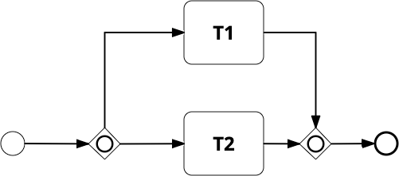

OR-block Processing Time = (P₁₂ * max(T1, T2)) + (P₁ * T1) + (P₂ * T2) P₁₂ = probability to execute both T1 and T2
P₁ = probability to execute only T1 P₂ = probability to execute only T2

