Introduction
This essay studies the hog industry, the Muyuan Foodstuff Co Ltd, and the new government policy of the hog market. The article mainly consists of company background, market structure, policy research, and economic analysis. Finally, using economic tools to analyze and summarize the impact of new policies on markets and companies.
Company background
Muyuan Foodstuff Co Ltd is a Chinese joint-stock company and listed on the Shenzhen Stock Exchange in January 2014. The company's current market value exceeds 150 billion yuan or about 21.5 billion US dollars. The company is mainly engaged in pig breeding and sales. The main products include piglets, boars, and commercial pigs (Bloomberg, 2019). The company is mainly facing the Chinese domestic market, and It is one of the largest pig breeding enterprises in China. It has a market share of more than 1%
Market background information
Market structure
The Chinese Hog industry can be considered a competitive market for three reasons.
First, in the Chinese pig market, the number of providers is vast. There are more than 100 large farms with more than 10,000 sows and incomputable small farms (McOrist, Khampee, & Guo, 2011). Consumers include individuals, government, and business originations. Hence, in the Chinese pork market, the single market share of demanders and suppliers is meager.
Second, although there are certain varieties of pigs, the products in the Hog industry are generally similar.
Finally, The new operators are not demanding to enter the industry because the breeding industry has a low barrier to entry. Furthermore, the Chinese government provides many benefits, such as tax exemptions, allowances, and disease prevention for Famer (McOrist et al.,2011). These benefits are significantly reducing the difficulty for new producer.
Therefore, the Chinese Hog industry is a competitive market. Because of this characteristic, the price of pigs is according to the relationship between supply and demand. Different farmers’ competitive advantage is based on the quality of products, public image, and price (Selva, 2005).
Elasticities
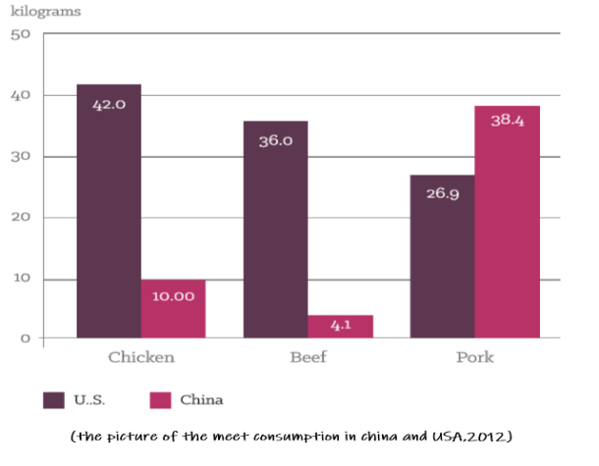
Unlike Westerners, the Chinese have a long history of eating pork. Although pork has other alternatives such as chicken, pork is still an inseparable part of the daily life for the Chinese. Therefore, the demand for pork is inelastic. One study shows that the price elasticity of demand for pork is 0.339 (Zhuang & Abbott, 2007). The supply of pork is elastic because the pork market is enormous and comfortable to enter. When prices rise, more suppliers will enter the market, and existing companies will also increase their production.
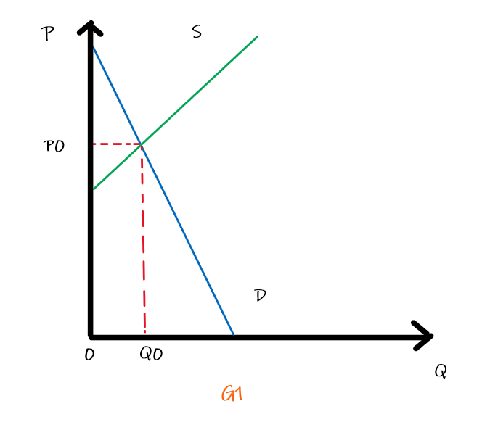
Domestic policy
The Chinese government released a total of 20,000 tons of reserve pork into the market in Sep/2019 (Xinhua, 2019). The reason is that pork prices have increased significantly due to the AFS (African swine fever) speeded. This policy aims to slow the growth of pork prices. Expect the main reason for ASF, facing the unclear relationship of Sino-US trade and the major national holiday approach, are the other reasons why the government needs a more direct way to intervene in the market and stabilize the public sentiment.

Economic analysis
Due to ASF, Chinese pig herd descends 40%, and prices increase 47% (Nathan Pitts &Tim Whitnall, 2019). The government wants to increase the quantity for the supply by released reserve meat into the market.
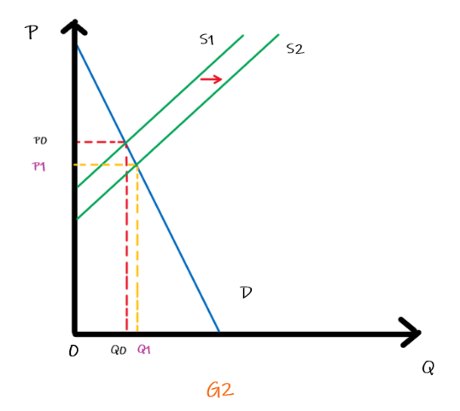
Show as G2, after release reserve pork, the supply increase, so the supply curve moves from S1 to S2. The quantity from Q0 to Q1, and the price reduced from P0 to P1. According to the real report, After the first releasing, the Pork price growth rate decline 0.8% ().
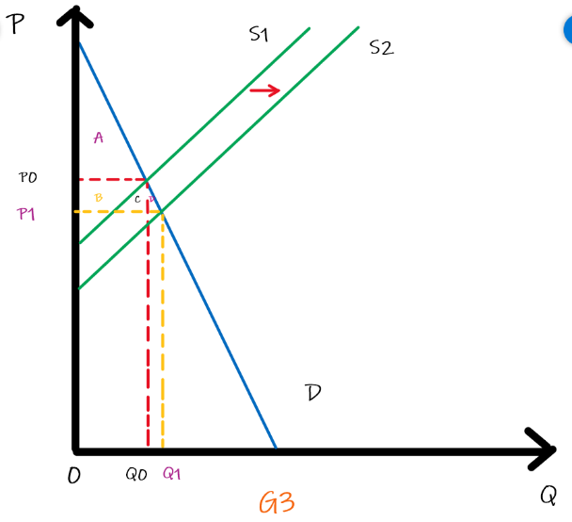
Show as G3, the consumer surplus change from A to A+B+C+D. It improves B+C+D，which means that consumer welfare increase.
Unintended Consequences
Some large companies, such as Muyuan Food Co Ltd, have increasing costs because of preventing ASF. However, due to the sharp increase in pork prices, the producer achieved a substantial increase in income. Many companies have just turned a profit. However, once the price increase trend is stopped or even dropped, and the cost of preventing the epidemic continues to increase. These companies will cause losses. This result will cause the market to lose more suppliers.
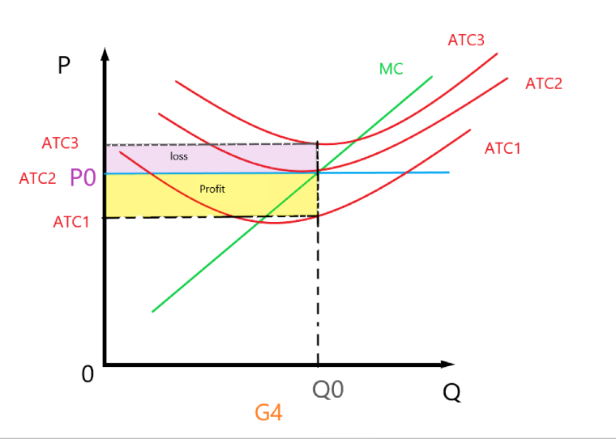

Show as G4. If the price stop increases and the cost for preventing the ASF keep increase, The ATC will move up from ATC1 to ATC3. At the ATC1, the company can get profit (yellow part). At the ATC2, The company will get 0 profit. When at the ATC3, the company will lose Profit (purple part).

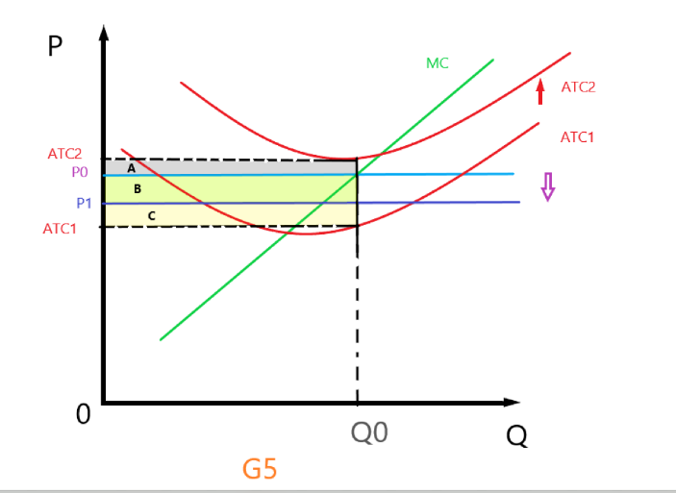
Show as the G5. If the price line down to the P1 because of the policy and the average total cost keep constant, The profit of this company will decline from color B + C to color C.
If the average total cost increase and price descend, the company will lose color A+B.
When P< ATC, the company will leave the market.
Other Reasonable Means
In essence, the reason for the current high price is the lack of supply because of ASF. The government can reduce the health expenditure of the company by subsidy policy to ensure that producers are not eliminated. In fact, the government has done this. However, due to the advent of particular holidays, the government needs to quickly suppress the growth rate of pork prices to keep the living standard for citizens. Another quick way is to increase imports, but because of political problems, this approach is full of uncertainty.
Government Intervention
Pork prices were too low in the first half of 2014. In order to curb the price drop, protect the interests of farmers, and maintain market stability, the government stored 65,000 tons and 88,000 tons pork in March and May. Similar to the economic model above, the price of pork is increased by reducing the number of products in the market. Although similar to the 2019 control policy, the number of controls is relatively small compared to the entire market, but it can enhance market confidence and is important for stabilizing prices.
Conclusion
According to the analysis of economic tools, this easy can concludes that the government's release strategy can restrain price growth and improve welfare to a certain extent, but it will also have specific adverse effects on enterprises. A simplified economic model can clearly show the impact of policies on the relationship between supply and demand. However, this article is limited because accurate economic models require more data to build. Although we believe that the hog industry is a competitive market, we only consider domestic producers and consumers while ignoring the impact of international trade.

Reference

McOrist, S., Khampee, K., & Guo, A. (2011). Modern pig farming in the People's Republic of China: growth and veterinary challenges. Revue Scientifique et Technique (International Office of Epizootics), 30(3), 961–968. https://doi.org/10.20506/rst.30.3.2091

Selva, G. (2005). Analysis of the Competitiveness of the Pork Industry in Denmark. IDEAS Working Paper Series from RePEc. Retrieved from http://search.proquest.com/docview/1697466175/

Zhuang, R., & Abbott, P. (2007). Price elasticities of key agricultural commodities in China. China Economic Review, 18(2), 155–169. https://doi.org/10.1016/j.chieco.2006.02.006

The picture of the meet consumption in china and USA,2012. Reproduced from Earth Policy Institute; http:/ /www.earthpolicy.org/datacenter/xls/update102_6.xls

Bloomberg.(2019). Muyuan Foodstuff Co Ltd. Retrieved from https://www.bloomberg.com/quote/002714:CH

Xinhua. (2019, September 26). China to release another 10,000 metric tons of pork from reserves before National Day Holiday [Press release]. Retrieved from http://english.www.gov.cn/statecouncil/ministries/201909/26/content_WS5d8cb01cc6d0bcf8c4c1421f.html

Nathan Pitts and Tim Whitnall. (2019). Impact of African swine feveron global markets. ABARES Agricultural commodities

