King’s College London
Faculty of Arts & Humanities
Coversheet for submission of coursework
(Undergraduate & Taught Postgraduate)

Complete all sections of this form and ensure it is the first page of the document you submit.

Failure to attach the coversheet as required may result in your work not being accepted for assessment.
Word count, which should be calculated electronically, must be stated accurately below.
For details of what is included in the word count, and penalties incurred by exceeding the word count limit, please consult the coursework submission policy in the Faculty handbook.

DECLARATION BY STUDENT
This assignment is entirely my own work. Quotations from secondary literature are indicated by the use of inverted commas around ALL such quotations AND by reference in the text or notes to the author concerned. ALL primary and secondary literature used in this piece of work is indicated in the bibliography placed at the end, and dependence upon ANY source used is indicated at the appropriate point in the text. I confirm that no sources have been used other than those stated.
I understand what is meant by plagiarism and have signed at enrolment the declaration concerning the avoidance of plagiarism.
I understand that plagiarism is a serious academic offence that may result in disciplinary action being taken.
I understand that I must submit work BEFORE the deadline, and that failure to do so will result in capped marks.

Candidate no. | Z | 2 | 1 | 8 | 2 | 6 | (This is a letter followed by five digits,  and can be found on Student Records)

Module Title: | Analysing the Cultural and Creative Industries
Module Code:  (e.g. 5AABC123 ) | 7AAICC56

Assignment:  (may be abbreviated) | Drawing on a cultural text or project of your choice (for example, an advert, music video, artwork, television programme, news article) provide a critical discussion of how representation may reinforce or subvert harmful depictions of a marginalised group. In your answer you should include a discussion on how representation works and critically engage with what 'harmful' might mean.
Assignment tutor/group: | Ricarda - Group 3
Deadline: | 05 November 2018
Date Submitted: | 04 November 2018
Word Count: | 1034

Your assignment may be used as an example of good practice for other students to refer to in future. If selected, your assignment will be presented anonymously and may include feedback comments or the specific grade awarded. Participation is optional and will not affect your grade.
Do you consent to your assignment being used in this way? Please tick the appropriate box below.
YES NO
x

Music video by JAY-Z performing Big Pimpin'. (C) 1999 Roc-A-Fella Records, LLC:
https://youtu.be/Cgoqrgc_0cM

With the establishment of hip hop during the late 1970s in America, rap remained prevalent and continues to dominate the mainstream music industry. However, hip hop culture has relied on the exploitation of women of colour, predominately black women, in order to produce and endorse successful black artists. This essay will demonstrate how society has, and continues to, normalize the fetishization of black women’s bodies in hip hop music videos, failing to comprehend how this portrayal of black women produces their hyper-sexualized reception in society. By analysing Jay Z’s ‘Big Pimpin’ music video, the essay will outline the multifaceted position of the video vixen, drawing upon the relationship between this representation of the black female body and the colonial constructions of black womanhood as a site for commodification. Unfortunately due to the word restriction of this essay, particular themes regarding this topic will be excluded or not expanded on, in order to remain concise.

The commercialisation of hip hop in the late 1990s, transformed and enhanced the concept of the music video. As budgets for music videos increased, rappers where encouraged to reveal themselves basking in ‘orgiastic levels of conspicuous consumption’ (Eshun, 2015). During this transition, the video vixen became a necessary addition to every rap video formula. These women embodied the ideal fantasy for every man who wished to be viewed as successful. The video vixen was typically a woman of colour who would accessorize the rapper and hold a significant sensual presence and allure in music video. Furthermore, the degrading sexual representations of Black women strengthened the existing negative stereotypes of black women as lascivious by nature, continuously ready for sex. (Balaji, 2010). In ‘Big Pimpin’ Jay Z is surrounded by numerous scantily dressed women in bikinis aboard a yacht in Trinidad. (see fig. 1 ) The camera directs attention to the most sexual parts of their bodies (see fig. 2), since sex is being sold as a part of the luxury benefits package that accompanies Jay Z’s extravagant lifestyle. The women in ‘Big Pimpin’ are viewed as objects of male satisfaction, on the receiving end of an active male gaze.

Furthermore, the women in ‘Big Pimpin’ have been dehumanized through the fragmented camera shots of their body (see fig 3.), which reduces them merely to body parts (Balaji, 2010). The focus on the women’s buttocks, breasts, and lips, highlight and reinforce their sexuality onto the audience. By dancing provocatively, gyrating and flaunting their assets towards the camera, the women perpetuate their sexiness through actions that reflect stereotypically lustful characteristics. Tricia Rose (2008) argues how the circulated image of the objectified black woman, is one that is constantly programmed into the mindset of our society, while simultaneously allowing black women to be mistreated and harassed. In a shot of Pimp C (see fig 4.) the woman is positioned alongside the rapper and a Mercedes Benz. Her outfit appears to complement the shade of the car and the camera angles used to accentuate the body of the vehicle mirror the perspective used to capture her own body. A parallel is made between the woman and the car, both to be considered as lavish objects of enjoyment, belonging to the male rapper.

Over recent years, academics have recongnised the relationship between, colonially constructed representations of black women and the hip hop video vixen. Previously, colonial depictions of black womanhood had been controlled by principles that refused to acknowledge Black women. (Emerson, 2002). Women such as Sara Baartman, a South African Khoikhoi woman, appeared as a spectacle, first displayed on stage in 1810, in London. Baartman was exhibited to spectators as ‘the Hottentot Venus’, received as a ‘marvel of nature’ (Scully and Crais, 2008,pp.301), as her protruding bottom and looming breasts were new discoveries to the Western world. Baartman’s colonial exploitation allows us to interpret how the experience of Black womanhood has been inherited by white societies. Black women continue to be defined by their sexuality navigating through a society that has already labeled them as unworthy of respect. Hip hop culture is responsible for perpetuating this colonial mindset of black women onto a mass audience to consume.

Although the damaging salacious representation of black women in hip hop has been discussed, it is important to expand on how the video vixen initially encouraged black women to reclaim ownership of their bodies and their sexuality. Former video vixens such as Melyssa Ford and Gloria Verez, acquired fame and success outside of the music video scene. These women utilized hip-hop as an opportunity to brand themselves and capitalize on their newfound fame. Moreover, Rottenberg (2016,p.332) indicates how identity construction encourages women to transform into ‘neoliberal human capital’, and the video vixen became a marketable product of self-agency. While some may view this as the objectification of black women, many believed hip hop provided a platform for these women to build careers. (Keyes, 2000,p.262). The women in ‘Big Pimpin’, in contrast to Baartman, are displaying their bodies out of freewill, they control their image and remain owners of their sexuality. These women embrace and glorify their curves whilst creating an alternative meaning for beautiful that had not been seen before in mainstream. Eurocentric models of beauty govern society and the vixens encouraged a generation of black women to feel beautiful and identify to a ‘positive self-identity’ (Emerson,2002, p.12.) in the way that they chose to.

In conclusion, ‘Big Pimpin’ is a suitable example of how hip hop reinforces the negative narrative of black women as carnal objects existing primarily to fulfill men’s sexual fantasies. Little has changed since the video’s release in 1999, as women continue to be highly sexualized in the industry in order to remain relevant. Music videos, like Tyga’s 2018, ‘Taste’ reinforce stereotypes of black women being promiscuous and rigid sex beings. Whereas, black female rappers like Nicki Minaj, continue to generate proactive material with sex remaining at the center of her image. As the music industry continues to shape society, one cannot ignore the upsurge in cosmetic surgery amongst all women. One must determine how the video vixen may have revolutionized the concept of beauty and influenced even women in white culture to desire the ‘black’ body that was once despised and ridiculed.

Bibliography

Balaji, M., 2010. Vixen Resistin: Redefining Black Womanhood in Hip-Hop Music Videos, Journal of Black Studies [online] Available at <www.jstor.org/stable/25704091> [Accessed 31 October 2018]

Emerson, R.A., 2002. Where My Girls At?: Negotiating Black Womanhood in Music Videos.” Gender and Society, vol. 16, no. 1, pp. 115–135.

Eshun,E., 2015. How hip hop style critiques, BBC Culture [online] Available at: http://www.bbc.com/culture/story/20150728-how-hip-hop-style-critiques-society [Accessed 4 November 2018]

Keyes, C.L., 2000, Empowering Self, Making Choices, Creating Spaces: Black Female Identity via Rap Music Performance. The Journal of American Folklore, [online] Available at < www.jstor.org/stable/542102> [Accessed 1 November 2018]

Rose, T, 2008, The Hip Hop Wars. New York: Basic Civitas Books

Rottenberg, C.,2017., Neoliberal Feminism and the Future of Human Capital. Signs: Journal of Women in Culture and Society 42(2): pp. 329-348.

Scully, P. and Crais, C. 2008, Race and Erasure: Sara Baartman and Hendrink Cesars in Cape Town and London, The Journal of British Studies, [online] Available at <www.jstor.org/stable/25704091> [Accessed 1 November 2018]

Illustrations


Fig 1.
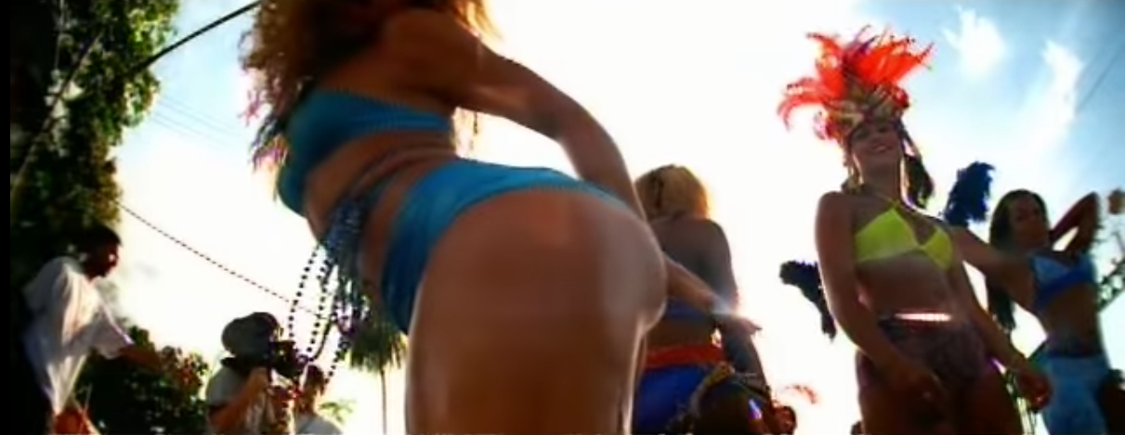
Fig 2.


Fig.3.


Fig.4.

