My part is woolworth’s response
Group Outline
1- Background ( Intro) (150)(1)
2- Facts ( explain the facts) (200)(1)
3- issues ( relevant law) ( how they breach) (580)(2)
4- Woolworth’s response (580)(3)
5- Judge decision ( reasons) (480)(4)

• To assist in your review, it may help you to refer to the Guide to Reading and Analysing Case Law which is available on Canvas (this is not a template to be used to structure your answer- it is simply a tool to help you understand what you are reading if you are new to reading case law). As a basic overview, you would need to make sure you explain the facts, what the issues were, what the relevant law is, how the law was breached or alleged to be breached, any previous case law considered, how the law was applied to the particular facts, the decision reached (and the reasons for the decision). All case discussion and analysis should reference relevant paragraph numbers in the judgment.
• Were there particular industry-specific concerns involved?
• Having regard to this case, what business advice would you give to other manufacturers/suppliers who market their products with environmental claims to ensure they are complying with the law? You should refer to other recent relevant case law examples.
• Do you think the current laws adequately deal with the issues raised in this case?

Assessment Criteria
1. Conforming with instructions (e.g. word length, font, other instructions) 2. Presentation, communication & style (written)
3. Clarity of expression (incl. accuracy, spelling, grammar, punctuation) 4. Referencing
5. Content and range
6. Use of literature/ Knowledge of theory
7. Context in which subject is used
8. Analysis
9. Critical reasoning / critical thinking
10. Interactive and group skills (include. Teamwork, Negotiation/micro-politics & empathy

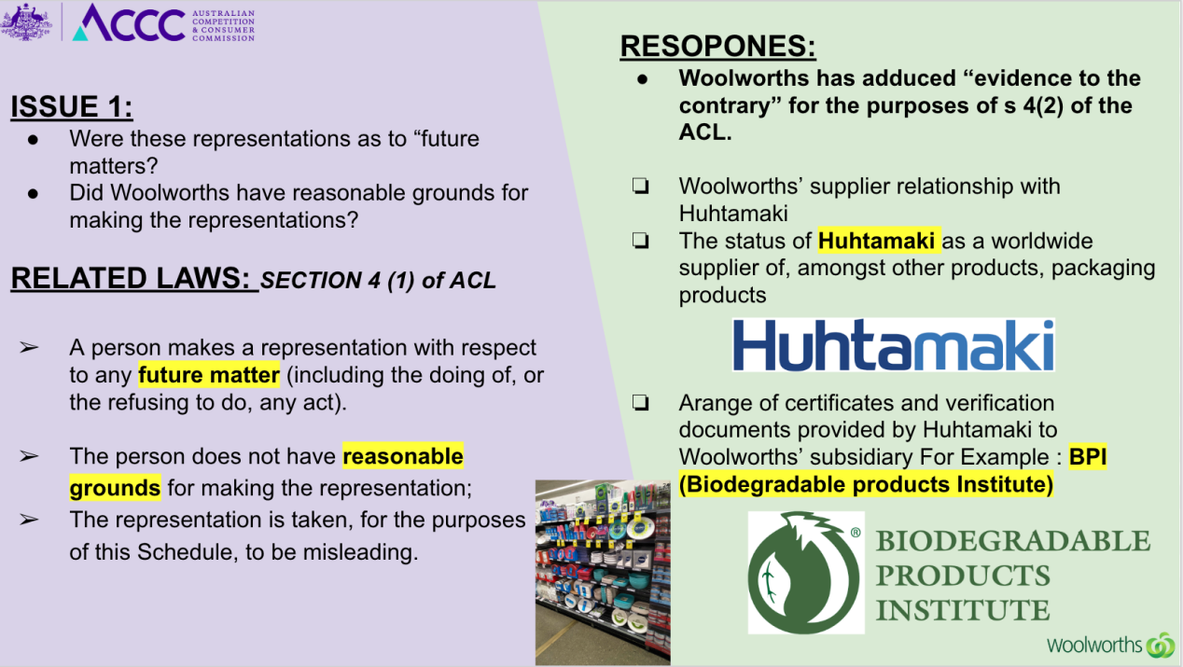
Pre 的内容
I am against hoc said that we haven’t evidences. According to S 4(2), we have some evidences can prove that we didn’t break this law.

Firstly, we have supplier relationship with huhtamaki, huhtamaki as a worldwide supplier of amongst packaging products and the company is a pioneer in exploring and using new sustainable materials. That can prove our supplier is regular

Secondly, huhtamaki given us some certificates like BPI which on the face of the document is connected to the US Composting Council and there were also four certificates from a Belgian corporation called Vincotte. They were entitled “Certificate for awarding and use of the ‘OK Compost Home’ conformity mark” that can prove our products can be compostable.
Thirdly, emails can show that we have a strong connection with huhtamaki and update certificate regularly.

Key point of the Case 209

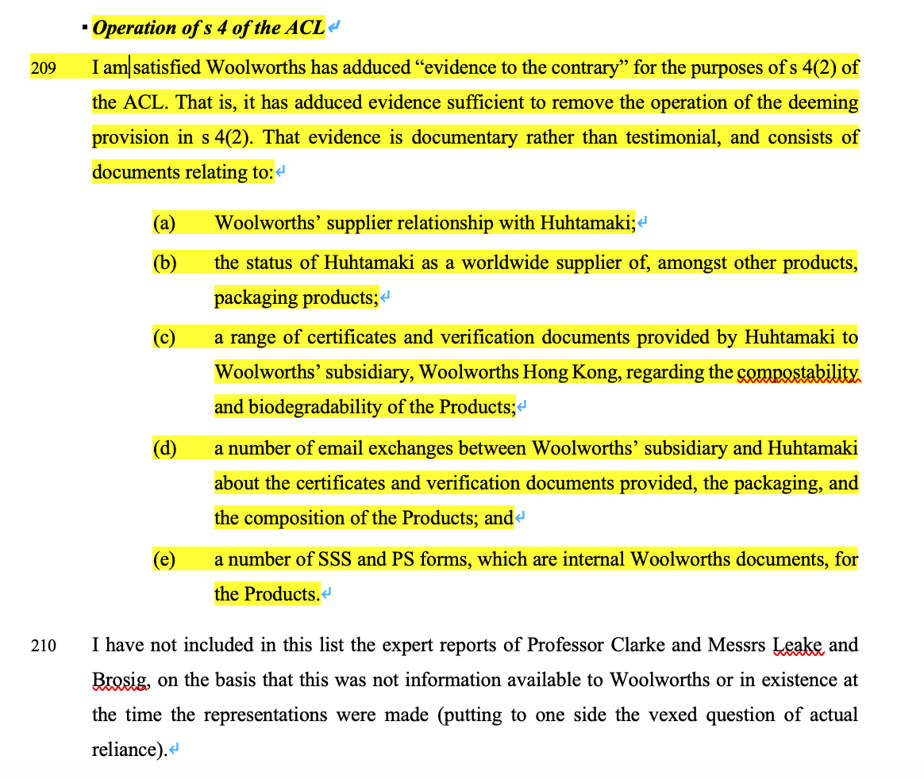
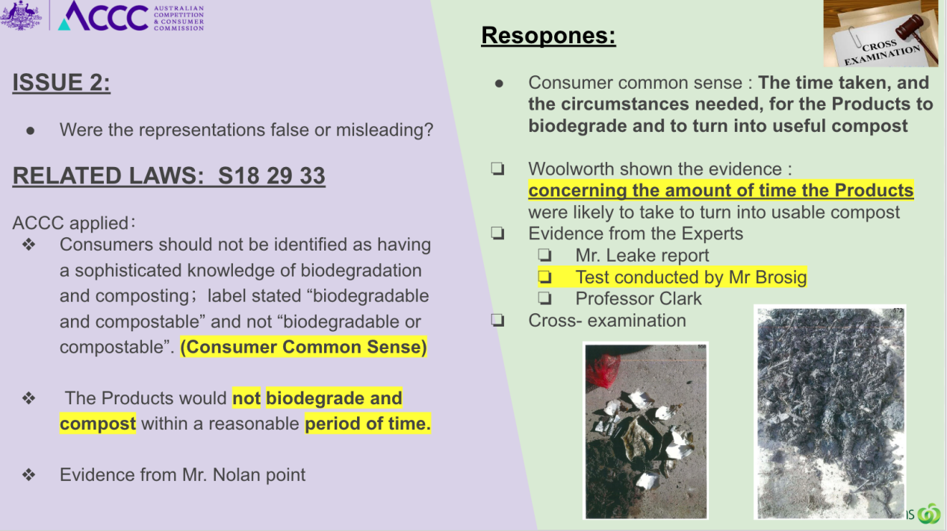
Case 的重点 151 152
