Part B requirement:
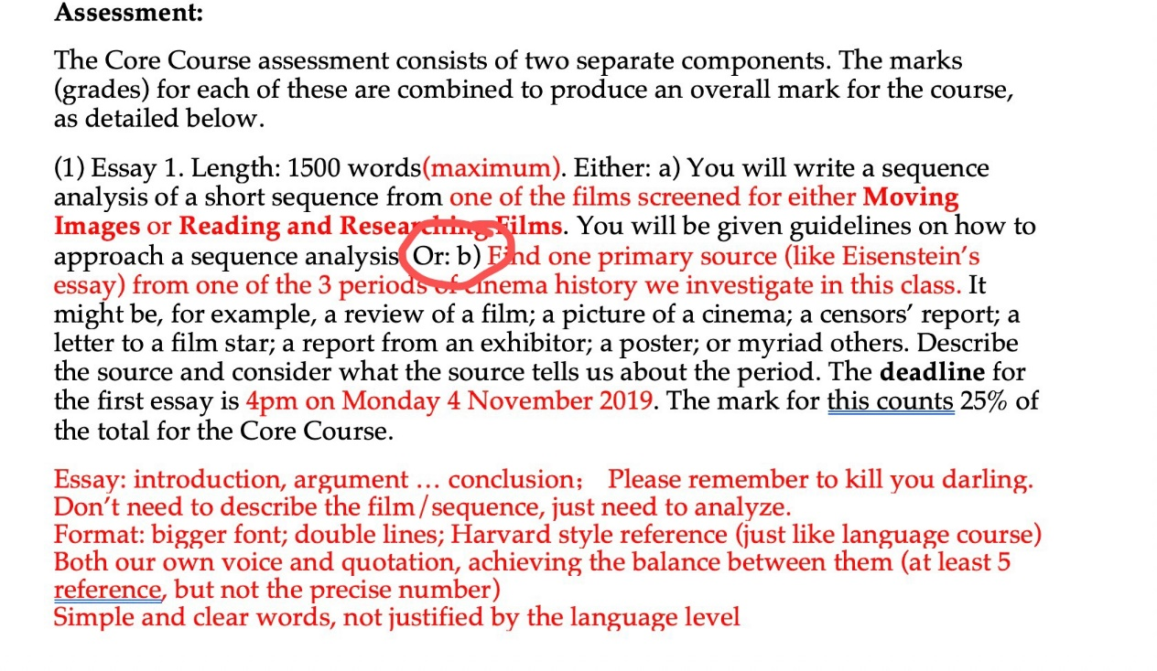
- Length: 1500 words
- Format: Bigger front, double lines, Harvard style reference (at least 10 references)
- Eg. A film review posted on NY TIMES could be a primary source.
- Three periods of profound transition in cinema and media history:
1. 1895-1927: The First Cinema(s)
2. 1954-1992: The Third Cinema
3. 1999-2020 The Last Cinema

- Primary source analysis
The aim of this exercise is to describe and analyze a primary source that helps us understand something about cinema history. Your task is to locate a source; describe it; and unpack what it can teach us. I am defining “primary source” here loosely as a document of some sort that comes from the time period under examination. For example: we looked in class at one of the bank reports written by bankers to enlist people to invest in Hollywood studios. This is a primary source. It could be used to explicate how investment banks work; or it can help us understand some of the operations of Hollywood studios in that period. I might, for example, explore how it helps us understand the distribution networks that the Hollywood studios were establishing in this period. Or, say, how the studios were using money to buy cinemas and to vertically integrate. To go about that I would describe concisely what the source is; where I found it; who it was written by, for what purpose, directed at what audience; and then I would pick out the things the report helps me see – not all of them, in this case, because it is a long report, so I would focus down my account: I am going to concentrate on what this report reveals about the process of vertical integration in the mid-1920s. You do not have to make a broad and sweeping argument: rather, this is one of the building blocks of analysis, like the sequence analysis is also.
You can choose any source you think helps you understand something about cinema history, particularly in the broad blocks we have been exploring: silent cinema; new wave cinema; contemporary cinema. Your source might be a review that reveals something about how people first perceived a new wave film or movement. Or, say, a report by a cinema exhibitor in the 1920s talking about what films his/her audience wanted to see. Etc, and etc. You might find it useful to look at some of the essays you have read for the course and reflect on how they use primary sources. What sources, for example, does Gunning or Musser use? What do they do with their sources? How do they begin to use these sources to help them understand some of the forces, dynamics, they are describing? To reiterate: your essay does not need to build an enormous argument from this. It is enough to patiently describe the source and begin to show us what it reveals
about issues that you find interesting. Be sure to balance description with analysis. Here is what is in my source. Here is what I think my source helps us understand.

- Course summary(might be helpful):
- What are the key transformative moments of cinema and media history? How did cinema begin? How and why did it change? What is the function of cinema? How did/does cinema emerge and transform across the world? What happens to film and cinema after the digital revolution? These and other questions about the history of cinema and media are central to this core module.
- The course is designed to work as a postgraduate-level foundation module both for students without any training in film studies and for those with a first degree in it or a related discipline. (Attached to the Core course is the related class: Reading and Researching Films.) Moving Images focuses on the four-way relationship between
- changing moving image technologies;
- the communicative and expressive forms associated with them;
- the reception of these technologies and forms by contemporaries, including practising film-makers, critics and theorists;
- the political, social and economic contexts in which these technologies and forms emerged and proliferated.
- In the first weeks of the class we will trace out the emergence of a dominant form of fictional, narrative, commercial cinema (often labeled ‘classical Hollywood cinema’) and in the following weeks address different political and aesthetic uses of cinema and the current transformations of the digital age. The course begins with cinema as it emerged in the second stage industrial revolution and traces out the global transformations that re-shaped cinema and media thereafter, and is designed to be a useful introduction to the diverse global cinema histories

