PROF1000 Workshop 10: Report writing, business correspondence and workplace documents

Reading
Course e-text pp. 412-490

Lecture review
You should have watched the online lecture for topic 9.

Objectives
- Apply the three-step writing process to business letters
- Discuss the writing strategy for good news letters
- Outline the order of information for a bad news letter
- Explain how to make persuasive letters effective
- Plan and organise material according to purpose, audience and context
- Write a long report using language suitable for the task and audience
- Format the front matter, body or main text and end matter correctly
- Edit and review the report for accuracy, consistency and clarity

Activities

Pair: Outline the parts of a formal report. Describe good practice for formal report writing.

Complete these activities on your own. Each letter should take no longer than 15 minutes to write.

- The more practice that you have in writing business documents, the better you will become. Use the principles you have just learnt to rewrite the following letters to make them more readable and effective.

Letter 1
Assume that you are the general manager of a new branch of the community bank VillageBank. You are overseeing the fitting out of the office space on the main street of the suburb of Eastleigh. You have ample supplies of VillageBank brochures but decide to do a mail-out of letters to every household in a five-kilometre radius of the bank. VillageBank head office has purchased the mailing list database for you from a commercial service and is interested in seeing whether a local mail campaign will have any impact on customer growth. The major banks have created much ill feeling in the past few years by increasing existing fees and creating new ones for personal and business customers. They have also alienated many of their older customers by forcing people to use automatic tellers and Internet banking. Write a letter to each household and business in your target area endeavouring to persuade them to set up at least one new account at the VillageBank branch or to consider taking out a loan for personal, housing or business purposes.
Letter 2

After receiving your shipment of returned books, we checked our records to see why we had sent them to you in the first place. Our records show that you did not want the selections. As you know, we will automatically send you the month’s new books unless you specifically ask not to receive them by our clearly stated deadline. This policy enables us to see that our subscribers have access to the newest books as soon as possible.

However, you are in luck. Because we value your membership in the Read-a-Lot Club, we are crediting your account for $29.50--the full price of the books that you returned.

In the future, please try to return your reply card promptly so that you won’t face the inconvenience of returning the books. In any case, we want to express our thanks for your long-term patronage of the Read-a-Lot Club. We think you will want next month’s selection, which is a murder mystery by John D. MacDonald.

Letter 3

We have included with this letter a list of videotapes, films, slides and other material that you may wish to order on the subjects of business mathematics and economics. Also included is a price list for these materials plus some other books you may wish to order.

Per your request, we are sorry to tell you that we cannot ship to you free examination copies of the books you requested as a result of reading a review in the Business Education Journal. The books, Business Mathematics Made Easy by Chester Sims and Economics Made Easy by Joanna Wesson, are well written in spite of being about a subject most people find difficult. The cost of printing and publishing these supplementary textbooks is getting higher every year, so I’m sure you can understand the reason for our not complying with your request for free examination copies.

We must request prompt payment for these books. The cost is $5.95 each plus $1.00 per book for postage and handling. These books would make good additions to your college’s bookstore, even if you don’t require them in your classes, because they are helpful supplements to the primary textbooks your students are probably using now. Your students could use the extra help, we’re sure. Let us know whether you decide to buy these books or not, the price is going up, so let us know soon.

Letter 4

Please accept our apologies for the delay in repairing your video game, which is being shipped under separate cover.

Let me explain what happened. Four Star Games, the manufacturer of your video game system, had expanded their production facilities to capitalise on the boom in video game sales that occurred in the early 1980s. When the market for such games declined, the firm was unable to meet the payment on their bank loans. The firm went bankrupt early this year, and we bought their assets. We also acquired their liabilities, which included all repairs under warranties.

Your broken game was just one of many that fell in our lap, so to speak. As you can imagine, it took us a while to sort out what was happening--hence the delay in repairing your video game.

In the future, we will be handling any further repairs covered by warranties through a new dealer network, created through the combination of Four Star’s best dealers and our own existing dealers. If you have any further problems with the game, please contact one of these dealers for repairs.

Thanks for your patience. Again, we apologise for the delay. Incidentally, I am enclosing a brochure showing some of our exciting new products.

Letter 5

We’d like to express our thanks for your letter of about six weeks ago. However, we regret to inform you that your claim for an adjustment on the Model XL dictation unit has been denied. Careful inspection by our engineering staff confirmed our original supposition that the unit has been damaged by improper treatment, either by user or by carrier.

Are you aware of the possibility that the Model XL dictation unit could have been dropped or abused by your employees? If this has not happened, you may file a claim against the carrier. It is more than likely that the unit was damaged in transit, because according to you, the unit has never worked properly and because we are clearly not at fault.

Our charges for repairing the unit will be $50 to cover labour costs; the parts will be replaced at no charge under the terms of our 90-day warranty. Please remit payment to us promptly.

We hope to see your representative at our sale, which will be held soon; pertinent facts appear in the promotional literature that is enclosed.

Letter 6

I regret to inform you that we must reject your application for admission into our law school program. This refusal is based on the fact that all applications must be received before 1 July. This policy is clearly stated in our catalogue. We even sent a letter to all law school candidates reminding them of this important deadline. We have made every effort to prevent late applications; therefore, we cannot make any exceptions. I trust you will understand the law school’s position. We deeply regret any inconvenience associated with our reply. Some law schools consider applications after our deadline. You should notify them of your interest.

Bovee, C L & Thill, J 1992,. Business Communication Today. 3rd ed. McGraw-Hill, New York.

Group activities
See page 470 of the course e-text for a model report.
Below is another sample report. First, is the letter of transmittal which is a covering letter addressed to the person/s who authorised the report.
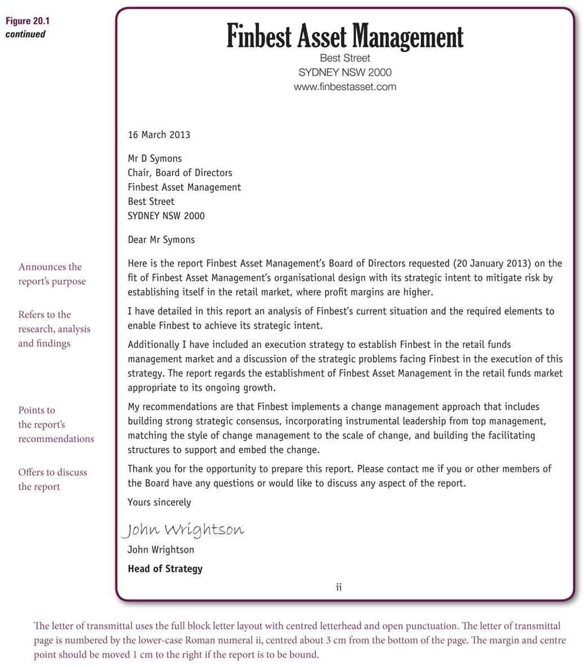
Next is the report title page. Note that it is centred and evenly spaced.
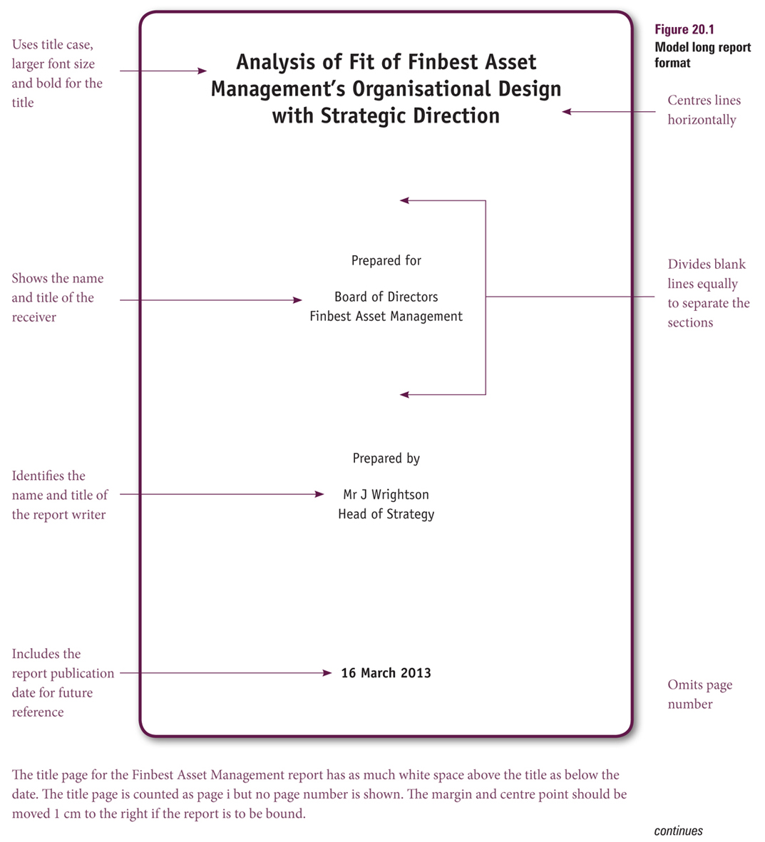

Use the automatic Table of Contents feature in Word. You will need to plan ahead and use appropriate heading styles.
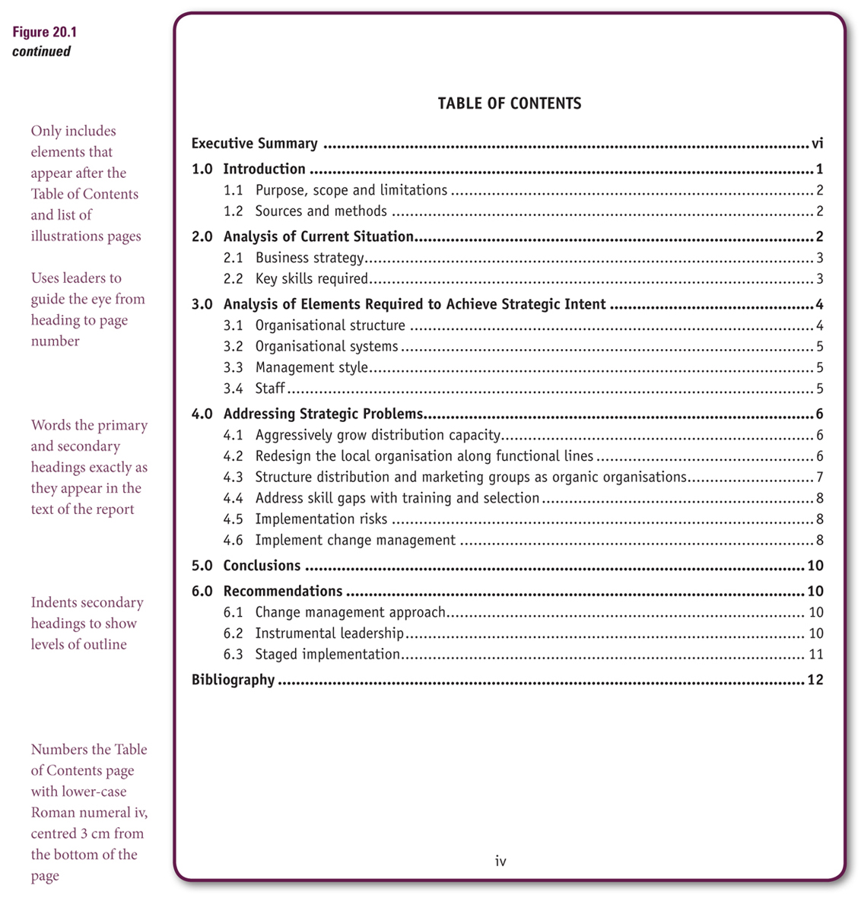

Your executive summary should summarise the entire content of the report, including the recommendations. Do not number the executive summary.
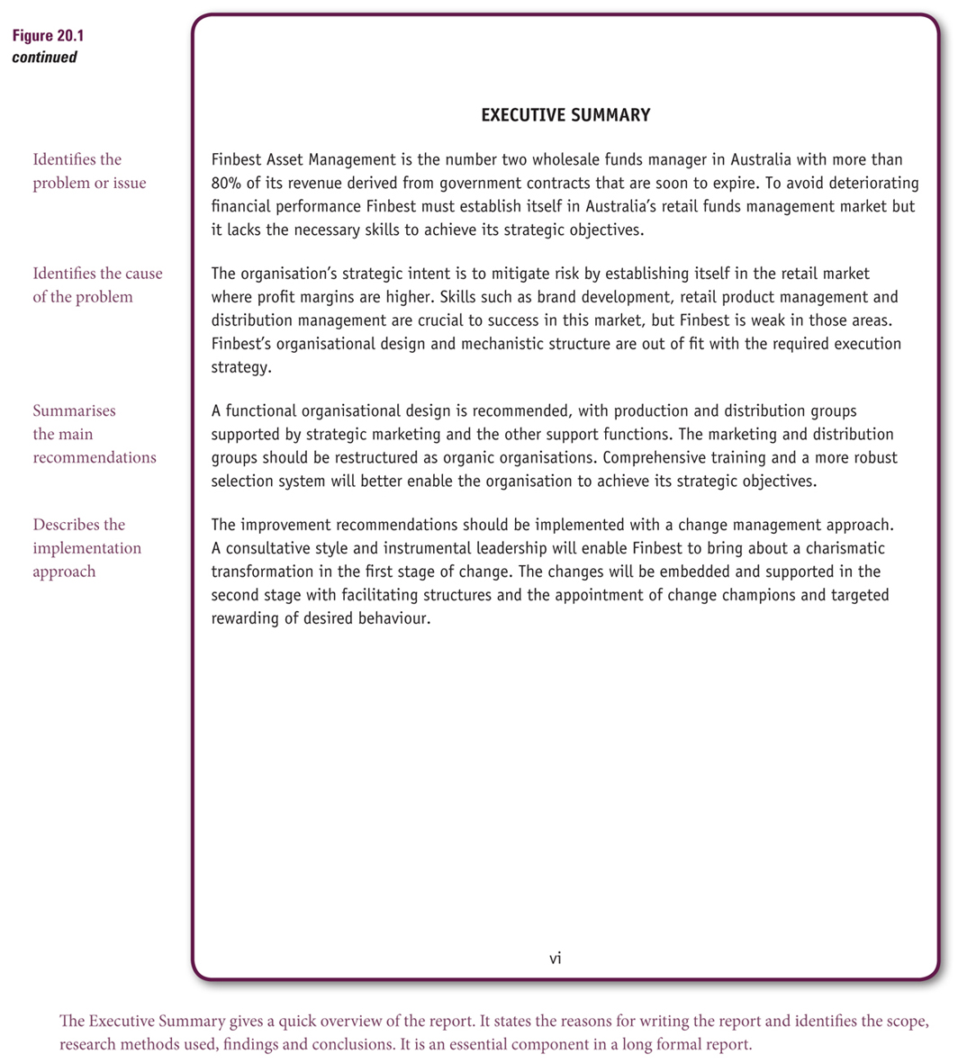

Over the next two pages, you can see the structure of the report introduction.
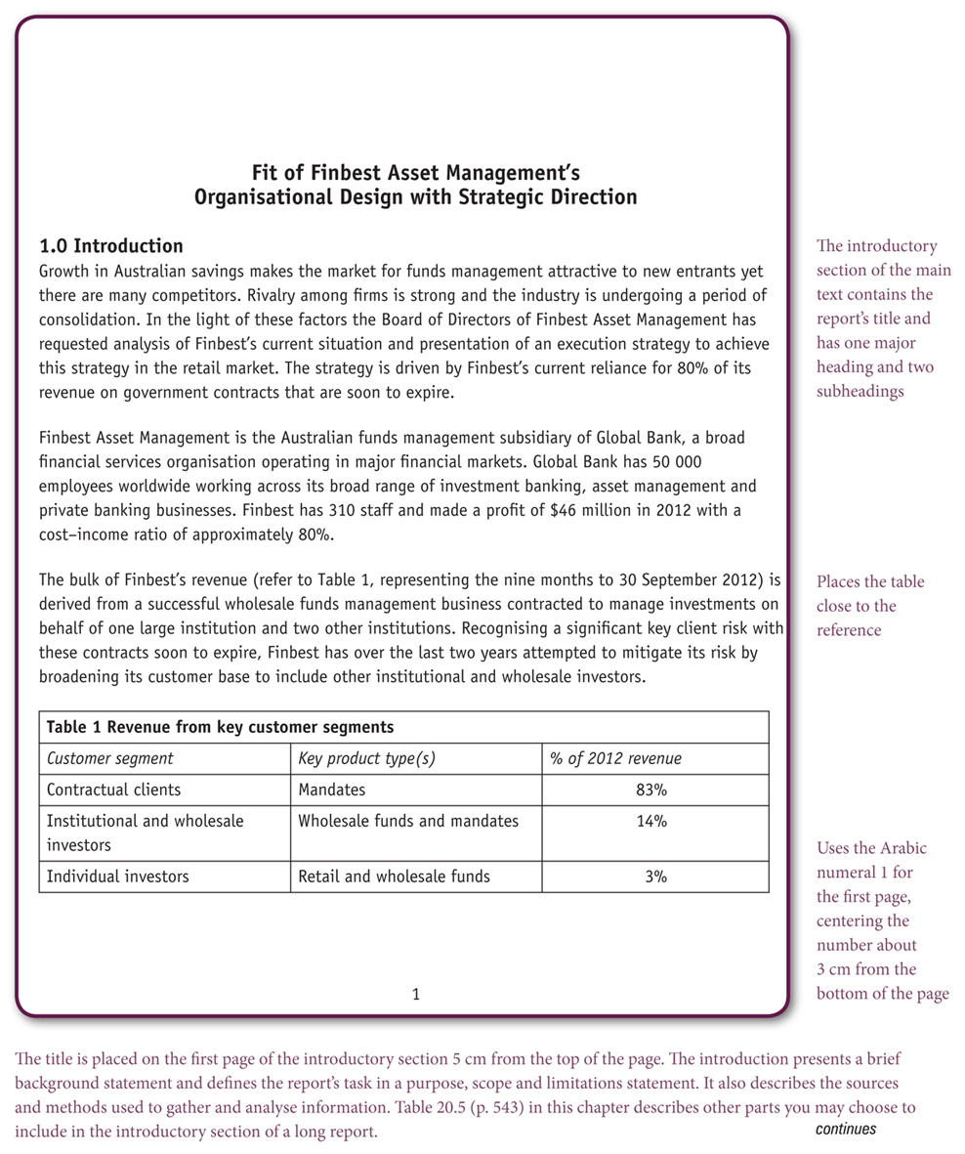
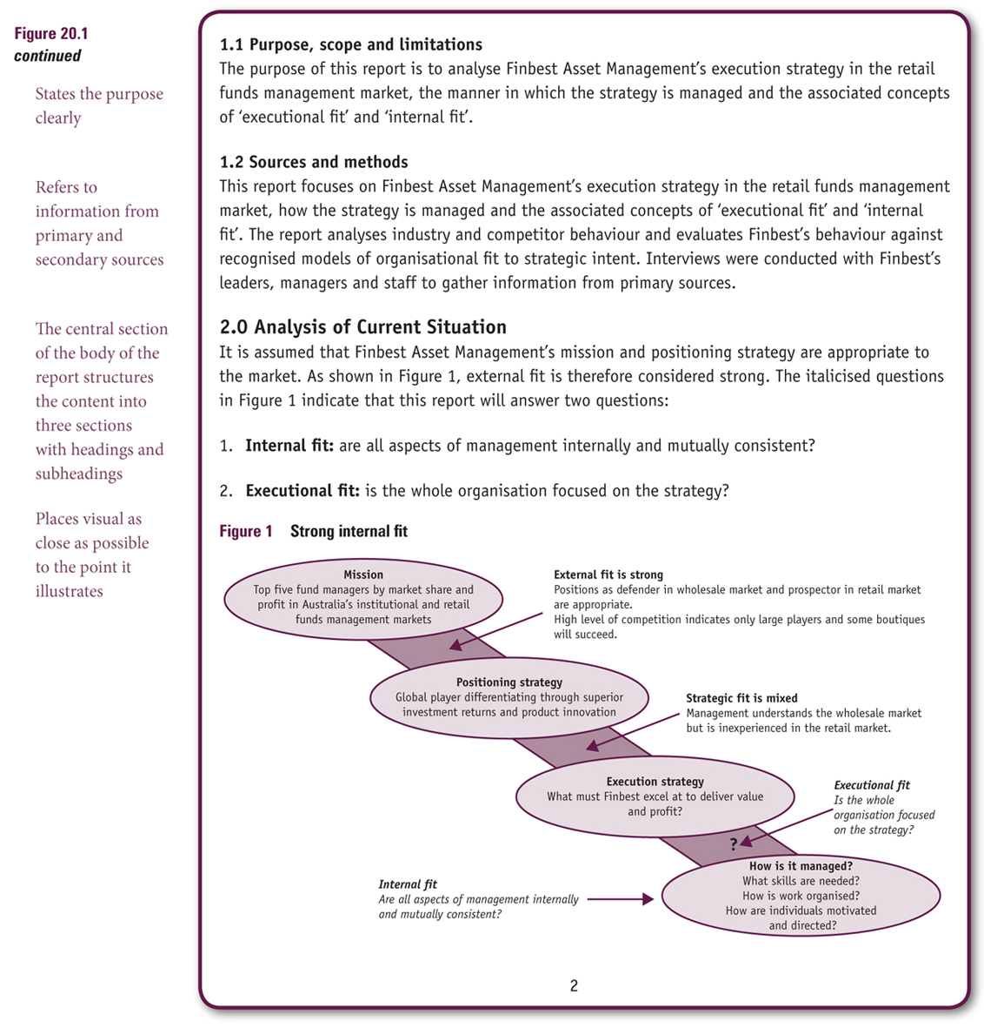

After the discussion, is the conclusion. There should be no new information in the conclusion and it should flow logically from the discussion and lead to the recommendations.
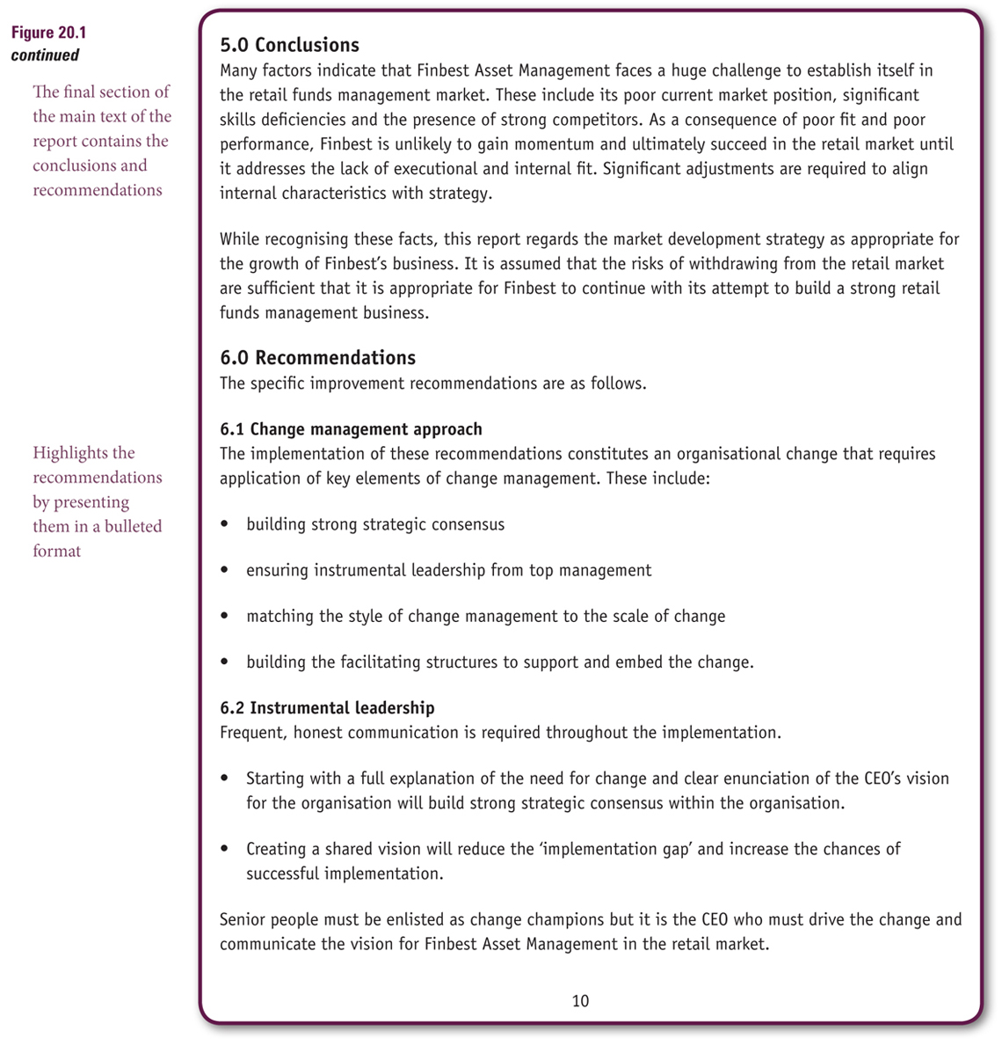

We would not use a Bibliography. Use a reference list. If you have appendices, place them after the reference list.
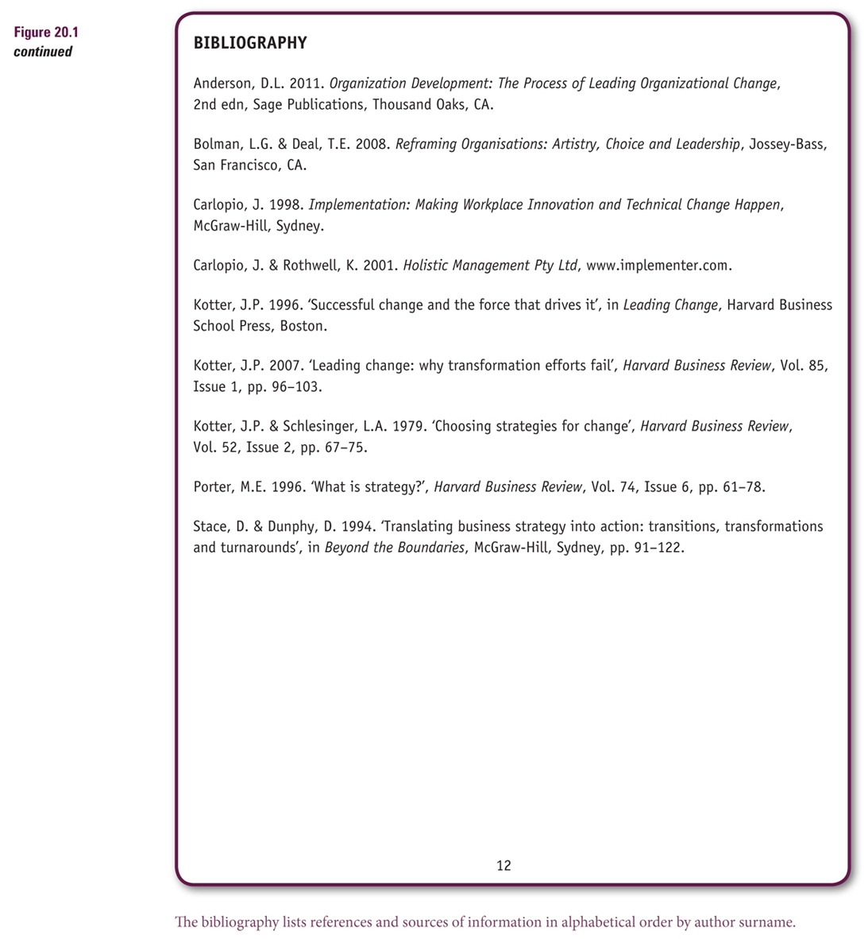
Now you have looked at the sample reports, complete the following activities.
First Things First
Assume you are the Training Manager with the Australian International Bank (AIB). The bank has offices in the capital city of each state and territory in Australia. The AIB plans to expand by establishing a branch network. Branches will then be located in the capital cities, and in every city and major town in every state and territory in Australia.
The Human Resource Manager has authorised you to investigate the effect of the expansion on staff training needs. You are to write a report titled ‘Expansion: The Impact on Staff Training’. This report is to determine the number of new staff needed to create the branch network, to investigate the training needs of staff, and to make recommendations in relation to new staff and existing staff.
You will submit the completed report to the Human Resource Manager and forward a copy to the General Manager of the Australian International Bank by 31 August.
a Write a title page to the long report.
b Create a table of contents that lists each of the basic parts of a long report and include the main headings that will appear in the body of this report. Start with the introduction and move through to the bibliography.
c Write the introduction to the report by:
i. preparing the purpose statement and making it the first sentence in the introduction. In the purpose statement, indicate your specific objective and what you hope to achieve
ii. stating the name of the organisation, the position of the person who authorised the report, the limits of the report and the date by which the report is to be submitted.
d Prepare the letter of transmittal and format it in block letter format.

