BAFI1042 - INVESTMENT

Semester 2, 2019

Portfolio Management Analytic Report (20%)

Instructions:

Written report based on dealing sessions weeks 9-11 where students are to report on how they construct portfolio, manage portfolio and analyse the performance of their portfolio in terms of returns and risks against a given benchmark.

This final report (20%) based on trading sessions (in weeks 9-11) will be submitted in week 12, 18th October 2019 by 5 pm. Please also note that there will be a penalty for late submission.

Write the analytic report as a business style report. You can refer to the suggested template below and address the feedback (if any) you receive during your dealing sessions to complete your final report.

The template is only for indicative/guidance, the group can design their own when presenting their findings and analysis.

The word limit is between 2,500 to 4000 words and 10% leeway is allowed.

Please note all assignments must be submitted online through the course Canvas (via the Turnitin link).

Assignments must be accompanied by RMIT assignment cover sheet, group work contribution statement (only if group dispute arises) and the originality report from Turnitin. Failure to include these documents in submission will result in a penalty for the report (5% deduction).

If you have any questions regarding the trading session, please contact your allocated dealing instructor.

Marking Rubrics:

Key Questions To Address In Stage 2 | Max Marks
- Discuss your investment goals and strategies while constructing your portfolio [Hints: active investment, value investor, growth investor or combination of two] | 1 mark
- Demonstrate your stock selection and weightings given to each stock when constructing Active Portfolio 1 in Dealing Session 2. | 2 mark
- Demonstrate your stock selection and weightings given to each stock when constructing Active Portfolio 2 in Dealing Session 2. | 4 marks
- For BOTH portfolios, explain which stocks contribute more towards the risk/return of your portfolio in terms of the contribution of the top 3 and bottom 3 securities to your portfolio return along with the largest top 3 positions (weights) to your portfolio return.  - Also provide the sectors and securities name that are underweight/overweight in your portfolio compared to the benchmark [Hint: allocation & selection effect]. You can use a table to distinguish between active and benchmark portfolio while explaining. | 5 marks
- Provide comments on total return& active return of your active portfolio and you are required to determine the total risk & active risk as well as the sources by looking at the tracking error of this portfolio. | 4 marks
- Finally, compare and contrast the 2 portfolios that you have created during sessions 2 & 3 and summarize your comments on outcome achieved. | 2 marks
- References and professional presentation | 2 marks
TOTAL | 20 marks

“Stage 2 Report Template”

(This is a guide only to assist you in designing your own
report using your analysis and findings)

PORTFOLIO MANAGEMENT ANALYTIC REPORT

Student Names & ID
Student Names & ID
Student Names & ID

Table of Contents

PROJECT OBJECTIVES AND STRATEGIES

Discuss your investment goals and strategies while constructing your portfolio (you have discussed this in stage 1 report in detail. Please have a brief discussion here again )[Hints: active investment, value investor, growth investor or combination of two, top down in stage 1]

Stock Trading Activity

Week 9 (Active portfolio 1)
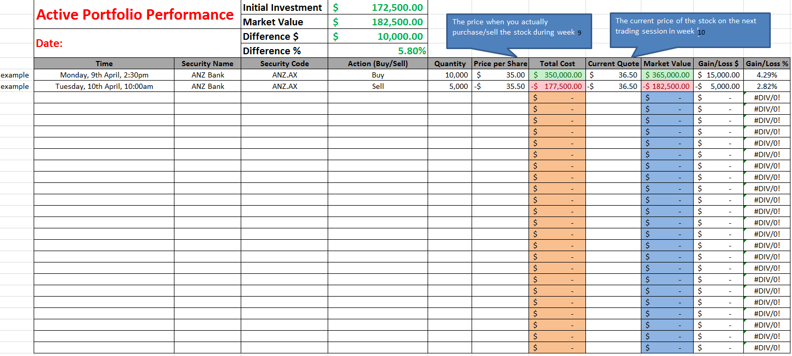

Briefly summarise your stock selection decision from stage 1. You can also present a table that lists your chosen stocks and the reason why you choose them

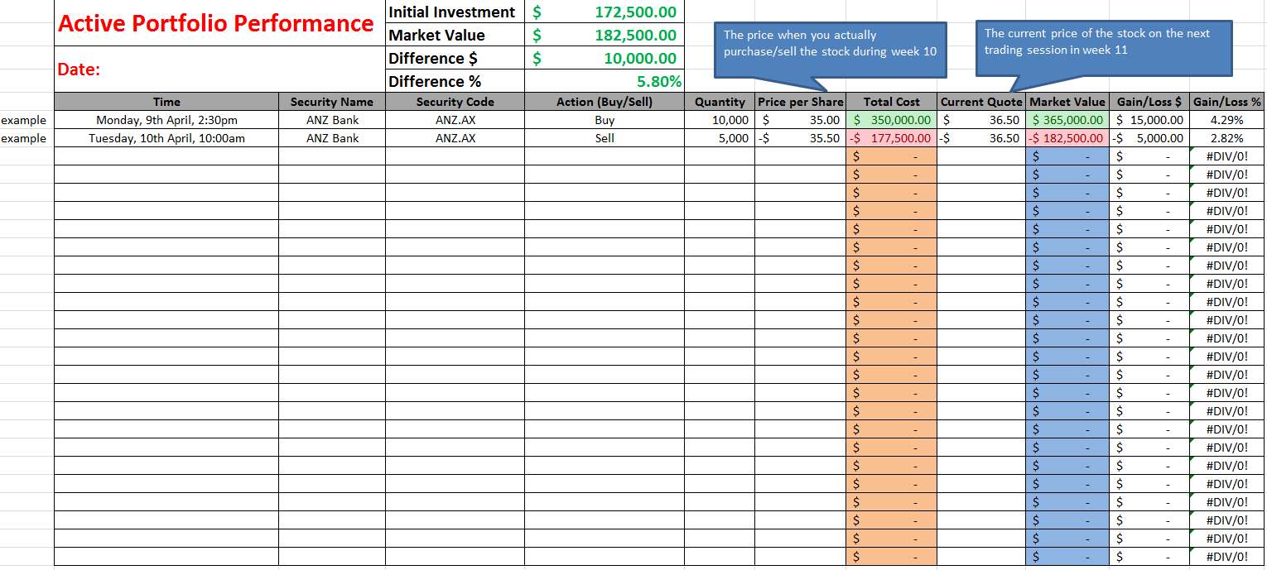
We have initiated the trading activities, …..

Week 10 (Active Portfolio 2)

For active portfolio 2, you will need to explain the adjustments made to your portfolio. For instance, you buy a new stock that is not in Active portfolio 1, you will need to show us the analysis done on this stock (fundamental, technical and/or company news)

PORTFOLIO EVALUATIONS

Total and Active Return
This can be found under ‘balanced summary --- contribution’
Tell us the return of each portfolio, and the active return of Portfolio 1 and 2 compared to the benchmark: do your portfolios outperform the benchmark?

Benchmark Portfolio

Active Portfolio 1 ( created in week 9)

Active Portfolio 2 ( created in week 10)

Contribution to Return

Benchmark Portfolio

Provide table/Figure: Benchmark Portfolio: Top 3 and Bottom 3 Contributors To Return
This can be done using ‘equity summary --- performance/contribution’

The top 3 performers of the benchmark Portfolio are xxxxx, the bottom 3 are

Active Portfolio 1 ( created in week 9)
The top 3 performers of the Portfolio 1 are xxxxx, the bottom 3 are

Active Portfolio 2 ( created in week 10)
The top 3 performers of the Portfolio 2 are xxxxx, the bottom 3 are

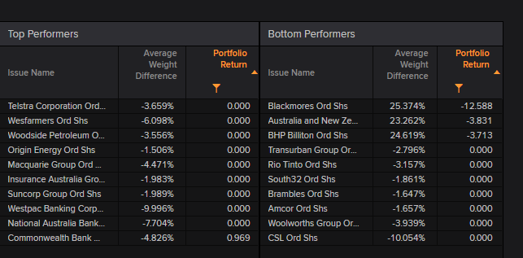

Contribution to weight
tell us the stocks that are most overweight and most underweight (top and bottom 3)
This can be done using ‘equity summary --- allocation
Do this for Active portfolio 1 and 2

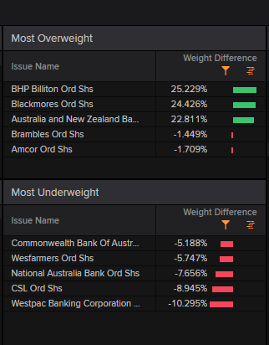

Portfolio’s Allocation and Selection Effect

Table: Sector Allocation and Selection Effects for Active Portfolio 1 and 2 (make your own table for comparison)

Example of one of the tables:
Portfolio | Allocation Effect | Selection Effect | Total Effect
ACTIVE1 | -0.074 | 2.616 | 2.542
Consumer Non-Cyclicals | -0.771 | 2.008 | 1.237
Basic Materials | 0.388 | 0.287 | 0.675
Financials | -0.008 | 0.320 | 0.313
Consumer Cyclicals | 0.100 | 0.000 | 0.100
Telecommunications Services | 0.066 | 0.000 | 0.066
Industrials | 0.050 | 0.000 | 0.050
Healthcare | 0.050 | 0.000 | 0.050
Energy | 0.030 | 0.000 | 0.030
Utilities | 0.021 | 0.000 | 0.021

- This section can be completed using ‘Brinson single currency’ in Eikon (refer to week 10 instructions) --- discuss the industry/sectors
This section explains why you underperform/outperform. You will need to have a good understanding of both the allocation effect and selection effect and let us know which one (or both) you are good at

- Tell us the top/bottom industry in terms of both allocation and selection effect
Via Binson single currency --- allocation and Binson single currency --- selection

- Note: stocks that you have over- or under-weighed could be the reason why you under-/outperformance the benchmark
Tell us the sectors that you over- or under-weighed

You do not need to conduct attribution anlaysis for the benchmark portfolio

Active Portfolio 1 ( created in week 9)

the allocation effect is…, indicating that….
The selection effect is …., suggesting that…..
In terms of allocation effect, the top and bottom 3 sectors are xxx, suggesting that
In terms of selection effect, the top holdings are xxx stocks, suggesting that

Active Portfolio 2 ( created in week 10)

the allocation effect is…, indicating that….
The selection effect is …., suggesting that…..
In terms of allocation effect, the top and bottom 3 sectors are xxx, suggesting that
In terms of selection effect, the top holdings are xxx stocks, suggesting that

Contribution of Risk for all 3 portfolios

Benchmark Portfolio

Figure/table: Contribution of Risk in Benchmark Portfolio (report the top 3 and bottom 3 risk contributors)

Refer to ‘Ex-ante multi factor risk --- portfolio summary’ provided by Eikon online (week 10 dealing session instructions)

Active Portfolio 1 ( created in week 9)

Active Portfolio 2 ( created in week 10)

ACTIVE RISK EVALUATION

Active Risk

Provide a Figure/Table Active Risk for the Active Portfolios and discuss the tracking error like allocation and selection effects.
This can be done via ‘Ex-ante multi factor risk --- active summary’--- look for the top and bottom active risk contributors

Only do it for the active portfolios:

Active Portfolio 1 ( created in week 9)

Active Portfolio 2 ( created in week 10)

SUMMARY AND COMPARISON OF THE PORTFOLIOS

Benchmark and Active Portfolio Summaries: This can be done via Return statistics

 | BENCHMARK PORTFOLIO | ACTIVE PORTFOLIO 1 | ACTIVE PORTFOLIO 2
Sharpe ratio
Treynor ratio
And other performance measures

The Sharpe ratio indicates that portfolio xxx performs the best…
The Treynor ratio indicates that portfolio xxx …….
Performance measure xxx indicate that ……
If rankings are different across ratios, explain why

Conclusion/Summary/Decision

Summarise this report. What is the overallperformance o f Active portfolio 1? How did you construct Active portfolio 2?
Looking at your objective(s) again, have you achieved your objective(s)?
If you have/haven’t achieved you objective(s), what are the major reasons?

