Group - 15
45219214 Indiketiya Hewage Manura Devinjith Mahanama
45230639 Onkar Khanolkar
45014035 Siyi Wei
45152674 Ying Wang
44114255 Yiyuan Hu
Tims 7328 Stratergies for Business sustainability and INnovation
Brisbane Airport Corporation Energy Supply Plan

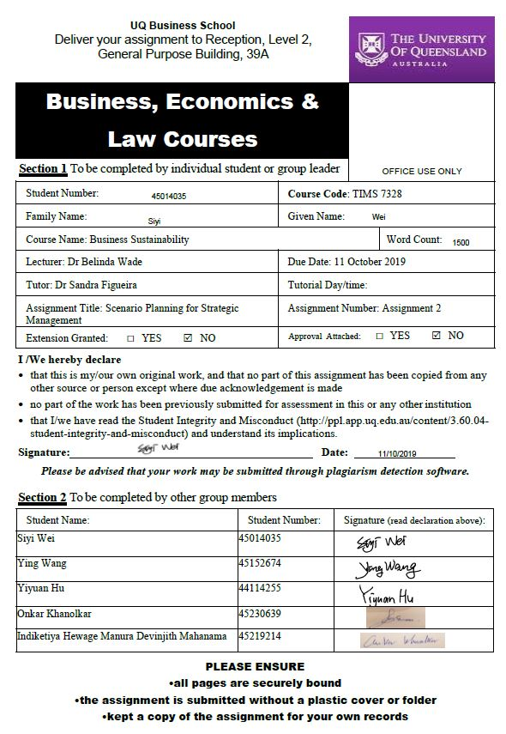
Table of Content

- Introduction 1
2. Leading events towards a high emission scenario 2
3. Scenario Implications for BAC 4
4. Adaptation and Resilience for high emission scenario 6
5. Conclusion 9
- Reference List 10
- Appendix 12

1. Introduction
Sustainable innovation and development have become a key survival strategy for organisations to combat climate change. Scenario development to analyse the current market and projecting it for the future is required to strategize for a particular future scenario.

Airports act as a hub for international transport for goods and people. The carbon emissions pertaining to airports mainly come from heat and electricity respectively (Scope 1 and scope 2 emissions) generated by the consumption of fossil fuels and other sources. Strategical analysis needs to be done over the dependence on toxic fuel sources for an organisation.

Climate change and energy supply play an important role in the future development of Brisbane Airport Corporation. BAC airport is a long-running civil airport, serving residents of Brisbane with international as well as domestic destinations. This report describes the future scenario Brisbane Airport Corporation (BAC) might face along with the strategies that BAC would need to adopt to insure their potential survival in the market.

2. Leading events towards a high emission scenario
We have built the future of BAC in a high-emission scenario. The following events have caused BAC’s emissions to increase. We call this scenario as “Deamon”.

Event one, most of Australia's electricity comes from coal-fired power generation, so BAC also indirectly increases its carbon emissions when they buy from the electric grid (Scope 2 emissions). Fossil industry is global powerhouse that can affect and alter economies; governments depend upon such industries for positive economic growth (Oil Change International, 2019). Hence to adopt renewable sources for the electric grid governmental approval is required.

Event two, changing the resource of energy supply to a renewable source requires investor motivation and fund procurement. According to the BAC report, the solar panels installed in 2018, account for 6% of the airport's total electricity use. However, the cost of solar panels is very high, and their viable life cycle is of 25 years (Vikram, 2016). Hence, fossil fuel sources being convenient and cheaper to invest in, will remain the major supplier for the energy demand.

Event three, over increasing population will cause stress on the energy supply. Increase in passenger travel is around 2.47 % annually at Brisbane airport (Brisbane Airport Corporation, 2018). Increasing population will increase the demand for more energy; lack of energy supply would increase the dependence on non-renewable sources of energy. Fast induction of new energy sources won’t be possible. Most renewable sources such as solar, wind and nuclear energies need a large area and human approval. Human approval is unpredictable and majorly depends upon financial profits. Hence, as renewables sources for now aren’t cheap they won’t be invested in.

Event four, global climates by 2050 will become unpredictable, which will become difficult to depend upon sources that utilise climatic conditions for energy supply. Also, extreme weather will cause BAC to produce more unnecessary emissions. For example, extreme storms delay flights, resulting passengers and staff stranded, resulting in a lack of local water and electricity supply. The rise of sea levels might lead to a loss of airport capacity. Due to lack of ground capacity, loss of airport infrastructure and ground transportation channels, more land will need to be invested which would result in a higher energy demand (Brisbane Airport Corporation, 2018).

3. Scenario Implication for BAC
In the high-emission scenario, the implication on BAC in general is high. Firstly, BAC will need to purchase more carbon offsets. This has happened in 2015 and 2016 (Brisbane Airport Corporation, 2018). Secondly, BAC's reputation will be affected and there will be an increasing demand from environmental organisations. Air travel accounts for 40 percent of the global tourism's total carbon emissions; it is a main contributor to the sector due to influx of growing tourists (Scott et al., 2008). BAC's high emissions will bring the corporation under the focus of many entities and, hence damaging its reputation.
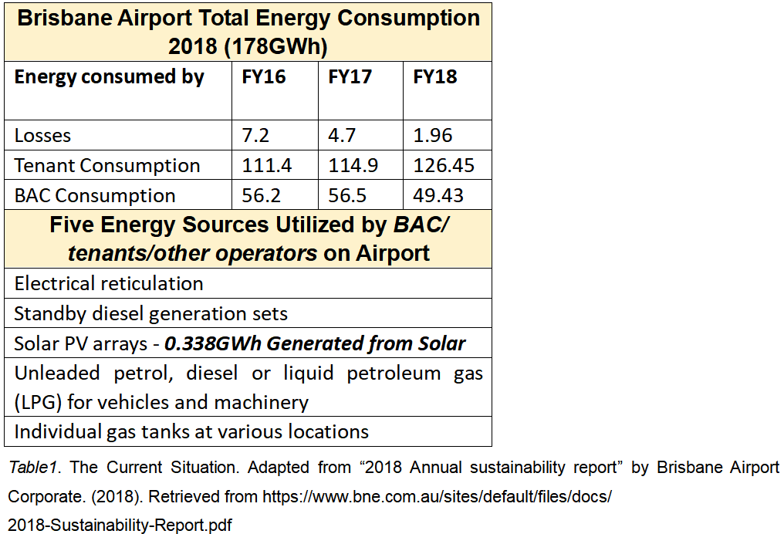

In terms of energy supply, firstly, BAC will be under pressure from the government and environmentalists. According to the table, airport tenants receive majority of energy supply. However, BAC’s current energy-saving measures focus on the two terminals, and not on the tenants (Brisbane Airport Corporation, 2018). Hence, focus need to be adopted towards the tenants and passengers. Australia needs to increase the penetration rate of renewable energy from the current 2% to 50% to meet the 2030 emission reduction targets (Sarkodie & Strezov's, 2018), this could affect BAC’s current functioning.

Secondly, due to high dependence on non-renewable energy, BAC may face the risk of insufficient energy supply. Australia's excessive fossil fuel exports, such as coal, may lead to instability in the regional energy supply (Pannett, 2017). BAC with a solar energy supply accounting for only 0.189% of its energy dependence could be the most affected (Brisbane Airport Corporation, 2018). Besides, the infrastructural risks of climate change can also cause problems in energy supply; the increased temperatures and extreme weather will damage the infrastructures and influence the energy suppliers (Brisbane Airport Corporation, 2018).

4. Adaptation and Resilience plan for the high emission scenario
To overcome the high emission scenario a sustainable model needs to be adopted which paves a way to reduction of emission at BAC. Energy generation from renewable sources is the best direction that can be adopted for a lower emission scheme, due to being environment friendly. ("Renewable Energy Technologies", 2019). Following are possible strategies to reduce pollution.

Firstly, BAC could adopt to use more solar energy, by integrating their electric grid, i.e., either buy electricity from solar companies or produce it. Electricity consumption at BAC in 2018 was around 178 GWhr, which is a number that will increase by 2050. For example, Kerala airport of India (Nations, 2019) became the world’s first airport to operate only using solar power. The airport generates an energy capacity of 40 megawatts. In 2018, solar electricity use at BAC amounted to 338,000 KWhr from the 6MW plant commissioned at BAC; similarly as the demand for electricity increases more solar output could reduce the consumption from the electric grid (Brisbane Airport Corporation, 2018). According to (Menon, 2019), Kerala airport uses more than 46,000 solar panels to generate this capacity. Associated challenges are loss of energy, weather conditions such as extreme rains and storms, adequate space for solar panels and a decreasing efficiency to meet the energy demand.

Secondly, adopting piezoelectric power which captures and converts energy from footsteps into electrical energy (Report, 2019). Piezoelectric materials can convert mechanical stress applied on them, from walking, to electric energy. Cost of introduction for an area of 1.5 square feet is around 190 AUD. However, this energy mode is a one-time investment barring the maintenance cost over a period. Output per step is around 3.8 Joules (Chew, et al., 2017). With the amount of passenger increase this energy supply mode could be a potential green solution to meet the energy demand. Abu Dhabi airport is currently using this method to generate energy in two of their terminals. This method could be developed to power the entire airport along with the use of renewable energy. Associated challenges for induction of this energy supply include the lack of a larger output system to harness more energy, a comparatively new technology hence extensive research is required to harness it and the cost of installation is high.

Thirdly we can tap into the geothermal energy of the earth referring to ‘the energy graphene project ‘("Stage 2 Innovations", 2019), where the heat present in the core of the earth is accessed and converted to electricity. This method enables the transfer of heat by using graphene as the heat transfer material, which is a highly efficient energy convertor. This method once installed will be a zero-emission source with an untapped resource for energy supply. This method is currently being tested and if efficiently installed could prove to be an efficient source to meet energy demand at BAC. Challenges include the high cost of investment, lack of research and investor motivation, high maintenance cost and loss of ground integrity.

Finally, changing the supplier of grid electricity for BAC. Wind energy is an efficient and clean source of energy, however installing wind turbines within the BAC could disrupt the daily functioning of airlines. Wind turbines can act as a potential accidental hazard for air travel; it could also cause a difficulty in flying during the night. Hence, if the energy supplier could provide a cleaner energy via wind or other sources it could reduce the scope 2 emissions for BAC. Other alternates could include the installation of vertical axis wind turbine (VAWT) alongside the runway at BAC. VAWT utilizes the wind power generated from locomotives and airlines and converts it to electric energy.

5. Conclusion
This study analyses the Brisbane airport corporation’s energy supply plan at a high emission future. We are expecting a high emission scenario in the future and constructs possible causes which could be leading towards this. Hence, dependency of coal and fossil fuel, costs and issues related to renewable energy and population growth and some other factors are presented. Then the study progresses in to analyzing possible methods to overcome this scenario and presents interesting energy technologies rising in the future. Study supports its factors using examples and concludes by demonstrating how to change the grid energy towards wind energy and what are the associated risks and benefits.

6. Reference List
Borunda, A. (2019). This is what cities need to do by 2050 to meet climate goals. Retrieved from https://www.nationalgeographic.com/environment/2019
/09/zero-carbon-cities-future/

Brisbane Airport Corporation. (2018). 2018 Annual sustainability report. Retrieved from https://www.bne.com.au/sites/default/files/docs/2018-Sustainability-Report.pdf

Chew, B. C., Loo, H. S., Bohari, I. A., Hamid, S. R., Sukri, F. H., & Kusumarwadani, R. (2017, March). Feasibility of piezoelectric tiles adoption: A case study at Kuala Lumpur International Airport (KLIA) Malaysia. In AIP Conference Proceedings. Vol. 1818, No. 1. AIP Publishing.

Menon, S. (2019). How is the world's first solar powered airport faring? Retrieved from https://www.bbc.com/news/world-asia-india-34421419

Nations, U. (2019). Cochin International Airport – the world’s first solar-powered airport. Retrieved from https://www.reuters.com/sponsored/article/Cochin-International
-Airport-the-worlds-first-solar-powered-airport

Oil Change International. (2019). Measuring Influence. Retrieved from http://priceofoil.org/fossil-fuel-industry-influence-in-the-u-s/
Pannett, R. (2017). How energy-rich Australia exported its way into an energy crisis. The Wall Street Journal Eastern Edition.

Report, S. (2019). Walk inside Abu Dhabi airport, generate electricity. Retrieved from https://www.khaleejtimes.com/nation/abu-dhabi/walk-inside-abu-dhabi-airport-generate-electricity

Renewable Energy Technologies. (2019). Retrieved from https://www.ucsusa.org/clean-energy/renewable-energy

Sarkodie, S. A., & Strezov, V. (2018). Assessment of contribution of Australia's energy production to CO2 emissions and environmental degradation using statistical dynamic approach. Science of the Total Environment, 639, 888–899. Retrieved from https://doi.org/10.1016/j.scitotenv.2018.05.204

Scott, D., Amelung, B., Becken, S., Ceron, J. P., Dubois, G., Gössling, S., ... & Simpson, M. (2008). Climate change and tourism: Responding to global challenges. World Tourism Organization, Madrid, 230, 1-38.

Stage 2 Innovations. (2019). Retrieved from http://www.stage2innovations.com/
Vikram, A. (2016). Are Solar Panels a Sustainable Product? Retrieved from https://www.motherearthnews.com/renewable-energy/are-solar-panels-a-sustainable-product-zbcz1609
Appendix- Business Model Canvas
Sr. no | Stakeholders | Activities | Resources and Capabilities
1 | BAC | Buying energy from sustainable electric suppliers | Airline connections
2 | Investors and airlines | Investing in sustainable technology | Energy supplier
3 | Governments | Investing in research to develop sustainable technology | Sustainable supplier reputation
4 | Energy suppliers | Lobbying governments to adopt eco-friendly reforms | Employee outreach for sustainability
5 | Technology supplier | Raising customer awareness via green initiatives | Adopting sustainable resources such as piezo plates, solar panels
6 | Human entities | Developing a social community department | Altering infrastructure like using glass ceilings
7 | Non-Governmental organisations | Influencing airline policy
8 | Sustainable department | Reducing energy consumption
Value Creation

Value Capture

The cost structure associated with the model is complex. The costs related to these new projects are high and without partnerships and government investments this is hard to afford by BAC. Energy suppliers, technology suppliers, investors and other airline companies plays a huge role in this project as stake holders.

Value position

This project profits not only the consumers of BAC, but also helps the environment, community and other related parties as well. This can hugely impact the upcoming energy crisis and to help achieve something better than the current electric and energy systems.

Sr. No | Profit | People | Planet
1. | Reducing carbon emissions for the organisation | Customers act as a source of energy supply | Biodiversity gain from cleaner energy use
2. | Gaining reputation as a green airport | Positive impact on the community at BAC and surrounding areas | Reduction in use of land use change
3 | Reducing the cost of Carbon offsets | Corporate sustainable standards will be met | Mitigating climate change
4 | Reducing the cost of energy supply as most of the energy will be derived within the company boundary | Company can be marketed as a customer friendly organisation | Reduction in global warming
5 | Positive biodiversity impacts | Raising awareness for better policies will increase social impact on the reduction of emissions | Greener initiatives may facilitate increase in forest or tree cover

Value delivery

The main relationship between the customer and the company is that BAC provides and accommodates consumers travel needs. The company fulfils travel, cargo and transportation needs. There are many customer groups in this process as tourists, businessman, patients, athletes and more. The main use of this project will benefit the entire society not just the airport users. We believe this power projects could also help the communities power needs as well.

