ACCT1101 Accounting for Decision Making

Virtual Business Enterprise (VBE) Business Plan Detail

Semester 2 2019

The Virtual Business Enterprise (VBE) learning resource developed for ACCT1101 is a 3D virtual world created around a small economy consisting of 20 student-run ‘businesses’ and supported by a central ‘bank’. This semester there are 10 virtual worlds. Students in groups of 4 manage their business in the VBE over the equivalent of one financial year (Practical sessions 2 and 3) while trading with other businesses in the virtual economy. Make initial contact with your group members at your induction session and then through your group member email addresses available on the job board. Alternatively, you can use the Boardroom in the Enterprise App.
An avatar that represents your business during the trading session carries out VBE business activity. Only one group member can log in and control the avatar during the trading session, while other members of the group use the VBE Control Panel for pricing, moving store stock, advertising etc., and the VBE App to communicate to other businesses in the live session, as well as assisting the group with decisions made as the session unfolds. Note that the VBE viewer (software) is available in nominated computer labs, on all UQ library computers across campuses (through the ZEN folder) plus your group avatar could also be accessed during the VBE trading session remotely provided the VBE viewer has been installed on a personal computer.
Success in the VBE requires effective teamwork. Your VBE group should confer regularly to plan the two trading sessions and reflect on outcomes from the past session. Important decisions include deciding who will control the avatar in each session and what roles the other group members will play during the session. To assist your group management, some key milestones for the ACCT1101 assignment are in the VBE resources.
The Practical Session 01 in week 03 commencing Monday 05 August 2019 is the mandatory VBE induction session. Students register for their practical session times through SI-net (shown as practical sessions) SI-net opens 6am 29 July and closes midnight Saturday 3 August 2019. It is at the first practical session that groups are formed, student groups are allocated to a business and the group’s VBE business login/passwords are issued.
The Induction session is followed by two in-world trading sessions, each of 50 minutes’ duration in weeks 04 and 05, scheduled for each student-run business at their practical session time as per SI-net. Refer to the ACCT1101 Roadmap for the trading session dates and your timetable for your session time.
For these two trading sessions, students must access the VBE from either the Chamberlain open lab (35-204), a UQ library (Zen Folder) or use their own laptop after downloading the VBE software.
Your business activity in the VBE world will generate a range of financial data. After the trading session, the VBE will translate this game play data into scaled, relevant financial statements for your group’s virtual business. You can access this information from your personal VBE Dashboard and after each in-world session. These financial statements will form part of the financial plan section of your business plan so make sure that you are familiar with these financial statements. These statements also represent your historical data. Trading session 01 represents 6 months; Trading Session 02 represents 12 months.

VBE instructional videos are available on the ACCT1101 Blackboard Site
The Virtual Economy - Overview
Your group has been tasked with running a virtual business for a virtual year. Your group’s business is one of 20 retailers operating in the Virtual Business Enterprise (VBE) world. Each business has 3 levels of product on offer at 3 different price and quality points. At the end of each in-world session, half yearly financial statements are generated for your business in your VBE dashboard. You should use these financial statements to help to plan and execute your group’s in-world sessions.
Some points to note about the VBE world:
- All trading sessions are monitored to ensure the UQ Student Code of Conduct is followed
- Email acct1101.vbe@gmail.com for any in-world problems. This email is the only email monitored during the trading sessions.
- After each trading session, a multiplier is applied to your VBE in-world activities to generate a more realistic turnover for your business. This means that sales revenue for example, reflects a multiple of the sales activity experienced in-world.
- Some of your business’ costs are fixed costs, for example, rent and depreciation. By definition, these costs will be incurred irrespective of sales volume and are automatically applied at the end of your trading session.
- Look at the sample Income Statements to see the expenses that are applied through the multiplier to estimate what you need to allow for the costs in your product pricing. Calculate the percentages for expenses to sales so that you know what you have to allow for when your pricing your goods
What can I do in the VBE World?
The VBE is not reality, it just tries to simulate aspects of reality that students would otherwise not be able to experience. The VBE is an experiential tool so that you can experience decision making in a small business. Managing a business, even for the short duration of the in-world session, leads students through a series of business decisions. Although the group cannot change some aspects of the virtual world (e.g. wages, rent, fixed costs), there are a number of variables under student’s control in-world including:
- Selling price of goods
- Advertising style and cost
- When to restock inventory
- Whether to take out an in-world bank loan. (Not connected to the business plan loan)

What happens automatically in the VBE?
Like all virtual worlds, the VBE is persistent, so the business activity continues even when you have logged off your trading session. This is most noticeable in your business’ financial statements which you can see in your VBE Dashboard. Here, you will see that for example, fixed costs such as depreciation and variable costs such as wages have been included as expenses. In addition, a multiplier has been applied so that reported revenues and expenses reflect a multiple of your in-world trading. Many expenses, including labour, rent and wages, are paid ‘automatically’ in the VBE so that students can focus on trading in-world during their sessions. Generally speaking, any in world bank loans must be paid back by the end of your second session.
All financial statements include previous year figures which are used for the discussion of the historical financial results in the financial plan section of your group assignment. Your VBE generated financial statements (current year) are used to project your Master Budget in your financial plan section
Below is a sample set of the three financial statements that are generated in the VBE:
SAMPLE VBE CASH FLOW STATEMENT
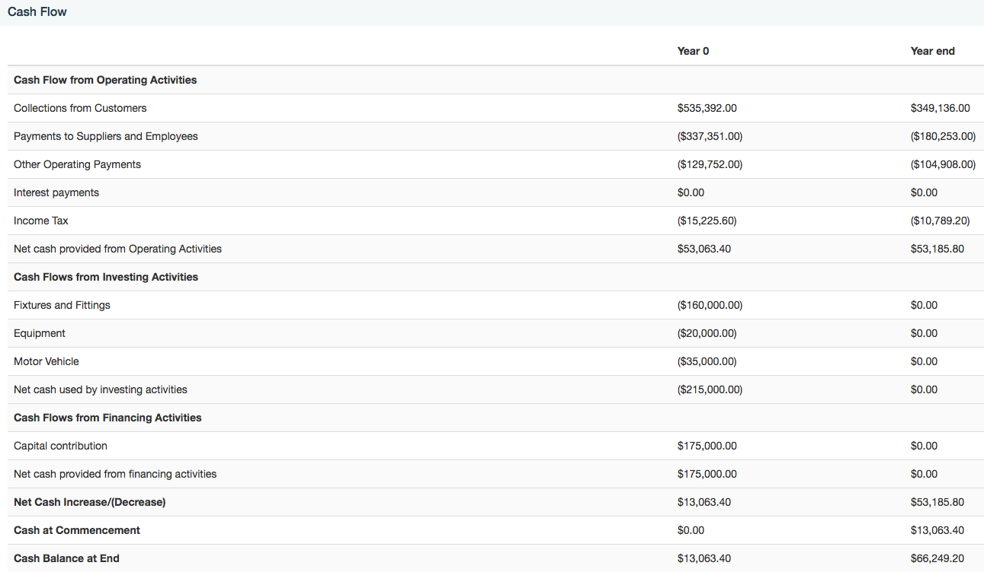
SAMPLE VBE INCOME STATEMENT

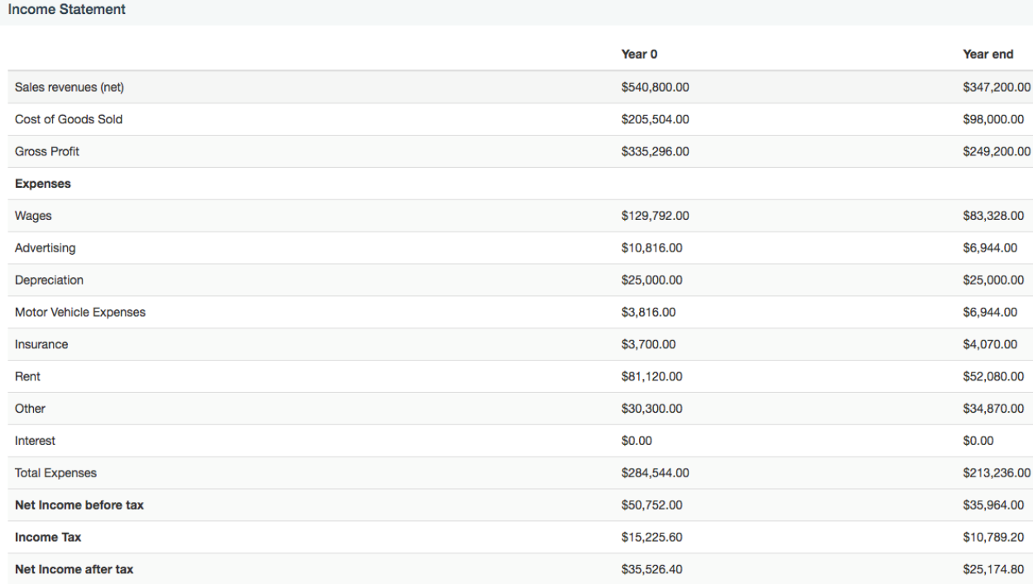

SAMPLE VBE BALANCE SHEET
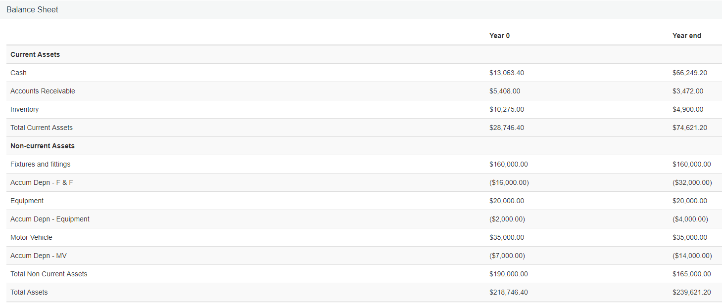

Background context for Business Plan - Virtual Island
The following information provided informs you of the environment Virtual Island operates in:
Demographic information
The shopping mall where your VBE business is situated is Virtual Island, a satellite city north of Brisbane, Australia.
- Virtual Island is a growing middle-class community with 25,000 residents (51.3% females and 48.7% males). The majority of these residents are families of four or more. The average age is 37.3 years of age, the same as the Australian median age.

- The main occupations of people in Virtual Island are Clerical and Administrative Workers 16.8%, Technicians and Trades Workers 15.8%, Professionals 14.3%, Community and Personal Service Workers 10.9%, Machinery Operators and Drivers 10.6%, Labourers 10%, Managers 10%, Sales Workers 9.8%.

- The median individual income is $750.00 per week and the median household income is $1675.00 per week.

- 9.7% of homes are fully owned, and 50.6% are in the process of being purchased by home loan mortgage. 39.7% of homes are rented

- Virtual Island adjoins the communities of North Lakes and Dakabin that have similar population size and demographics.

- The Brisbane CBD is a 40 minute drive from Virtual Island.
Economic background
- There is currently an economic boom in the Virtual Island area, primarily in response to new employment opportunities due to the area’s growth. The expected annual growth in the region will be 10%.

- The market primarily consists of individuals although there are opportunities for some sales to the corporate sector.

- The level of competition in all industries is high.

- Consumer sentiment is expected to rise over the next three years.

- Future revenue growth in the area is expected to increase in line with economic and population growth.

- Business Hours are unregulated with trading currently permitted 24 hours, 7 days a week with businesses deciding their own trading hours.
Schools
- There are two primary and two secondary public schools in the area and one P-12 independent School.

Transport
- The area is well served by Bus and Rail transportation.

Growth drivers
- The new shopping mall and hotel complex on Virtual Island has generated the largest growth in recent years with many new businesses recently opening and bringing new products and services to the area.

Assessment relating to the VBE is as follows:
- Group Assessment: A single online submission through TurnItIn of a business plan for the group's VBE business due noon Wednesday 25 September 2019. (30%)

- Peer Review: An individual online submission is due noon Wednesday 25 September 2019. Students do not peer review themselves only the other group members. All students are required to complete and submit an individual peer assessment form.

- Students wanting to have a variation in the allocation of assignment marks based on group
member’contributions must advise the course coordinator after submission by email

- Include: GoogleDoc link (enrol the course coordinator with full edit access to the GoogleDoc), any screen chats etc and before the assignment
results have been released. The course coordinator will consider the peer reviews and the GoogleDoc. The details of any reallocation of marks will be on the assignment title page.

- Students must attempt all pieces of assessment

The two VBE trading sessions are intended as a pathway to the development of a business plan for your virtual business. Your group’s performance in running your virtual business will be reflected in the financial statements generated at the end of each trading session. The final set of financial statements generated at the end of trading session 2 will form the basis for the financial plan section of your business plan.

Only use the trading session 2, 12 months trading financial statements, for your business plan.

Only 12 months figures are used in your business plan assignment. Year 2017 represents the previous year (automatically provided in your financial statements and represent 12 months) and Year 2018 represents the current year generated by your trading in your virtual world.

The purpose of the business plan is to support a loan application with a local financial institution to assist with the cost of your business expansion. The amount of loan funds requested is up to you.

The business plan is a group assignment and must contain the following sections:
 | Percentage of total assessment (30%) | Component | Word count  (4,000 words)
 | 1 | Description of business | 200
 | 6 | Marketing Plan | 800
 | 6 | Operating Plan | 800
 | 1 | Environmental management plan | 200
 | 5 | Financial Plan – discussion (refer to template and rubric for guidance) | 1 800
 | 10 | Financial Plan – Appendix  - Historical statements from session 2  - Master Budget  All figures are shown as single annual figures only | nil
 | 1 | Executive summary | 200

There is 10% +/- flexibility around word limits for each section and in total. Business plans that exceed 10% of the word count may incur a 10% penalty of the total available marks.
Additional demographic information about the virtual world is provided in the “Background context for Business Plan - Virtual Island” to help with completion of the first four sections of the business plan.
All student groups must create a Google Doc and register their name on the GoogleDoc. Insert the Business Plan template including the rubric. Students work collectively on their group’s Google Doc ensuring well-developed linkages across the various sections of their business plan. Refer to the VBE Business Plan Assignment Milestones for further detail.
The SSG will be available in 39-113 from Monday 26 August 2019 to assist students with establishing their GoogleDoc, allocating tasks if required and group issues. Please refer to the SSG consultation timetable.
Please note:
The financial plan and associated appendix is a key focus of the assignment and must not be allocated to or completed by one group member.
The financial plan contains the discussion, the appendix contains the historical VBE financial statements, and Master budget made up of the supporting budgets and projected financial statements.
At a minimum the following must be included:

- A request for a specific loan amount, interest rate, and period of time. A full explanation and justification of how the loan funds will be used including a breakdown

- An explanation of how the business will generate sufficient cash to repay the loan and interest. This explanation should be supported by your Cash Flow Statement

- All groups must submit a business plan for a bank loan. Any group that has a high level of surplus cash is still required to apply for a bank loan. Marks are lost if a bank loan does not support the Business Plan.

- Historical financial results and projected financial data is discussed in depth.

- All assumptions used in the Master Budget must be provided and discussed.

Appendix

- The Master Budget i.e. a projected cash flow statement, projected income statement and projected balance sheet for the next financial year with supporting assumptions, calculations and supporting budgets. Your budgets and projected financial statements should be consistent with the other parts of your business plan. For example, if you are planning a major marketing campaign in your marketing plan, this should be reflected in budgeted marketing expenses in your projected income statement plus all other relevant line items in this financial statement and the cash outflow in the Projected Cash Flow Statement. This is evidence of your business plan being ‘integrated’ and your Master Budget being consistent with the other parts of your Business Plan.
- Final financial statements (Income Statement, Balance Sheet and Cash Flow Statement) for your business at the completion of the 2 trading sessions (only provide trading session 2 financial statements which represent annual figures)

Your business plan should not exceed 4,000 words and is due by 12 noon Wednesday 25 September 2019.
- A single group online submission through TurnItIn – no hard copies accepted
- The submitting student must do all originality checks
- File name for uploading to TurnItIn must be in the following format
  - Practical session number_business name eg. P05_CandyShoes
  - TurnItIn automatically identifies the submitting student’s name

