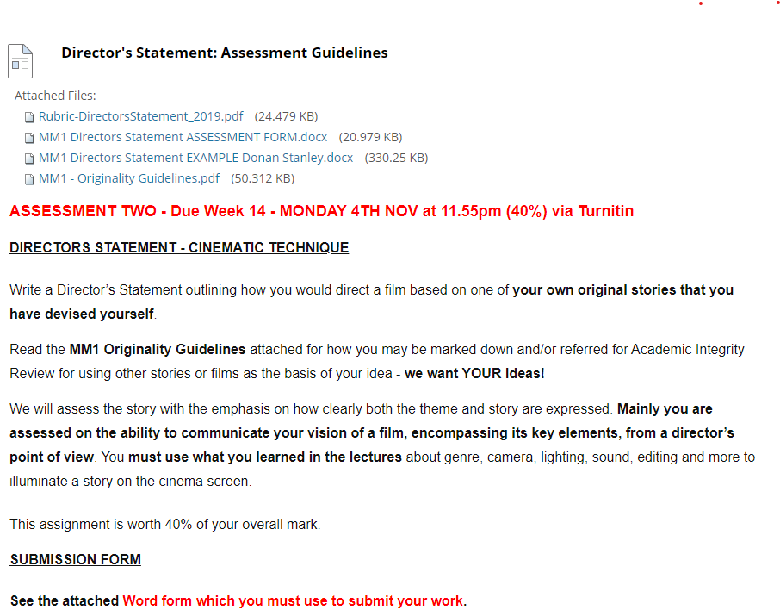
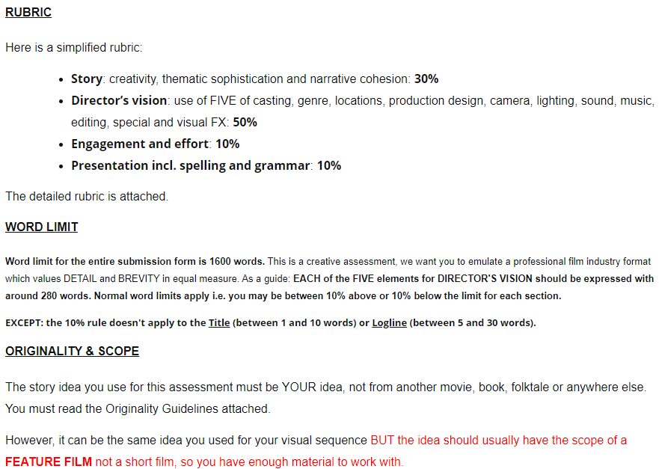
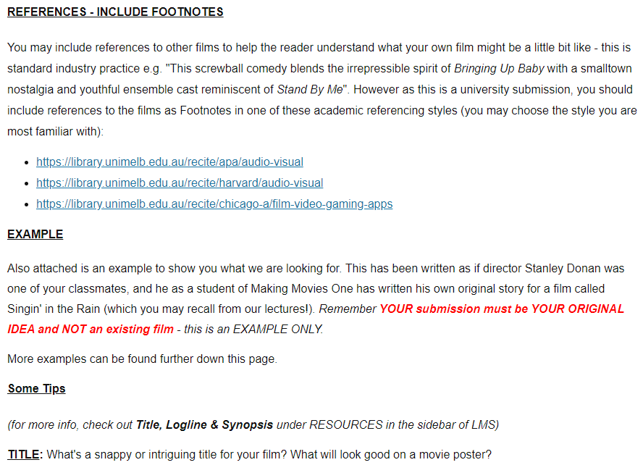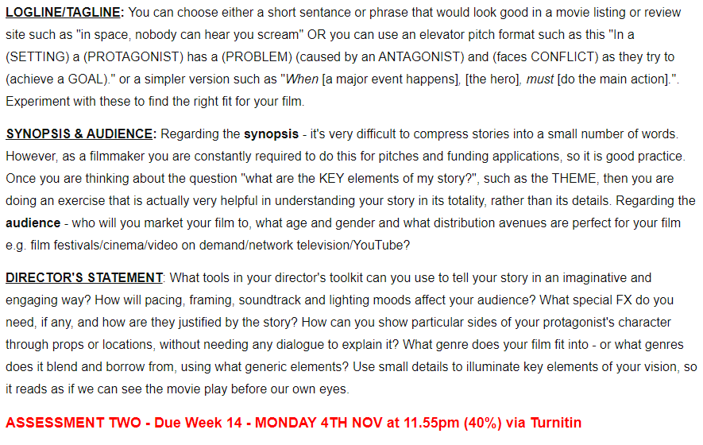

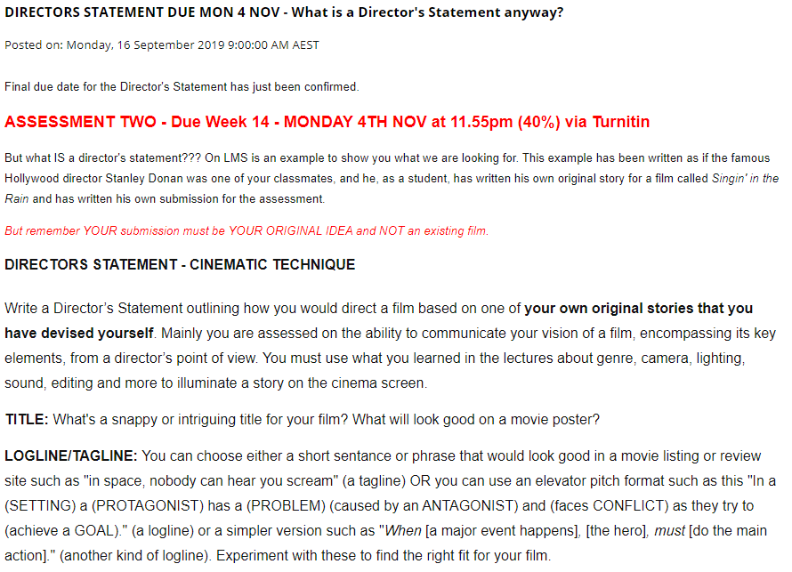
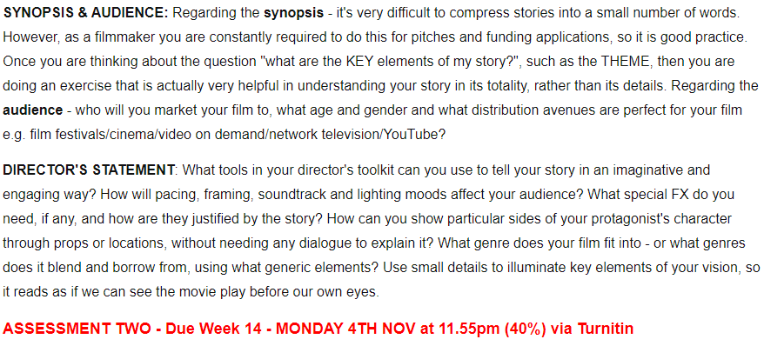

Proofreading and Editing Your Writing
Posted on: Monday, 14 October 2019 9:00:00 AM AEDT
Many students submit work for their "Director's Statement" that does not seem to have been edited or proofread.
We expect all submissions to be edited and proofread for errors.
These are important academic writing skills - if you don't have these skills yet, this assessment could be your chance to learn how.
Writing a paper isn't nearly enough to be finished - you must revise, edit to be more concise, check for spelling errors and grammatical errors, and refine your language until it flows better on the page.
This is no easy task if English is not your first language - so make sure you allow plenty of time for this part of the process - not five minutes at the end.
If you’re not sure how to go about this process, or even if you have done it before it’s still worth a look, you can access all the Academic Skills learning modules, including those on editing and proofreading here: https://services.unimelb.edu.au/academicskills/home/as-hub
You can book an individual tutorial here: https://ask.unimelb.edu.au/app/answers/detail/a_id/3734/~/academic-writing-assistance
It’s also a good idea to have another student help you by identifying syntactical or grammatical errors in your paper. That person should not necessarily fix those errors for you, but they can point them out, and you can fix them yourself. It's good to print out your paper, and your friend can mark errors in red pen.
The library has an excellent checklist for proofreading and editing here: https://library.unimelb.edu.au/__data/assets/pdf_file/0003/1924077/Editing_Proofreading.pdf
Finally - Microsoft Word - free to all Melbourne uni students via the university website - has a Spell Checker which all of you should use prior to submitting your work. Word now has extended Editing features which take a while to learn, but could be very powerful: https://support.office.com/en-us/article/editor-is-your-writing-assistant-91ecbe1b-d021-4e9e-a82e-abc4cd7163d7
Good luck!
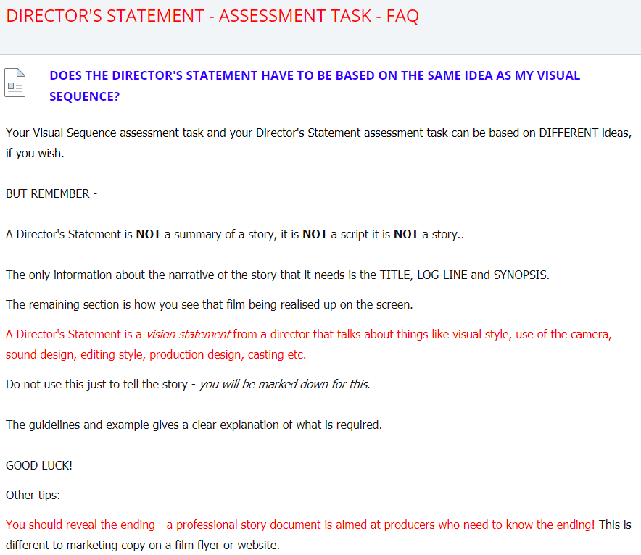
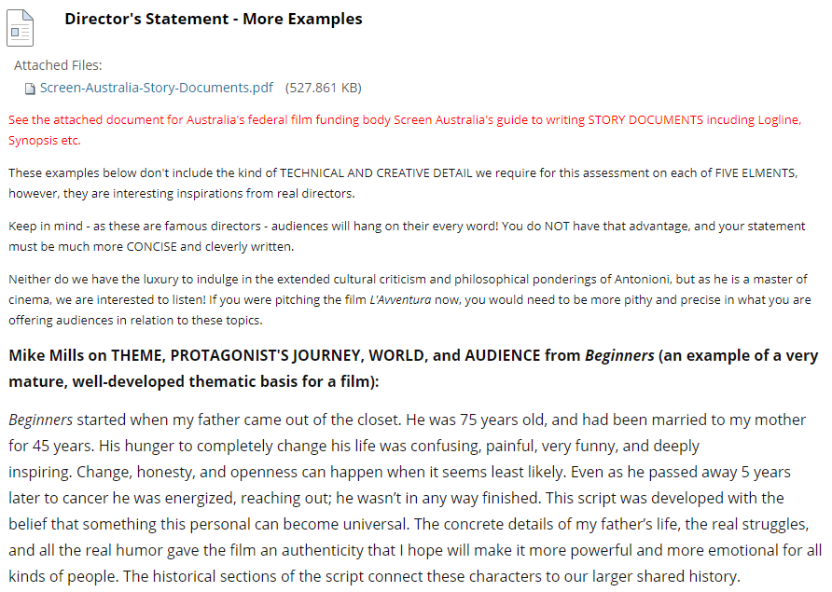
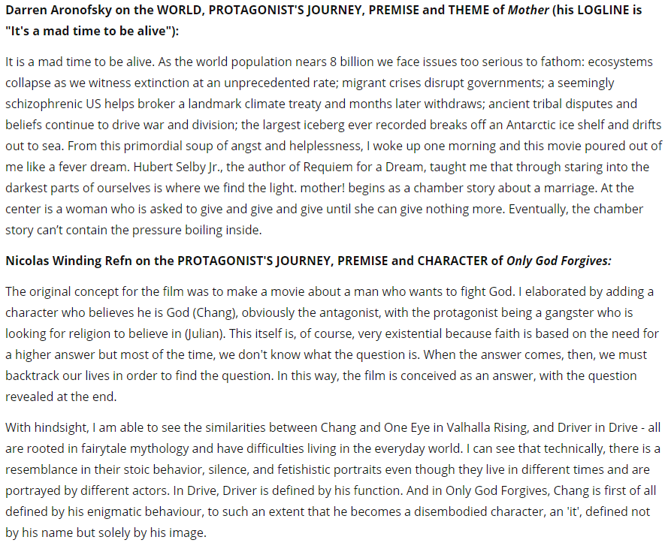

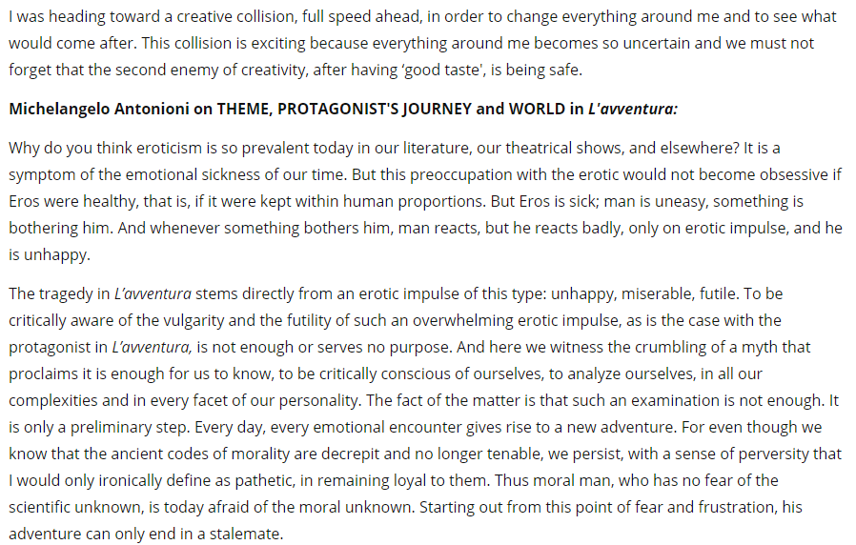

Tarantino's 10 Tips for Directors With Vision

https://app.lms.unimelb.edu.au/bbcswebdav/pid-7613959-dt-content-rid-65402341_2/xid-65402341_2

