Winery:
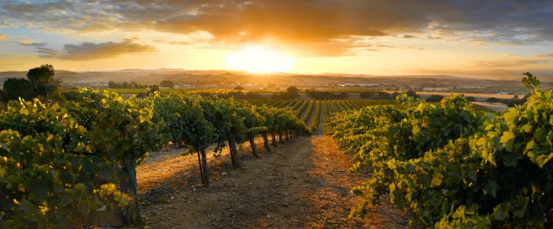
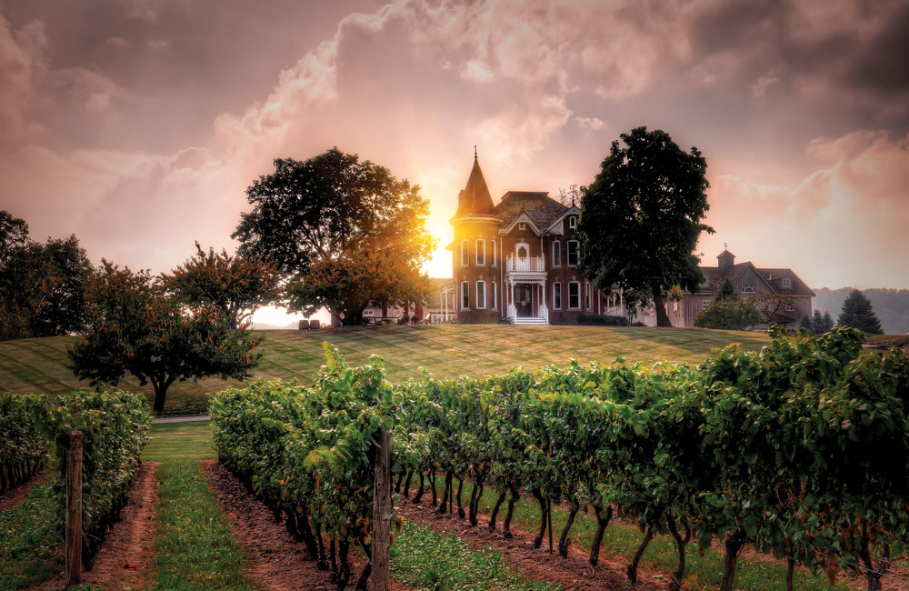
- What is the image/positioning of your winery
- Hazy Moon winery brings consumers a real experience.
- Each customer needs to be at least 18 years old. Our target group is the business group, because our aim is to “win-win”, to bring customers a perfect and good taste of the winery, to meet each customer wants and needs, and finally increase our profits.
- Fully equipped
- State-of-the-art Production Facilities

- Wine Production: Grape varieties - specialise or have a cross section of varieties
Aromas: http://wine-tasting-reviews.com/wine-types-varieties-grapes/red-wine-types/68-cabernet-sauvignon-wine-flavor-aroma-characteristics.html
Pairing strategies: https://justwines.com.au/blog/what-is-cabernet-merlots-ideal-food-match/
https://www.foodandwine.com/slideshows/cabernet-sauvignon-pairings#1

Grape varieties | Aromas | Pairing strategies
Cabernet Sauvignon | Skin Colour: Black.  Wine Type: Red wines Red Wine Blends.  Currant, Bell Pepper, Vanilla | Sticky Barbecued Beef Ribs Pairing: 2009 Columbia Crest H3 Cabernet Sauvignon.
Merlot | Skin Colour: Black.  Wine Type: Red wines Red, Wine Blends.  Herbal, with plum, red berry and currant flavours, low in tannin and full of appealing fruit flavours, with plum, red berry and currant flavours. | The richness of fatty meats like beef and lamb goes beautifully with the tannins. The combination of the two results in the Cabernet Merlot providing a smoother mouthfeel. Slow cooker beef pot roast is not just easy to cook but makes for an ideal partner with the blend! Barbecued beef, cooked till slightly charred, is fantastic too!
Viognier | Skin Colour: Green  Wine Type: White Wine, White Wine Blends.  - Citrus, grapefruit, apple, pear, peach, apricot, pineapple, floral, spice, mineral.  The trademark aromas and flavours of viognier wines include apricots, peaches, blossom and violets. | Viognier pairs well with grilled seafood; it’s also a good match for most foods flavoured with fruit salsas.
Syrah/Shiraz | Skin Colour: Black  Wine Type: Red wines Red, Wine Blends.  - Fruit, Berry, Meaty, Cocoa. Syrah/Shiraz flavours and aromas include peppers, berries, currants, and even chocolate.  Syrah wines have some of the strongest, most distinctive flavours and aromas of any red wine. | It has also become the signature grape of Australia, where it’s called Shiraz, and typically produces fruitier, less tannic wines marked by sweet blackberry flavours. Barbecued foods with a smoky char pair nicely with Syrah, as do lamb, venison and game birds.

- Architecture & design
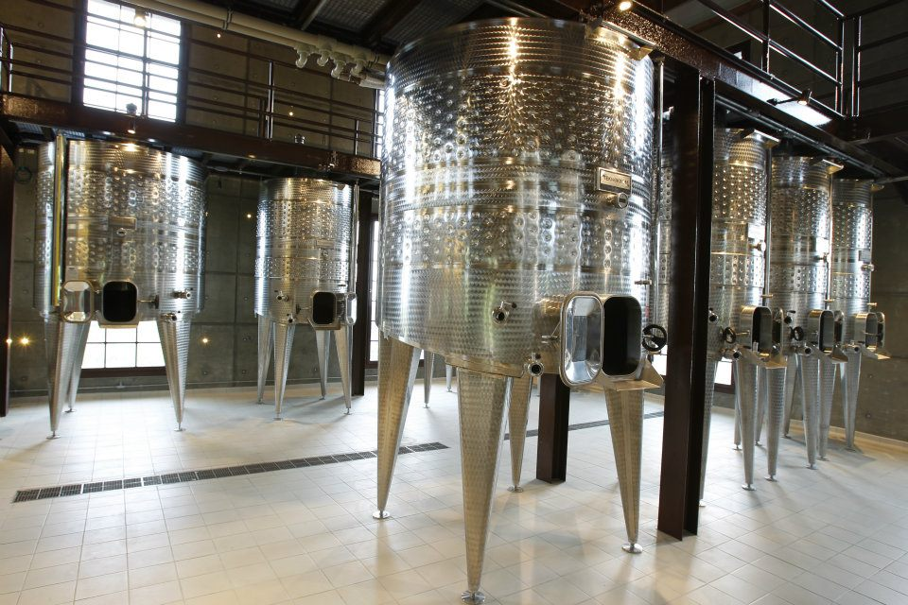
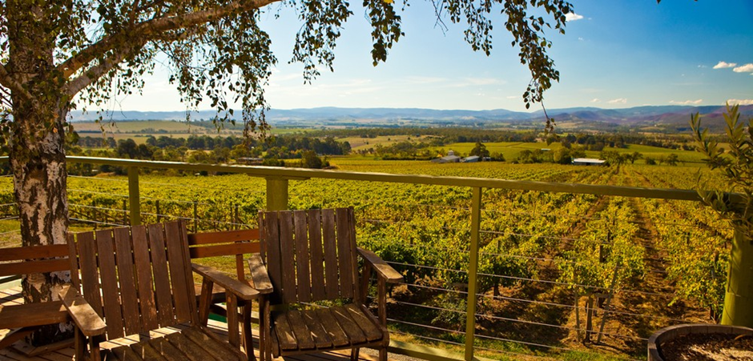
- Winery building at LOT 1 Pinnacle Rd, Wellington Park TAS 7054 Hobart， Tasmania.
- This is a classically elegant winery building with a cubic framed glass for the curtain wall, and the entire building is set on the hillside.
- In this winery, not only a winery, but also more diverse businesses, such as hotels, cafes, restaurants, and concerts. This will attract more tourists.
- The winery is built on the top of the mountain, which will help the culture and broaden the horizon, so that visitors can truly experience the landscape of nature.

Proposed cellar door
- Architecture & design
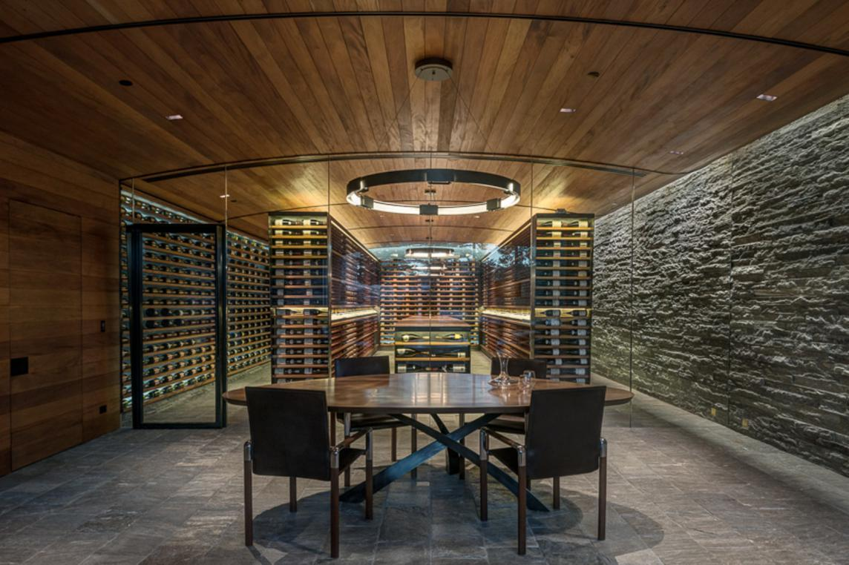
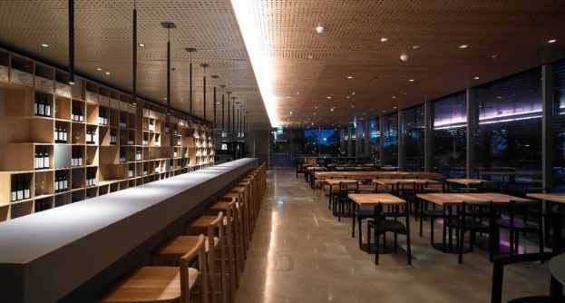
- When dining at the wine cellar, visitors can see the entire winery landscape.
- Can accommodate 150 people for a meal together so that weddings can be held at our winery.
- You can taste different wines and you can book a meeting room.

The following are the experiences that we are going to offer to our high-end customers
- Facilities
In the wine factories, the company introduced the new facilities to produce different kinds of wines. The benefits of using these new facilities are environmentally-friendly, as well as increase wine quality.

- Winery tours
As our factors will be located in countryside, so customers could drive to our factors directly, or they could book pickup services online. Drivers will pick our high-end customers from their home by luxury vehicles. Visitors will be allowed to visit the cellar door, and appreciate cups of wines in our restaurant. When they are visiting the cellar door, we would like to introduce different kinds of wines to our visitors, aiming to enhance their knowledge in relation to different kinds of wines.

- Attractions
As our location is in countryside, visitors can not only appreciate cups of wines with their friends or family members, but also can touch with nature. Outside our cellar is a park, visitors can see cows, kangaroos, turkey and so on. These animals are very interesting. Next to this the part is our vineyard, we planted grapes there, while visitors can come into vineyard to see how these grapes are planted environmentally-friendly.

- The target market of our winery is high-end customers.
- The key word of our winery is classical.
- Classical architecture (castle) and brewing technology (oak barrel) bring visitors back to the middle ages.
- We are not only steadfastly committed to produce the world’s finest wine, but also devote ourselves to provide a special dream winery tour to customers.
- The winery tour includes visit cellar door, wine-tasting, meals and accommodation. In addition, we offer some interesting courses, for example, food and wine pairing course.
- Tasmania has a moderate maritime climate, which can make the grapes are ripening slowly, and result in the best flavor of the grapes. (Wine Tasmania, 2018)
- The soils of vineyard are formed from ancient sandstones and mudstones and from more recent river sediments and igneous rocks of volcanic origin as well. (Wine Tasmania, 2018)
- Because of the exceptional soil and cool climate, our vineyard plant 4 kinds of grapes for wine production, which includes Pinot noir, Chardonnay, and Sauvignon Blanc.

Tasting experience play an important part to customers. Most customers feel that buying wine is risky, so they pay more attention to sensory experience (Thomas, Gómez, Gerling & Mansfield, 2014, p. 63). Our tasting fee is just $10 per person and no appointment. Tasting red wine is divided into four steps: looking the color, smelling the wine, tasting the wine and spiting (Cicchetti & Cicchetti, 2008, p. 185). Liquor has light yellow-green; red wine has purple or ruby color. Wines deepen as they age, but red wines lose color (Parr & Heatherbell, 2003, p. 82). Wine can be identified by the smell of wine (Rinaldo, Duhan, Trela, Dodd & Velikova, 2014, p. 209).
Except to the wine tasting, the choice of food is also concerned. Fruit wine is a light and smooth wine. It can be paired with light foods, such as salads or cold dishes (Čakar, Petrović, Živković, Vajs, Milovanović, Jiri & Đorđević, 2016, p. 663). Light wines are suitable for delicate dishes, such as steak or fish (Gómez Gallego, Sánchez-palomo, Hermosín-gutiérrez & González Viñas, 2013, p. 649). Strong red wine is good for meat, such as steak, lamb chops or duck. The outlet of the menu is that the lighter wines or food before heavier wines or food and dry wines before sweet. Individual and group meals will also be on the menu for more than one guest. In addition, pizza choices are available.

References
Cicchetti, D., & Cicchetti, A. (2008). The balancing act in consistent wine tasting and wine appreciation: Part II: Consistency in wine tasting and appreciation: An empirical-objective perspective. Journal of Wine Research, 19(3), 185. Retrieved from http://search.proquest.com.libraryproxy.griffith.edu.au/

Čakar, U.,D., Petrović, A.,V., Živković, M.,B., Vajs, V. E., Milovanović, M.,M., Jiri, Z., & Đorđević, B.,I. (2016). Phenolic profile of some fruit wines and their antioxidant properties. Hemijska Industrija, 70(6), 661-672. doi:http://dx.doi.org.libraryproxy.griffith.edu.au/

Gómez Gallego, ,M.A., Sánchez-palomo, E., Hermosín-gutiérrez, I., & González Viñas, ,M.A. (2013). Polyphenolic composition of spanish red wines made from spanish vitis vinifera L. red grape varieties in danger of extinction.European Food Research and Technology = Zeitschrift Für Lebensmittel-Untersuchung Und -Forschung.A, 236(4), 647-658. doi:http://dx.doi.org.libraryproxy.griffith.edu.au/

Parr, W. V., White, K. G., & Heatherbell, D. A. (2003). The nose knows: Influence of colour on perception of wine aroma. Journal of Wine Research, 14(2), 79-101. Retrieved from http://search.proquest.com.libraryproxy.griffith.edu.au/

Thomas, L., Gómez, M.,I., Gerling, C. J., & Mansfield, A. K. (2014). The effect of tasting sheet sensory descriptors on tasting room sales. International Journal of Wine Business Research, 26(1), 61-72. Retrieved from http://search.proquest.com.libraryproxy.griffith.edu.au/

Rinaldo, S.,B., Duhan, D.,F., Trela, B., Dodd, T., & Velikova, N. (2014). Evaluating tastes and aromas of wine: A peek inside the "black box". International Journal of Wine Business Research, 26(3), 208-223. Retrieved from http://search.proquest.com.libraryproxy.griffith.edu.au/

Wine Tasmania. (2018). Retrieved August 13, 2018, from http://winetasmania.com.au/about_our_wine

