COMPANY ANALYSIS REPORT

Student Names & ID
Student Names & ID
Student Names & ID

Table of Contents
Introduction 3
Stock Evaluation 4
ANZ 4
CBA 6
NAB 8
WBC 10
IAG 11
MQG 12
SCG 14
SUN 15
TLS 17
SUMMARY AND COMPARISON OF THE PORTFOLIOS 18
Reference list 18

Introduction

This portfolio is designed to be a value portfolio. This is mainly because that all the ASX20 stocks are large-cap, relatively mature companies. Most of them pay regular dividend. Therefore, they are considered all value stocks. Given the recent volatility and future uncertainty in the Austrian and world equity market, this portfolio also aims to avoid excessive risk taking and provide long-term capital gain as well as dividend income to investors. Hence, this portfolio is designed to invest in the following stocks:

Value Investing | Growth Investing
- ANZ.AX  - CBA.AX  - IAG.AX  - MQG.AX  - NAB.AX  - SCG.AX  - SUN.AX  - TLS.AX  - WBC.AX | None

In choosing the stocks, this portfolio adopts a top-down approaching by firstly examining the general economic conditions in Australia, then examining industrial conditions, and lastly analyse individual company performance. Since recently, the RBA (2018) has indicated that it may further cut the interest rate to stimulate Australian economy, we expect the general economic conditions in Australia to be sound and positive. The potential interest rate cut may largely boost the performance of banks, hence we decided to invest heavily in the banking sector by incorporating all the Big 4 banks (ANZ, CBA, NAB, and WBC). Besides, the portfolio will invest heavily in other financial companies including IAG (insurance) and commercial banks (Macquarie and Suncorp). Furthermore, the portfolio diversifies by investing in consumer Staples Company (Scentre) and telecommunication company (Telstra).

Stock Evaluation

ANZ
ANZ is one of the “Big 4” Banks. Its main businesses involve retail banking and commercial banking.

Fundamental Analysis

 | Net interest margin | Efficiency ratio | Loan growth | Deposit growth | Non-performing loans to total loans
2014 | 2.13% | 53.60% | 8.10% | 9.00% | 2.90%
2015 | 2.04% | 53.00% | 9.40% | 10.60% | 2.76%
2016 | 2.00% | 60.20% | 1.30% | 3.70% | 2.92%
2017 | 1.82% | 51.10% | 1.00% | 2.40% | 3.00%
2018 | 1.87% | 50.00% | 4.40% | 3.80% | 2.89%

Over the past five years, ANZ’s net interest margin (representing the profitability of a bank) was relatively staple; there was no significant increase or decrease. This indicates we may expect further stable profitability of ANZ. Besides, its efficiency ratio is reducing, meaning that the company is making profits in a less and less cost-effective manner. The loan growth was lower than deposit growth over the period, yet then tend to move with similar magnitude, meaning ANZ was matching its loan given out with deposits received, which implies that the bank is expanding business in a relatively sustainable manner (not too aggressive). ANZ’s non-performing loans was keep below 3% of its total loans, meaning the bank is having an effective risk control mechanism.

Overall, ANZ is deemed a company with stable, moderately positive outlook and moderate level of risk.

The potential interest rate cut by RBA in the future would have positive impacts on ANZ’s share price.

Technical Analysis
Using the one-year data, we can that currently the 50-day moving average is below the 200-day moving average, yet the difference is shrinking in the past few trading days. The volume is around the average level. We will wait to see if there will be a golden cross in the next several trading days, which could be a “buy” signal. Yet up to the date of completing this report, we cannot draw any useful conclusion from the technical analysis.
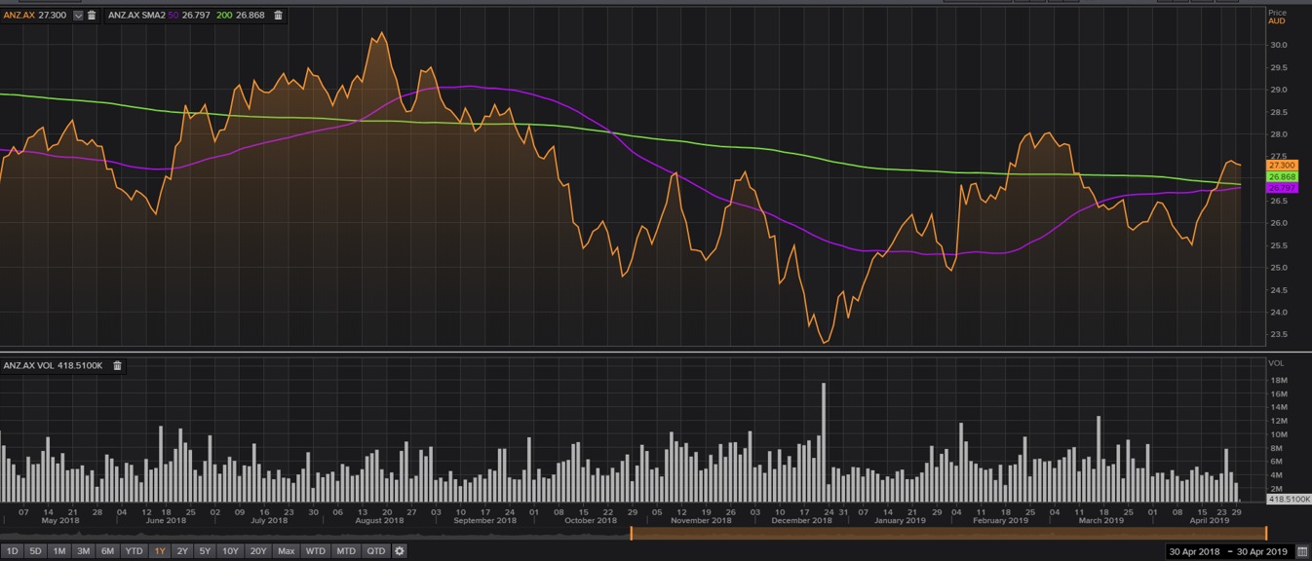

CBA
CBA is one of the “Big 4” Banks. Its main businesses involve retail banking and commercial banking.

Fundamental analysis
 | Net interest margin | Efficiency ratio | Loan growth | Deposit growth | Non-performing loans to total loans
2014 | 2.14% | 49.90% | 3.00% | 7.00% | 2.69%
2015 | 2.09% | 49.80% | 7.40% | 10.90% | 2.55%
2016 | 2.07% | 42.60% | 8.40% | 6.30% | -
2017 | 2.11% | 42.10% | 5.80% | 6.70% | -
2018 | 2.15% | 44.10% | 1.50% | -1.50% | 2.11%
Over the past five years, CBA’s net interest margin (representing the profitability of a bank) was relatively staple. This indicates we may expect further stable profitability of CBA. However, its efficiency ratio is reducing, meaning that the company is making profits in increasingly costly way. The loan growth sometimes exceed the deposit growth, meaning that CBA may be expanding business too aggressively. CBA non-performing loans was keep below 3% of its total loans (despite the missing data), meaning the bank is having an effective risk control mechanism.

Overall, CBA is deemed a company with stable, moderately positive outlook and moderate level of risk.

The potential interest rate cut by RBA in the future would have positive impacts on CBA’s share price.

Technical analysis
Using the one-year data, we can that currently the 50-day moving average has crossed above the 200-day moving average. With an average-level volume and a trend that broke through a resistance level, we believe CBA’s price chart has shown a strong “buy” signal.

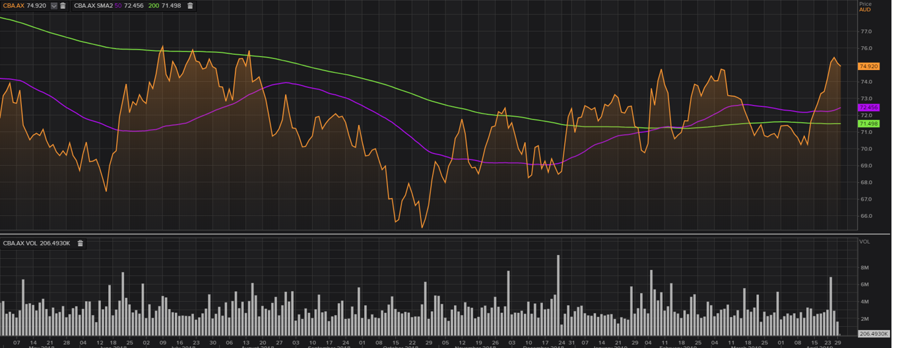
·因为澳联储下月降息的可能性激增，澳元已大幅跌至七周来的新低点。在今晨7:10，一澳元买入70.1美分。与复活节星期五（即：耶稣受难日）的汇率(71.5美分)相比，这一汇率大幅下跌。澳元抛售系由昨天（4月24日）疲弱的消费者价格指数（CPI）引发。此数据显示，核心通胀率(1.4%)已跌至至少16年来的最低水平。三年来，通胀率一直保持在央行制定的2%-3%的目标区间以下。上周，澳大利亚央行（即：澳联储）曾表示，如果失业率上升，通胀“不再上升”，降息将是“适当的举措”。联邦就业和小企业部昨天公布的职位空缺数据显示，月度就业广告降幅为六年来最大，这通常预示着失业率的上升。

NAB
NAB is one of the “Big 4” Banks. Its main businesses involve retail banking and commercial banking.

Fundamental analysis
 | Net interest margin | Efficiency ratio | Loan growth | Deposit growth | Non-performing loans to total loans
2014 | 1.91% | 69.10% | 6.40% | 8.70% | 3.38%
2015 | 1.90% | 57.40% | 23.50% | 1.90% | 1.90%
2016 | 1.88% | 56.60% | -3.80% | -6.50% | -
2017 | 1.85% | 52.00% | 6.10% | 3.40% | 2.44%
2018 | 1.86% | 51.90% | 5.20% | -1.10% | -

Over the past five years, NAB’s net interest has been shrinking, and its efficiency ratio is decreasing too. These two trends signal that NAB is suffering from reducing profitability. This will continue affecting the bank in the near future. Besides, we can see volatile and inconsistent loan growth and deposit growth, which suggest that NAB might be struggling in funding its loans sustainably. Its non-performing loan ratio is also relatively volatile despite the missing data, imply the bank may have issue in risk control.

Overall, NAB is deemed a company with a negative outlook.

The potential interest rate cut by RBA in the future would have positive impacts on NAB’s share price.

Technical analysis
Using the one-year data, we can that currently the 50-day moving average is below the 200-day moving average, yet the difference is shrinking in the past few trading days. The volume is around the average level. The price chart suggests that NAB’s stock price may stay at currently level in the near future.

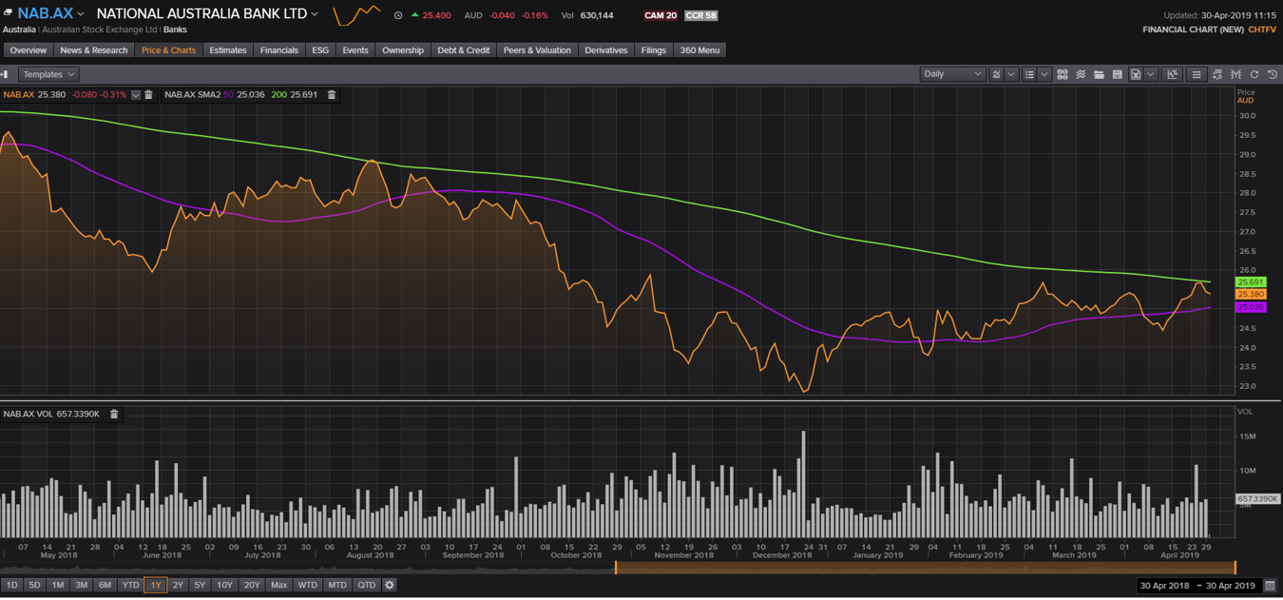

WBC
WBC is one of the “Big 4” Banks. Its main businesses involve retail banking and commercial banking.

Fundamental analysis
 | Net interest margin | Efficiency ratio | Loan growth | Deposit growth | Non-performing loans to total loans
2014 | 2.09% | 42.90% | 8.40% | 10.60% | 0.39%
2015 | 2.10% | 43.90% | 6.20% | 7.50% | 0.48%
2016 | 2.10% | 43.90% | 6.20% | 7.50% | 0.48%
2017 | 2.06% | 43.30% | 3.50% | 4.60% | 0.50%
2018 | 2.13% | 43.80% | 3.60% | 3.90% | 0.56%
Over the past five years, WBC’s net interest margin and efficiency ratio were both stable. This indicates we may expect further stable profitability of WBC’s. Also, WBC’s loan growth is consistent with deposit growth, meaning the profitability is relatively sustainable. Notably, the non-performing loan ratio of WBC is very low, meaning that the bank has very strict risk control mechanisms.

Overall, we think that WBC has a positive outlook.

The potential interest rate cut by RBA in the future would have positive impacts on WBC’s share price.

Technical analysis
Using the one-year data, we can that currently the 50-day moving average is below the 200-day moving average, yet the difference is shrinking in the past few trading days. The volume is around the average level, and there is currently no major trend reversal. Therefore, the price chart indicates WBC’s price will stay around the current level in the near future.

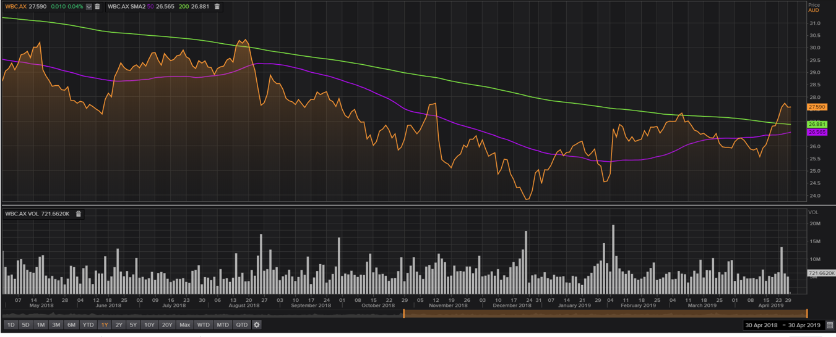

IAG
IAG is a major Australian insurance provider. It mainly provides life insurance and term insurance services to retail clients, and business insurance to business clients.

Fundamental analysis
 | loss ratio | investment ratio | return on asset (ROA) | return on equity (ROE) | Debt/equity
2014 | 60.20% | 3.70% | 6.60% | 31.70% | 0.27
2015 | 67.20% | 4.10% | 3.10% | 14.20% | 0.26
2016 | 65.60% | 3.00% | 3.00% | 13.80% | 0.3
2017 | 62.00% | 1.60% | 4.50% | 20.50% | 0.25
2018 | 60.20% | 1.70% | 4.80% | 21.30% | 0.29

For an insurance company, lower loss ratio indicates a higher profitability. In the past five years, we can see a volatile loss ratio of IAG, which indicates future volatility in IAG’s profitability. However, we see a significant drop in investment ratio (which indicates the company’s ability in earning returns using its funds) in the past two years, meaning that IAG is inefficiently using its premium to generate investment income. The ROA and ROE have both been decreasing. On the other hand, the company’s debt/equity s remained at below 30%, which indicates a stable financial structure.

Overall, IAG is perceived to have a slightly negative outlook with moderate risk.

Little current event may have significant impacts on IAG’s share price.

Technical analysis

Recently, the 50-day moving average has crossed above the 200-day moving average, indicates a buy signal. The current trading volume is at average level, yet the price increasing momentum is strong, which reinforces the buy signal. We should wait for further trend reversal signs to make decisions.
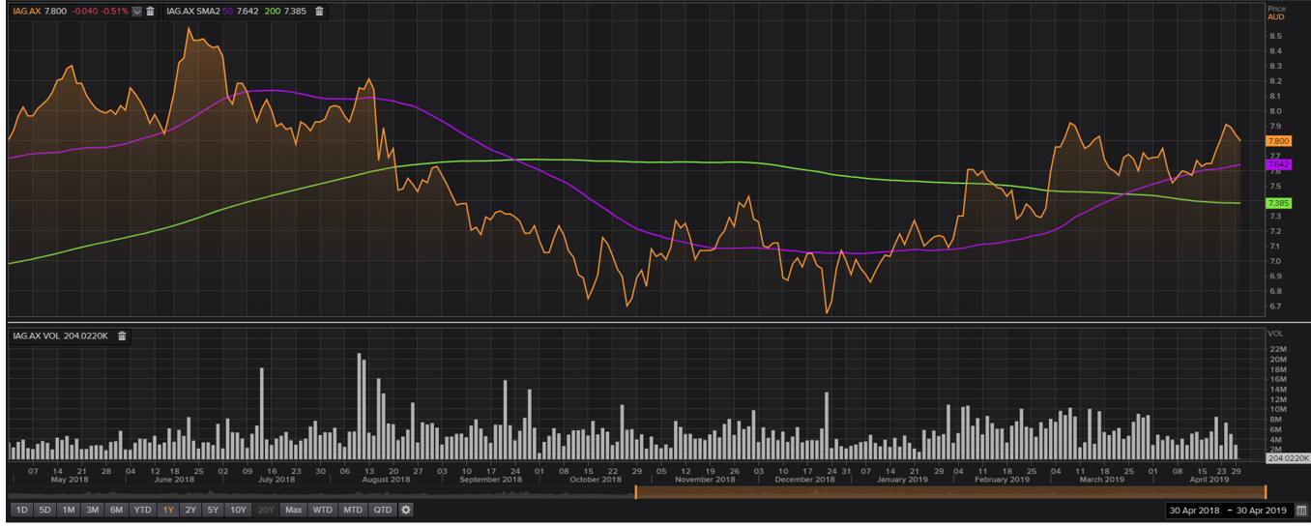

MQG
MQG is a commercial bank mainly providing wholesale banking services such as issuing debts, consulting and IPO to business clients.

Fundamental analysis

 | ROE | efficiency ratio | loan growth | deposit growth | Nonperforming Loans (% of Total Loans)
2014 | 18.50% | 74.00% | 15.60% | 3.20% | 0.70%
2015 | 19.90% | 71.60% | 23.90% | 11.80% | 0.85%
2016 | 20.80% | 69.10% | 10.50% | 10.30% | 0.53%
2017 | 20.20% | 70.70% | -4.60% | 10.50% | 0.74%
2018 | 21.70% | 71.30% | -4.10% | -16.10% | 0.49%

As a commercial bank, MQGs’ profitability is examined by its ROE. In the past five years, we can see the bank’s ROE has been increasing, indicating a strengthening profitability. This is so despite the company’s increasing efficiency ratio, meaning the bank was actually generating income in a more cost-effective way. Besides, we see some significant volatility and inconsistency in loan growth and deposit growth, meaning the bank’s suitability is questionable. Lastly, the bank’s non-performing loan ratio is well below 1%, indicating a strong risk control mechanism.

The potential interest rate cut by RBA in the future would have positive impacts on MQG’s share price.

Technical analysis

MQG’s 50-day moving average has crossed and stayed well-above the 200-day moving average. Furthermore, it has a strong upward trend recently. These two facts are strong buy signal. However, the volume is current below average, which might be a warning sign.
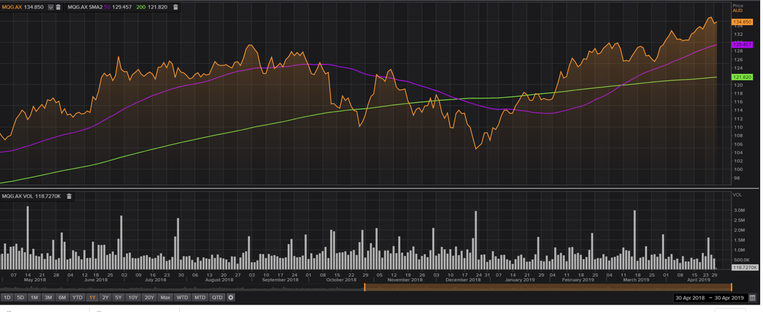

SCG
SCentre Group is a large shopping center operator in Australia. It operates in the consumer staples industry, and is strongly affected by consumer sentiment and economic conditions in Australia.

Fundamental analysis

 | Operating margin | Asset turnover | Current ratio | Debt/equity | Occupancy rate
2014 | 70.70% | 0.07 | 0.83 | 0.83 | -
2015 | 66.20% | 0.09 | 0.2 | 0.7 | 99.50%
2016 | 74.40% | 0.08 | 0.36 | 0.65 | 99.50%
2017 | 80.00% | 0.07 | 0.18 | 0.58 | 99.50%
2018 | 74.50% | 0.07 | 0.25 | 0.65 | 99.30%

SCG’s operating margin has been relatively volatile in the past 5 years. However, the level was pretty high, indicating future high profitability of the company. This is strengthened by the impressively high occupancy rate across the five years. The company’s asset turnover ratio was stable, suggesting its efficiency was relative stable over the period. The company’s current ratio has significantly dropped over the past five years and is now well below one, meaning the company may encounter difficulties in meeting its short-term debt obligations. Its debt/equity ratio has decreased, meaning the company is having a lower leverage.

Overall, SCG is determined to have a positive outlook yet with high short-term risk.
If the RBA cuts interest rate, SCG is expected to be positively influenced.

One external factor might influence SCG’’s future performance is that recentl the Chinese economy has slightly recoverd, this might affect the dock loading/unloading volume in Australia and hence impove SCG’s performance (Janda 2019).

Technical analysis
Currently SCG’s 50-day moving average is below the200-day average, and the price has been moving within a narrow band for over 8 months, with average-level volume. This price chart does not indicate any short-term buy/sell signal.
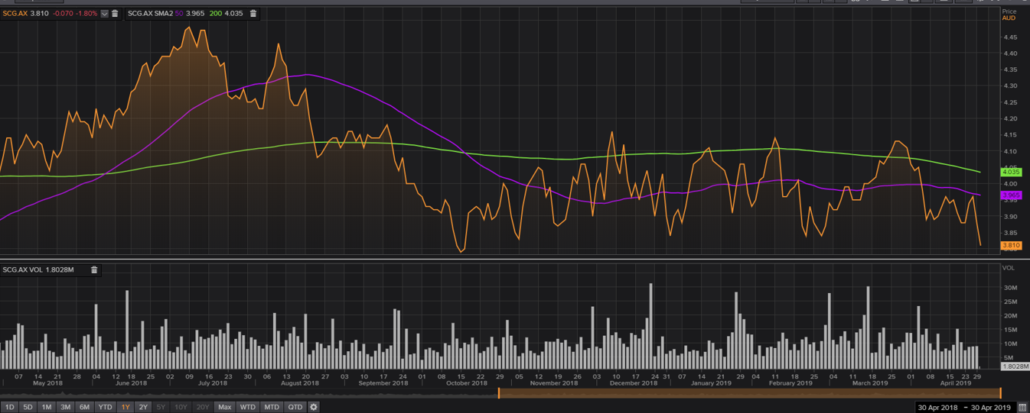

SUN
Suncorp Group is a provider of general insurance, baking, superannuation and life insurance services to nth retail and business clients in Australia.

Fundamental analysis
 | loss ratio | investment ratio | return on asset (ROA) | return on equity (ROE) | Debt/equity
2014 | 67.80% | 40.20% | 1.20% | 8.50% | 1.14
2015 | 71.00% | 33.70% | 1.70% | 12.20% | 1.24
2016 | 71.30% | 29.50% | 1.60% | 11.10% | 1.29
2017 | - | 23.60% | 1.70% | 11.80% | 1.27
2018 | - | 28.80% | 1.60% | 11.40% | 1.38

With missing data, we can expect SUN’s loss ratio to have moderate increase over the past two years (based on the data from 2014-2017). However, its investment ratio has significantly dropped. Altogether, these two ratios indicate that SUN may have significantly lower profitability in the future. Over the past 5 years, SUN’s debt level has increased. Its stable ROA and ROE imply the company still has sufficient ability to generate sufficient earnings for shareholders, yet given the loss ratio and investment ratio, this ROA and ROE might be unsustainable.

Overall, we have a negative view towards SUN.

The potential interest rate cut by RBA in the future would have positive impacts by increasing the demand for financial market (as people seeking higher return than bank deposits), thus push up SUN’s share price (Li et al. 2007).

Technical analysis
Using the one-year data, we can that currently the 50-day moving average is below the 200-day moving average, yet the difference is shrinking in the past few trading days. The volume is around the average level, and there is currently no major trend reversal. Therefore, the price chart indicates SUN’s price will stay around the current level in the near future.

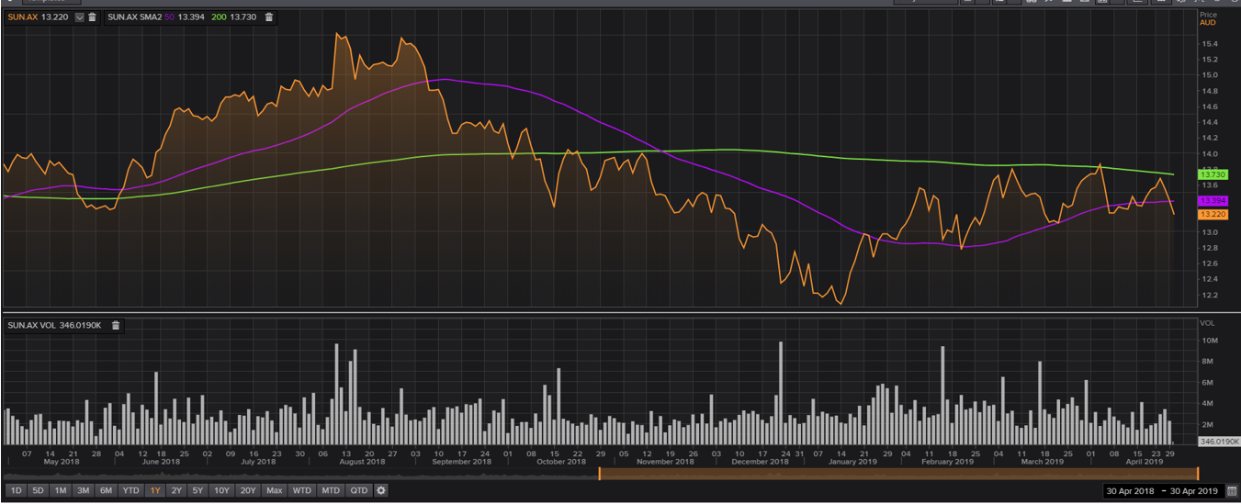

TLS
Telstra is a major Australian telecommunication service provider. Its main business includes telecommunication infrastructure construction, mobile and NBN services.

Fundamental analysis
 | Net margin | asset turnover | ROA | current ratio | debt/equity
2014 | 18.00% | 0.65 | 16.00% | 1.2 | 1.14
2015 | 16.10% | 0.64 | 14.70% | 0.86 | 1.11
2016 | 14.80% | 0.62 | 13.40% | 1.02 | 1.09
2017 | 14.90% | 0.61 | 13.20% | 0.89 | 1.22
2018 | 13.60% | 0.61 | 12.00% | 0.83 | 1.16

During the past five years, we see a decrease in Telstra’s net margin and lowered asset turnover, as well as reducing ROA. These ratios indicate Telstra’s weakening ability in making profits and reducing operational efficiency. Moreover, the current ratio of the company has now been below 1, meaning that the company may have difficulties in meeting urgent cash needs. On the other hand, the leverage of the company, as demonstrated by the debt to equity ratio, has remained stable.

Overall, Telstra is determined to have a negative outlook, especially among the current global turbulence regarding the 5G (SBS News 2019).

Technical analysis
From the chart, we can see that the 50-day moving average has crossed above the 200-day moving average; the trend is upward, and the volume is at average level. These indicators sign strong buy opportunity. However, we will remain caution about Telstra, given our fundamental analysis.

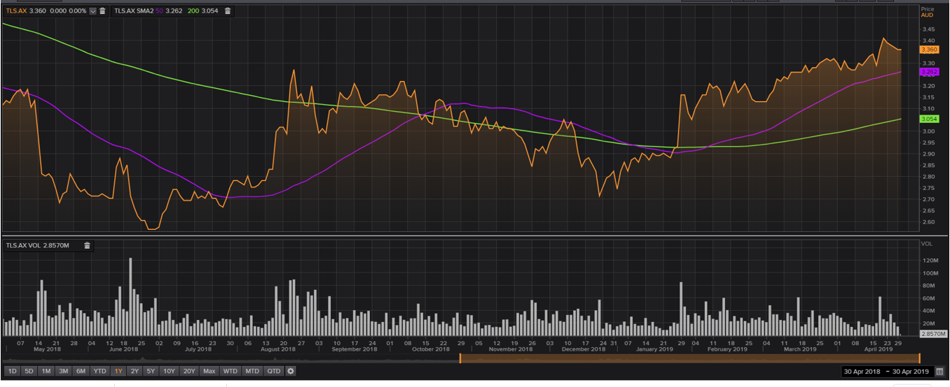

SUMMARY AND COMPARISON OF THE PORTFOLIOS

Conclusion/Summary/Decision

The weight allocated to each stock is presented in the table below

Stock | Weighting
ANZ.AX | 15%
CBA.AX | 15%
IAG.AX | 5%
MQG.AX | 10%
NAB.AX | 15%
SCG.AX | 7.5%
SUN.AX | 10%
TLS.AX | 7.5%
WBC.AX | 15%
Total | 100%

As can been seen, we invest 60% of our funds into Big 4 bank stocks, with each Big 4 bank takes up 15%. This is consistent with our “value” portfolio strategy. Furthermore, we also invest heavily in other financial service providers including MQG, SUN and IAG. Given our anticipation of a future interest rate cut by RBA, we would like to speculate on this anticipation. Besides, we invest relatively lightly in stocks in other industries (SCG and TLS) to have a certain level of diversification.

Reference list

Janda, M. 2019. Chinese economic revival may not be as good as you'd expect for Australia. ABC News. Viewed May 1, 2019, from https://www.abc.net.au/news/2019-04-23/chinese-economic-revival-may-see-stimulus-wound-back/11037872

Li, D., Moshirian, F., Nguyen, P. and Wee, T., 2007. The demand for life insurance in OECD countries. Journal of Risk and Insurance, 74(3), pp.637-652.

RBA. 2019. Statement by Philip Lowe, Governor: Monetary Policy Decision. Viewed May 1, 2019, from https://www.rba.gov.au/media-releases/2019/mr-19-07.html

SBS News 2018. RBA strikes dovish tone in Dec minutes. SBS News. Viewed April 26, 2019, from https://www.sbs.com.au/news/rba-strikes-dovish-tone-in-dec-minutes

SBS News 2019. Telstra cuts payout as NBN drags on profit. SBS News. Viewed April 28, 2019, from https://www.sbs.com.au/news/rba-strikes-dovish-tone-in-dec-minutes

Thomas Reuters Eikon 2019. From https://apac1.apps.cp.thomsonreuters.com/web/Apps/Homepage

