Apparel sector
Nike
https://about.nike.com
https://www.ukessays.com/dissertation/examples/business/competitive-challenge-nike.php
https://www.managementstudyguide.com/swot-analysis-of-nike.htm

use theory like: Porter’s five forces analysis, PSSTEL model (Part 2) etc.
useful sources: peer-reviewed journals

Introduction: (300 words)

Background
Give a brief introduction to Nike (the company's main business, business scope, and revenue in recent years). Check out the company's website.

Body:
- Competitive advantages: (300 words)
Resource-based view (VRIO framework)
- Low-cost (outsourcing)
- High-quality products (Differentiation, diversity)
- Brand (Brand value, customer loyalty)
- Distribution channels (advantage)

- Host country analysis (600 words)
current political situation (opportunities and challenges)
- Demand has increased as the population has risen, Two-child policy
- political stability
- encourage foreign capital investment and import trade e.g. China import international expo （competition encouragement）
- Us-china trade war
- The rise of local sports brands （Anta, Xtep）
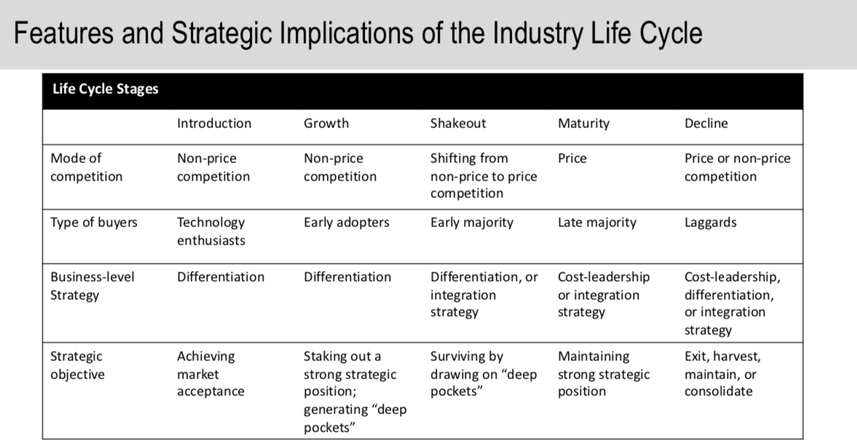

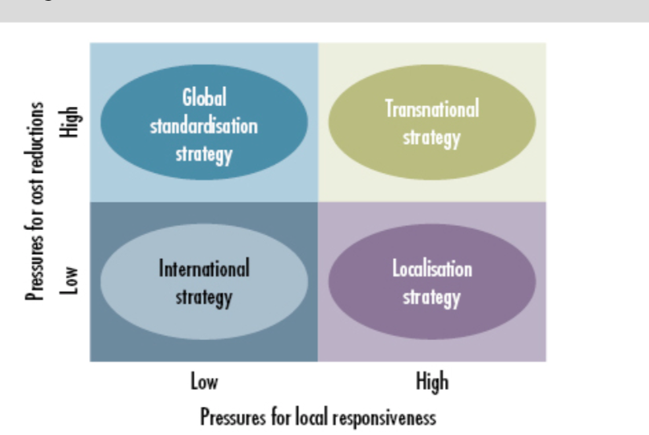
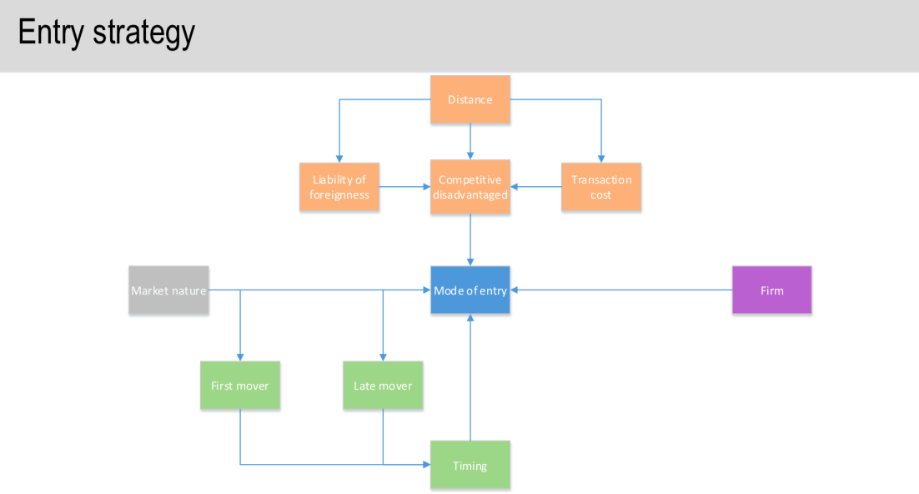
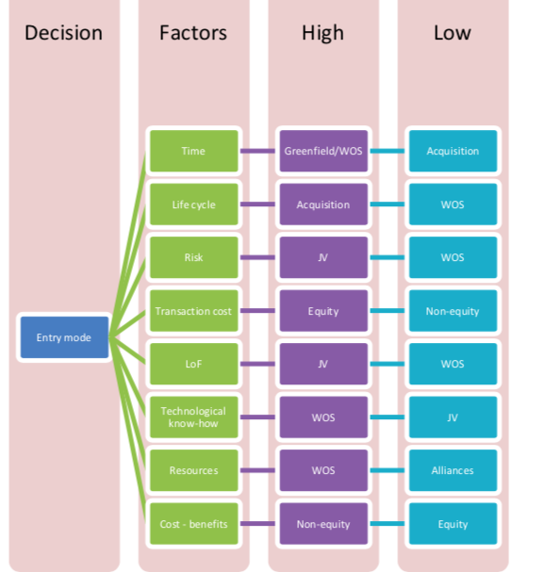
- MNE’s strategy in China (1100 words)
Entry mode choices ---- Analysis of the sportswear market, the approach and strategy that Nike choose to enter the market)
How to enter the Chinese market (2008 Olympics, advertising to enter the Chinese market)
The biggest competitor: Adidas

Nike's business model in China is completely copied from other production centers, including internal management resources and external distribution channels.

Evaluate the benefits and pitfalls

Additional actions

Conclusion:
Summarize Nike's operation in China market.

Reference
UKEssays. November 2018. Nike’s Competitive Advantages: Strategies in China. [online]. Available from: https://www.ukessays.com/dissertation/examples/business/competitive-challenge-nike.php?vref=1 [Accessed 7 October 2019].

Cavaleri, S. & Shabana, K., 2018. Rethinking sustainability strategies. Journal of Strategy and Management, 11(1), pp.2–17.

