Submission: This assignment needs to be submitted electronically via Grade Centre (on the AYB 219 Blackboard site).

Only one submission is required from each group (consisting of Parts A and B).

Each group is required to make three (3) separate pdf submissions for this assignment:

- the cover sheets (ie. the Group Contribution Sheet and Group Integrity Declaration) combined into one scanned pdf file. These documents can be found on pages 41 and 42 respectively of this assignment.

- Part A (Christopher’s 2017 tax return) should be printed from HandiTax to pdf; and

- Part B (the technical reflection of the two tax issues) should be prepared in Microsoft Word but saved as a pdf document.

Group or Individual: Group

This assessment item assesses the following learning outcomes:

Knowledge and Technological Skills (KS)
1.2 Apply technical and technological skills appropriate and effective for real world business purposes and contexts.

Teamwork and Self (TS)
4.2 Apply teamwork knowledge and skills for effective collaboration across diverse purposes and contexts.

ASSESSMENT OVERVIEW

Part | Description | Pages
A | Prepare Christopher Cross’ 2017 income tax return using Sage Handisoft’s HandiTax software package in a group of 3 or 4 students from the same tutorial class (15 marks) | 4 – 13
B | Group Technical Reflection (5 marks) | 14 – 15
C | Professional Approach | 16
D | Academic Conduct | 16
E | Submission Requirements | 17 – 18
 | Details of Christopher Cross for the year ended 30 June 2017 | 19 – 40
 | Various Administrative Documents | 41 – 44

Notes:

- It is each student's responsibility to form into appropriate groups for this assignment and the groups must be formed and a Group Formation sheet submitted to the student’s tutor by Tuesday 24 April 2018.

- It is each student’s responsibility to research the issues contained in this assignment. QUT staff members will not be answering any questions or issues relating to this assignment.

- However, if clarification of a particular point is required, please send an e-mail directly to the Unit Co-ordinator, Stephen Marsden, and not to your tutor.

- Students are required to periodically check their QUT emails and the “Announcements” section of the AYB 219 Blackboard site for updates and any clarifications that may be required for the HandiTax Project.

Assessment Submission and Extensions

In both your QUT study and your professional life you will be expected to meet deadlines. In keeping with this expectation, assessment submitted after the due date will not be marked and will receive a grade of 1 (ie. 0%).

Students cannot apply for extensions for this assessment under the QUT Assignment Extension process as it is a group assignment and students have had a number of weeks to complete the task.

If a member of the group falls sick or is incapacitated that student can apply for special consideration but this should not impact on the ability of the rest of the group to complete the project by the due date. This rule will apply even if one member of the group provides a medical certificate.

Furthermore, extensions will not be granted because the group has had communication problems with one (or more) members or has not been able to contact certain group members. Students are expected to be able to sort out group issues or problems themselves and not seek an extension from the unit co-ordinator.

For this reason, it is strongly recommended that students start working on the HandiTax project when it is released via the AYB 219 Blackboard site.

Once the assignment has been submitted via Grade Centre, students are not able to resubmit any other versions or attach any supplementary documents. In other words, once submitted, this group submission is final. Furthermore, the group is not able to resubmit another version as we do not allow multiple submissions of the assignment.

It is the sole responsibility of each group to ensure that the complete (and final version) of the assignment is submitted by the due date. Students are not permitted to resubmit or send us supplementary pages or replacements pages once the assignment is submitted. No submissions will be accepted by any academic staff member by any means (hard copies or e-mails) at any time.

In other words, each group only gets one (and only one) opportunity of submitting their assignment (comprising Parts A and B) via Grade Centre.

Markers will only be marking the first (and only) submission that was submitted by the group via Grade Centre. Hence, there is no point uploading a second or third submission, as it will be ignored and not marked.

For this reason, students should make sure that the version being submitted via Grade Centre is the final version that the group has agreed that should be submitted.

ASSESSMENT REQUIREMENTS FOR EACH PART

PART A: Prepare Christopher Cross’ 2017 income tax return using Sage Handisoft’s HandiTax software package in a group of 3 or 4 students from the same tutorial (15 marks)

The group is required to complete (but not lodge) Christopher Cross’ 2017 income tax return using Sage Handisoft’s HandiTax.

HandiTax has been loaded on all QUT computers in the computer labs in both B and Z Blocks. Students should be able to access the program when they login. Students should search for the program in the HandiTax program search function in the bottom left corner of the Windows tab.

Alternatively, for those students who wish to use HandiTax from home, there is a link that Sage Handisoft has provided QUT that allows students to download the program on their home computer if they wish to access the software off campus.

However, in downloading this software you agree as a student of QUT to only use this software for educational purposes and not for commercial purposes.

Please note that the software is only compatible with Windows, not Mac.

Instructions are below:

1. Download the software from the following link and save the file to your computer:
https://sageau.exavault.com/share/view/igq1-6sfapgol.

The following screen should appear.

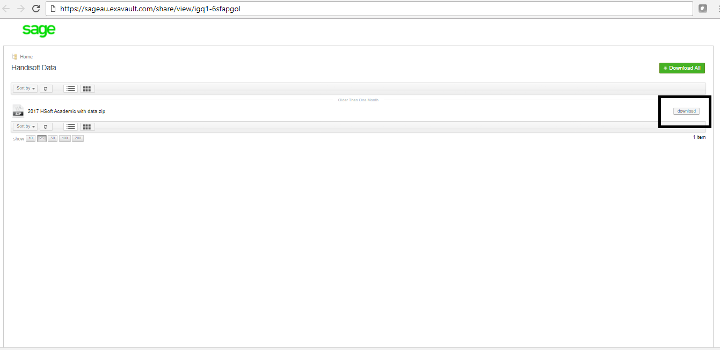

Click the download button as indicated above.

Please note that the file is over 300mb in size, so the downloading process may take some time, particularly if you have a slow internet connection. Hence, be patient.

2. Save the compressed zip files to your chosen destination (eg. F drive). Extract all files to your chosen location. Depending on the speed of your internet connection, this downloading process may take several minutes.

3. You will then need to extract all files to your chosen location. You must extract the files before opening them. Please note that it is not possible to extract files form a compressed zip location.

4. After unzipping the files, go into the "Apps" folder and double click on the Ht17.exe file to open the software (see screen extract below). There is no need to open other HandiSoft applications for the purposes of this assignment

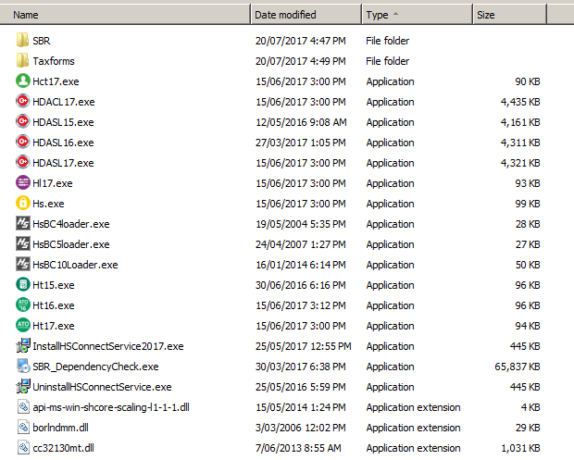

- By clicking on this link, the program should automatically open up.

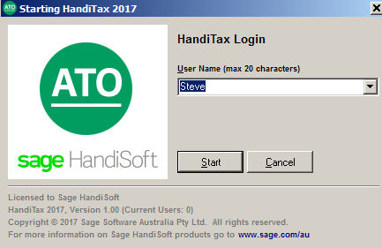

- Sample client files have been provided within HandiTax. However, these are not related to the AYB 219 assignment, and as such, should be ignored. You will need to start a new client by clicking on the "new" tab three-quarters of the way down the screen.

- If you have any problems with downloading the program, please ring or log a job with the IT Help Desk at QUT on (07) 3138 4000.

- Saving your HandiTax file to a USB Flash Stick. Should students want to work on the client data between multiple computers or places, it is very easy to save the file to a USB stick (or another nominated location).

Firstly, students need to tag the client. This is done by clicking on the "tag" box three-quarters of the way down the screen. Once tagged, the name of the client is shown with an asterisk * next to it.

Next click "Tools" from the drop down menu and select "copy tagged clients to disk/e-mail". HandiTax will then ask you for the directory/path to save the file to.

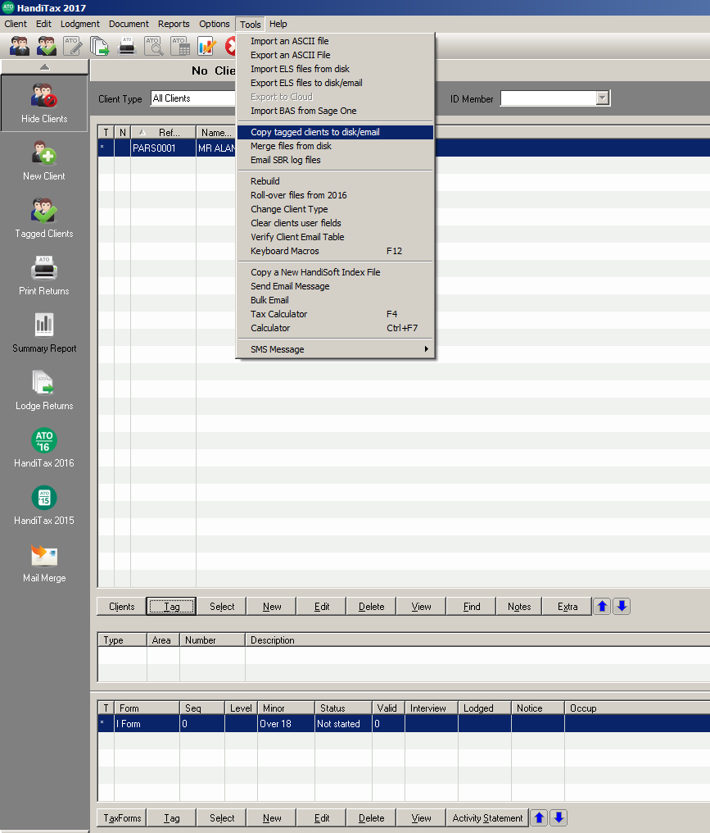

- To upload the saved HandiTax data file from your USB flash stick at the new computer, open HandiTax and click "Tools" from the drop down menu.

Select "merge files from disk". HandiTax will then ask you for the directory/path to upload the file from to the destination computer.

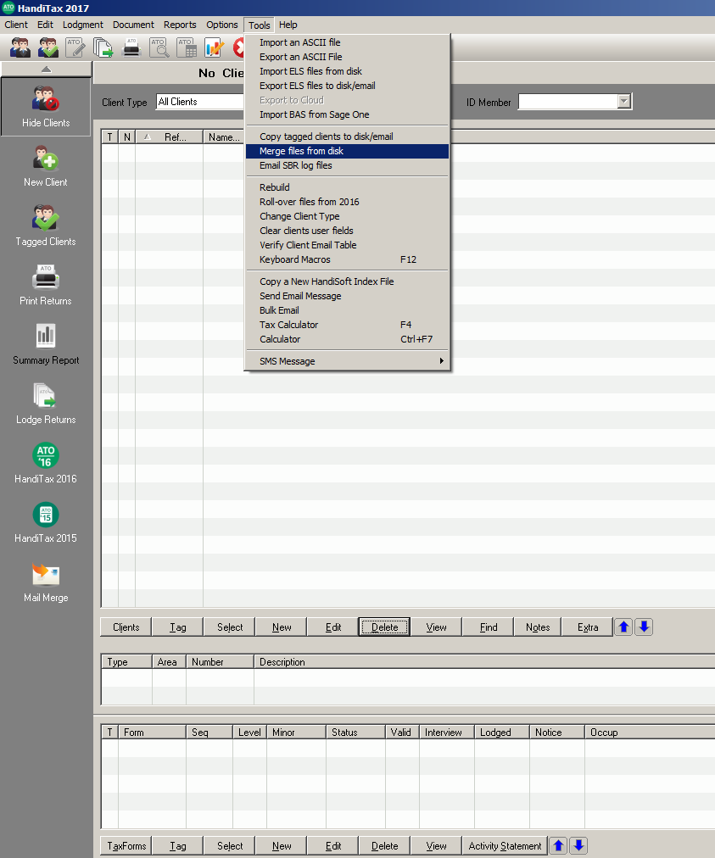

STUDENTS MUST USE HANDITAX

TO COMPLETE THE ASSIGMMENT

Students are not permitted to use any other electronic tax lodgment software packages (eg. MyTax, Solution 6, MYOB Accountants Office, Tax Assistant etc).

Failure to use HandiTax to complete Christopher’s return will automatically result in the group receiving an overall mark of zero out of 15 for Part A.

Instructions on Printing the Final Tax Return in HandiTax

In printing the completed tax return to pdf, please click “edit” from the pull down menu at the top of the screen and click the last option entitled “view return with worksheets”.

This will not only provide you with a print preview of the tax return itself, but also the accompanying worksheets, schedules and the tax estimate (see screen dump on the following page).

It is essential that you print "view return with worksheets” as this version of the tax return not only includes Christopher's tax return but also schedules and worksheets, which we mark as part of the marking scheme.

If you click "view return for lodgement", this option in HandiTax does not print the accompanying schedules and worksheets. Hence, when marking, if you do not include the worksheets, we will not be able to award several marks.

Please ensure that you print this document to pdf, ready to upload via Grade Centre by the due date.

Only one tax return is required to be lodged by the group.

Please ensure you print "View Return with Worksheets
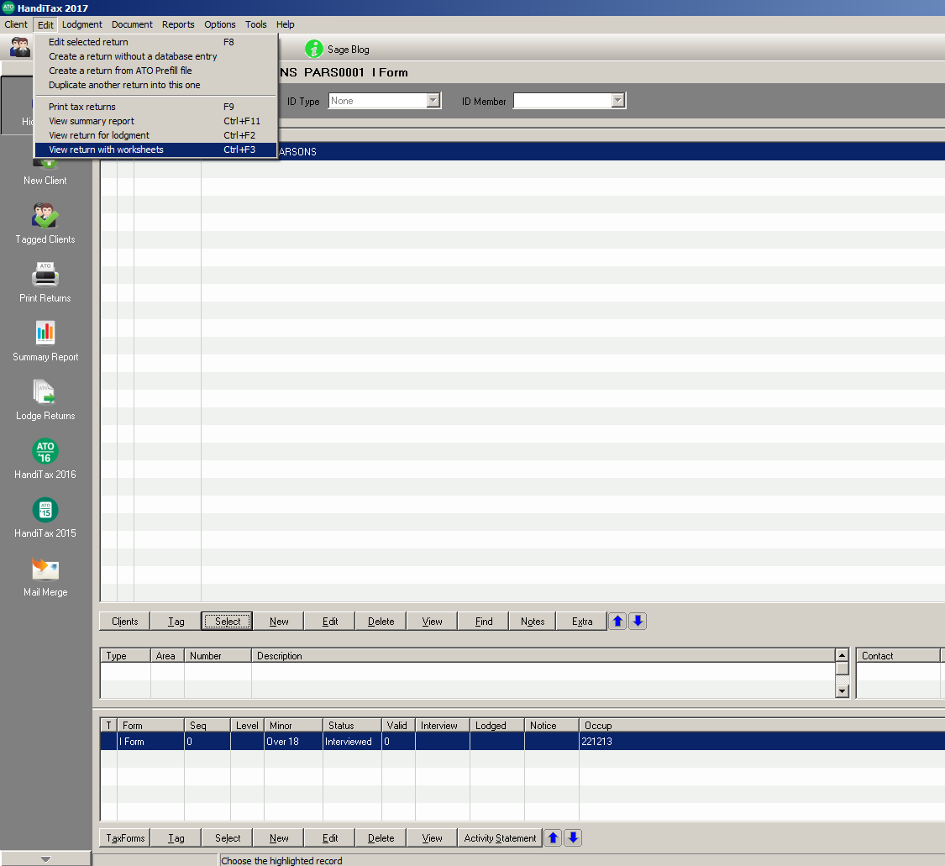
Points to Note on How Part A is Marked:

- Part A (being the tax return itself) is worth a total of 15 marks. A total of 15 numbers will be marked in Christopher’s income tax return. Either the answer is correct (1 mark) or incorrect (0 marks). In one or two instances where the label comprises several figures (eg. work-related expenses), half-marks may be awarded were students only make one mistake in their calculation.

- Furthermore, please note that in respect of Part A, students will be marked not just on the correct amounts entered into HandiTax, but whether the amounts have been entered at the correct locations (ie. item numbers and item labels) in Christopher’s income tax return. For example, all work related deductions should be entered at Label D5 (Work Related Deductions) and for the group to get the single mark, then the correct final amount must also be entered at this label.

- If the amount entered is wrong, no marks will be awarded. Furthermore, if the correct amount is entered at the wrong label in the tax return, no marks will be awarded.

- Whilst we mark the overall net capital gain numbers contained in Label 18 of the tax return, if these numbers are wrong, then we will look at the CGT worksheet to award you part marks.

- If you do not attach the CGT worksheet, then we will not be able to give you part marks. Students will not be able to submit the CGT worksheet after the due date.

TIPS ON USING HANDITAX

- Students are expected to learn how to use the software package, HandiTax themselves. However, Wayne Marriage (a former sessional staff member in this unit) has recorded a 15 minute instructional video on YouTube explaining to students completing the assignment how HandiTax works. Specifically the video covers such matter as to how a client is set up in HandiTax, how to enter data into HandiTax, how to identify errors and how to save and print the tax return. This instructional video can be viewed at:
https://www.youtube.com/watch?v=Q6AUMcHi4NY&feature=youtu.be.

- Furthermore, we have placed the 2017 HandiTax user manual on the AYB 219 Blackboard site for students to refer to for assistance in completing the tax return. This 205-page manual is available for students to download in pdf format.

- HandiTax also has a useful “help” feature within the program itself. At each item in the tax return, more information about what should be (and what should not be included) at each item can be found by pressing the function key “F1').

- HandiTax has a useful “Errors” button at the bottom of the screen. Students are advised to regularly click this button as it will reveal any errors with the tax return. The end goal is to ensure that that there are no error messages and that the tax return is ready to lodge.

- In clicking the “Errors” button, HandiTax does provide you with “Warnings”. However, these warnings are not serious (as they do not constitute errors). Instead, warnings are designed to provide alerts to the preparer to double check calculations. In effect, they are “tips” to the preparer to look out for things in the tax return. Generally speaking, if the data has been entered correctly, then these warnings can be ignored.

- If you get a "SBR" warning (such as the one shown below), please ignore this, as this refers to data encrypted in HandiTax to ensure that the data is SBR-compatible with the ATO.

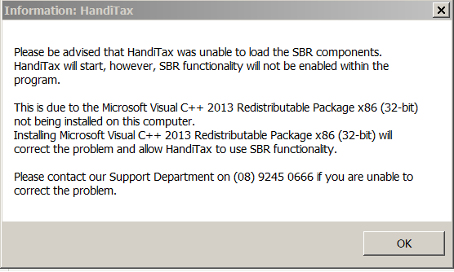

TIPS ON USING HANDITAX (Continued)

- Please ignore the electronic funds transfer (EFT) on the front cover the tax return.

- At the very end of the tax return itself, please put a member of the group's name as the tax agent and a phone number. Please put "Tax Agent" in the box entitled "Position".

- HandiTax automatically assigns a client reference number.

- Being a student (demonstration) version, HandiTax will automatically insert a tax agent number of: 0000000.

- An error message with a code of V1211 may come up saying that the "production return cannot have a test Tax Agent number" (as shown below):

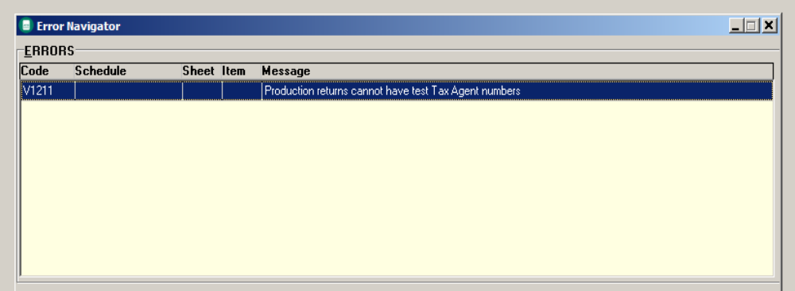

- If so, it is safe to disregard this error message.

- Furthermore, the following warning message may appear which states that the "Income for surcharge purposes is used to determine if the taxpayer is liable for the Medicare Levy Surcharge. Where applicable, complete Deductible personal superannuation contributions (Label H) from the Supplementary section." (as show below).

- If you see this warning, once again, please disregard it.

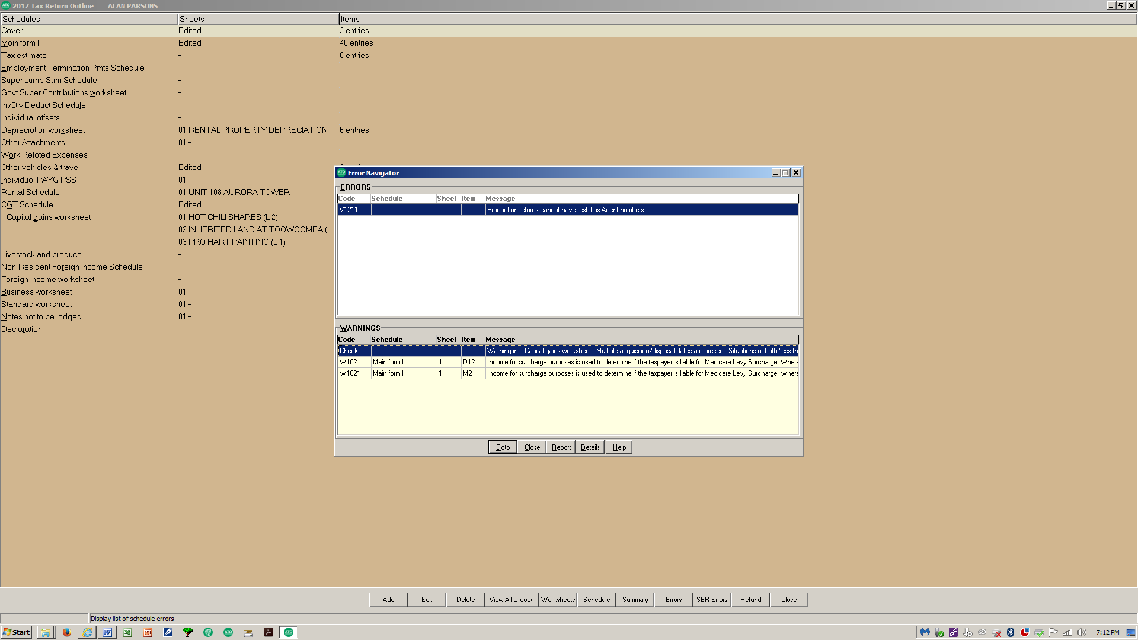
PART B: Group Technical Reflection (5 marks) (1,000 Words Maximum)

Only one technical reflection is required to be lodged by the group.

Part B requires each group to provide a written group reflection on how the group researched the following two (2) specific tax issues contained in Part A of this project, namely:

(i) Item 11 – page 31, being the payment of the business class economy return airfare totalling $8,140 to British Airways in relation to the International legal conference held by the International Law Society. You are to advise Christopher exactly how much is tax-deductible in relation to the return airfares.

(2.5 marks)

(ii) Item 14(b) – page 33, being the costs of $1,744 incurred by Christopher in paying for breakfast for himself and clients where he meets with clients to discuss a range of legal issues and to gather information and evidence about pending legal cases he is working on.

(2.5 marks)

Notes:

For each item above, students are required to outline:

- what section references, cases, rulings, determinations etc. were used as authority by the group to research the two abovementioned tax issues; and
- the conclusion (ie. claim the deduction or not claim the deduction for these two items).

Please do not quote the 2018 CCH Australian Master Tax Guide at all in your answer as this is not a source of taxation law. No marks will be awarded if the Master Tax Guide is referenced in your answer.

Furthermore, please do not simply quote websites or provide hyperlinks to websites (including the ATO website) in your answer. This includes ATO fact sheets and publications as these are not considered a source of taxation law (as outlined in Lecture 1).

Students are required to professionally quote relevant sections, cases, taxation rulings, taxation determinations, ATO interpretative decisions etc. The simple inclusion of hyperlinks to web page references (as outlined above) will not be sufficient.

Note: The group is only required to provide one written technical reflection.

We do not want reflections from each individual student. Instead, it is a requirement that at the end of completing Part A the group gets together to reflect upon their experience and write the written reflection.

This task is not to be allocated to one group member to complete.

The maximum number of words is 1,000. You must use 11 point Arial font with 1.5 line spacing. Make sure your reflection is clearly labelled.

Please use Microsoft Word to write this summary and please limit your submission to no more than two pages.

Please use each of the two issues as two headings in your reflection. contained above.

Students are encouraged to use bullet points and be concise and succinct in their answers to each of the abovementioned issues.

There is no need to include a list of references at the end of your Part B reflection. Instead, include references to sections, tax cases, tax rulings, tax determinations, etc. throughout your Part B reflection, similar to how referencing is used in the lecture notes.

There is no need to apply the ILAC model. Any format will do, as long as you answer the two questions outlined above.

Please ensure that you upload Part B to Grade Centre by the due date.

PART C: Professional Approach

This assessment expects a professional approach to presentation similar to that expected when preparing and delivering a tax return to a client.

A professional approach also means that it is the responsibility of each student to ensure that the complete assignment is submitted by the due date and complies with the requirements in submitting the assignment in the correct order.

---------------------------------------------------------------------------------------------------------------------

PART D: Academic Conduct in Completing this Asessment

Academic conduct is expected to be ethical and above reproach in producing this assessment in the same way you would be expected to produce a client’s tax return as their registered tax agent or tax advisor.

Students who are found to have committed academic misconduct as detailed below will be immediately referred to the QUT Business School academic misconduct committee. Please note that penalties will be applied not only to the student(s) who have used this information but also to the student(s) who have shared this information.

This integrity must be applied to all sections of the assignment including the task and reflection.

To this end, each student is required to sign a group integrity declaration (page 42) confirming that they have not used or plagiarised the work of others.

More information on plagiarism and QUT’s range of penalties that can be imposed can be found at: http://pilot.library.qut.edu.au/module6/6_5/index.jsp.

PART E: Submission Instructions

The HandiTax group project (consisting of Parts A and B) should be submitted (uploaded) via Grade Centre no later than 9:00 am on Tuesday 22 May 2018.

As previously mentioned on the first page of this assignment, there are three (3) separate pdf submissions required for this assignment:

- The cover sheets (ie. the Group Contribution Sheet and Group Integrity Declaration) combined into one scanned pdf file. These documents can be found on pages 41 and 42 respectively of this assignment;

- Part A (Christopher’s 2017 income tax return) should be printed from HandiTax to pdf; and

- Part B (the technical reflection of the two tax issues) should be prepared in Microsoft Word but saved as a pdf document.

Failure to submit any of the above documents will result in an automatic mark of zero out of twenty for the whole assignment.

For the two cover sheets listed in (a) above, students are required to print off these two pages, then complete and sign (as detailed below) and then scan into one pdf file and then upload into Grade Centre.

(i) Group Contribution Sheet (on page 41)

Please complete this form, including:

- the name of your tutor and tutorial time;
- the student numbers and names of each student in your group;
- a contribution percentage for each group member (this contribution must be agreed to and signed off by each member of the group and must add up to 100%);
- each student in the group must personally sign their contribution percentage.

It would be hoped, and expected, that an equal contribution would be the norm.

For example, if there are 4 members in the group and everybody has made an equal contribution, 25% will be entered beside each person’s name.

In this case, if the group gets a mark of 15 out of 20 for the project, then each person in the group will receive this mark of 15. However, if each person has not made an equal contribution, then differing percentages that reflect each person’s contribution should be entered.

For example, if there were four people in the group, and it was agreed that two students contributed 30% each whilst the remaining two students contributed 20% each and the group was given a mark of 15 out of 20, the 30% students would receive a mark of 15 out of 20 and the 20% students would get a mark of 10 out of 20 (being two-thirds of the marks awarded to the two students who contributed the 30% as they have done less work compared to others).

If you do not submit this signed group contribution sheet – each member of the group will incur a (10) mark penalty.

(ii) Group Integrity Declaration (on page 42)

This declaration needs to be read and signed by each member of the group.

This is a declaration stating that work submitted by each member of the group (including the group as a whole) is their own original work and that each member of the group has not copied or plagiarised any of the content in their HandiTax project from other people (including current or past students) nor have they provided their work to other groups.

Please make sure you carefully read this declaration as this declaration applies to all parts of this assessment task.

If you sign this declaration and are subsequently caught using or reproducing the work of other students, then serious penalties will be applied.

If any member of the group does not sign and/or submit the group integrity declaration, your assignment will not be marked and will be automatically awarded a mark of zero out of 20.

Furthermore, it is not acceptable for any member of the group to sign on behalf of another group member. This is akin to forgery.

This constitutes academic misconduct and each member of the group will automatically awarded an overall mark of zero. The case will also be referred to the QUT major academic misconduct committee.

In the past where this has happened, the committee has required all students to front the committee and resulted in the withholding of student grades until the matter was resolved.

HANDITAX GROUP PROJECT (20%)
CHRISTOPHER CROSS’S DETAILS

FACTS: Christopher Cross is an Australian resident. He works full-time as a senior solicitor for McMahon & Tate, a firm of legal practitioners in Brisbane city.

Christopher lives in a three-bedroom house in Indooroopilly with his wife of eighteen years, Jessica, and their two children, Isaac, aged thirteen and Sophie, aged nine. Christopher and Jessica purchased the Indooroopilly property in joint names in January 2011 and regard it as their main residence.

Christopher has various investments, including shares in listed Australian companies and a rental property which was bought during the current income year.

Last year, Christopher utilised the services of a local tax agent in Toowong. However, he was dissatisfied with their service and has approached your group to assist him in preparing his 2017 income tax return using Sage Handisoft’s HandiTax software program.

Christopher has supplied your group with the following information relating to his personal income tax affairs for the year ended 30 June 2017.

However, not being a tax expert, he is not certain whether everything he has supplied your group with is necessarily assessable or deductible. Accordingly, he asks your group to carefully go through each item in order to determine its assessability and deductibility.

Needless to say, Christopher wishes to minimise his 2017 taxable income wherever legally possible.

PERSONAL INFORMATION

Full Name: Mr Christopher Anthony Cross

Date of Birth: 11 July 1977

Occupation: Solicitor

Tax File Number: 212 237 802

Daytime Telephone Number: (07) 3878 4109

Mobile Telephone Number: (0418) 322 775

E-mail address: christopher.cross@mchmahontate.com.au

Home Address: 47 Landsdown Drive
Indooroopilly, QLD, 4068.

Postal Address: as above

Child Support Payments: Christopher did not make any child support payments during the 2017 income year as he is still with his wife, Jessica, and both dependant children (Isaac and Sophie) are still residing with both parents in the family home in Indooroopilly.

-----------------------------------------------------------------------------------------------------------------------------

Information relating to Christopher's wife, Jessica, is shown below:

Full Name: Mrs Jessica Louise Cross

Date of Birth: 17 March 1979

Period: Jessica was Christopher's dependent spouse for the entire 2017 income year.

Spouse’s TFN: Not required

DETAILS RELATING TO INCOME

1. Gross Salary and Wages

During the entire 2017 income year, Christopher worked for McMahon & Tate.

Christopher was provided with his annual PAYG Payment Summary from his employer in relation to the period 1 July 2016 to 30 June 2017. His 2017 PAYG Payment Summary revealed the following:

Name of Payer: McMahon & Tate
ABN of Withholder: 69 086 651 014
Gross Salary: $148,000
PAYG Tax Withheld: $42,862
Reportable Fringe Benefits Amount: $9,780
Reportable Employer Superannuation
Contributions: $11,400

The reportable fringe benefit amount of $9,780 shown on Christopher’s 2017 PAYG Payment Summary related to a salary-sacrifice arrangement that the firm has in place with all of their senior solicitors. Christopher arranged for McMahon & Tate to pay several personal expenses on his behalf. These expenses were all subject to fringe benefits tax.

- Car Travel Reimbursement

As part of his job, Christopher is frequently required to use his own motor vehicle to visit clients and to make regular court appearances. In addition to his gross salary shown at Item 1 above, during the 2017 income year Christopher was reimbursed for 5,457 work kilometres that he had travelled during the 2017 income year.

McMahon & Tate reimbursed Christopher 70 cents per kilometre travelled. Hence, Christopher received reimbursements totalling $3,820 during the 2017 income year. PAYG withholding tax of $1,170 was deducted from this amount. Both of these amounts were shown separately on Christopher’s 2017 PAYG Payment Summary.

If your group decides to enter these amounts into HandiTax, please enter them at Item 2 and not Item 1 of the tax return.

3. Interest Income

Christopher maintains accounts at two different Australian banks. Christopher has provided the following information in relation to interest he has earned during the 2017 income year:

$

- Westpac online savings account (total gross interest received) 311.26
- NAB access account (net of 49% TFN withholding tax - see below) 79.56
- NAB term deposit (year-end interest accrued - see below) 348.48

Christopher opened his NAB access account on 17 August 2016. When opening the bank account, Christopher did not have his tax file number (TFN) with him. He subsequently forgot to provide the bank with his tax file number.

Accordingly, the bank has deducted 49% (or $76.44) in TFN withholding tax in respect of interest paid on this account during the 2017 income year. The net remaining amount of $79.56 (representing 51% of the gross interest received) was credited to his NAB access account.

Furthermore, on 17 March 2017, Christopher invested $40,000 into a six month term deposit earning 3.00% interest with NAB with interest to be credited on maturity. Interest of $600 is expected to be credited to his bank account upon maturity on 16 September 2017. Christopher has calculated that interest of $348.48 has accrued as owing to him as at 30 June 2017 in respect of this term deposit.

When entering the above information into HandiTax, please leave the “Branch” and “Account Number” boxes blank. The above interest has been derived from personal investments, and not in relation to any business activity undertaken.

4. Dividends Received

Christopher owns shares in several Australian listed public companies (tax rate 30%).

During the 2017 income year, Christopher received the following dividends:

Name of Company | Unfranked | Franked | Franking Percentage attached to Franked Dividends
- AMP  2. Cabcharge  3. CSR  4. Flight Centre  5. Iluka Resources (see below)  6. Oz Minerals (see below)  7. Seven West Media  8. Telstra | $180  $62  -  -  $110 (a)  no cash (b)  $140  - | $340  $158  $1,075  $920  -  -  $430  $720 | 100%  75%  100%  100%  -  -  80%  100%

(a) Iluka Resources Limited Dividend:

Christopher owns 5,000 shares in Iluka Resources Limited. In March 2017, the company announced an unfranked dividend of 4.32 cents per share. Therefore, Christopher was entitled to an un-franked dividend of $216.00.

However, Christopher once again forgot to quote his tax file number (TFN) to the share registry and the share registry consequently deducted 49% (or $105.84) TFN withholding tax in respect of this dividend and paid just the net amount of $110.16.

This amount was paid into Christopher’s bank account on 10 April 2017.

(b) Oz Minerals Limited Dividend:

Christopher owns 1,000 shares in Oz Minerals Ltd. In May 2017, the company announced and unfranked dividend of 44 cents per share which entitled Christopher to a dividend of $440 (unfranked). However, instead of receiving the cash dividend, Christopher elected to apply this amount under the company’s dividend reinvestment scheme so that he received an additional 44 shares in the company.

On the date of the dividend was declared, the share price of the company was $10.00 per share. Hence, instead of taking the $440 cash dividend (which would have been unfranked), Christopher elected to receive an additional 44 shares in the company.

5. US Dividend Received

Christopher owns 1,000 shares in the US fast food company, McDonalds. On 12 April 2017, he received a dividend cheque of US$680 from the company’s share registry.

According to the dividend statement that accompanied the cheque, foreign withholding tax equivalent to 15% of the gross dividend (being US$120) had been deducted from the gross dividend of US$800 which was payable.

The foreign exchange rate on the date the dividend was received was $A1.00 = $US0.74. There were no franking credits in respect of these foreign dividends.

Christopher advises you that he does not have more than $A50,000 invested in foreign assets.

Important Tip Relating to Entering Foreign Dividends into HandiTax

HandiTax has a “Foreign Income” worksheet. This worksheet asks the preparer to enter details relating to foreign income. However, students are advised NOT to use this worksheet and instead, enter the foreign dividends outlined above directly into the relevant label in HandiTax.

6. Rental Property – Unit 108, Quay West, 132 Alice Street, Brisbane

On 2 October 2016, Christopher purchased a one-bedroom unit in Quay West, located at 132 Alice Street, Brisbane, QLD, 4000, at a cost of $620,000 in his own name. Stamp duty and legal fees relating to this acquisition totaled $17,110 and were also paid on the same date.

To finance the purchase of his unit, Christopher borrowed $500,000 from Westpac on 2 October 2016. The term of the loan is 25 years. He incurred loan establishment fees totalling $1,724 in relation to the loan on this date.

Interest on the Westpac loan for the period 2 October 2016 to 30 June 2017 totalled $16,808. On 25 June 2017, Christopher received a letter from Westpac offering him the option of prepaying an additional two months interest on the loan (for the months of July and August 2017).

As Christopher had surplus cash available, he accepts the Bank’s offer. He then pays the additional two months interest totalling $3,218 to the bank on 29 June 2017.

As part of the purchase, Christopher was provided with a detailed quantity surveyors report from Blake’s Quantity Surveyors advising that Quay West was constructed on 17 February 1997. The schedule confirms that the construction cost specifically attributable to his unit (Unit 108) was $200,000.

The unit (Unit 108) has been permanently rented out since 2 October 2016 (ie. 39 weeks). For the 2017 income year, Christopher received gross rental income of $25,150.

Expenses relating to the rental property for the 2017 income year were as follows:

$

- Building and pest inspection prior to purchasing the property 820
- Body corporate fees 5,340
- Cleaning 280
- Council rates 5,179
- Incidental repairs and maintenance (all tax-deductible) 164
- Interest on CBA loan (from 2 October 2016 to 30 June 2017) 16,808
- Landlord insurance 1,178
- Property agents commission 2,052
- Travel to and from the rental property to inspect prior to purchase 87
- Travel to and from the rental property to inspect after purchase 128

The property was rented out partially furnished. On 2 October 2016, Christopher purchased several items for the benefit of his tenants. These items are detailed as follows:

$

- Rug 275
- Freestanding mirror 960
- Washing machine 1,240
- Clothes dryer 1,320

In March 2017, Christopher decides to replace the toilet and shower in the main bathroom. The toilet is quite old and has not been replaced since Quay West was constructed. Due to almost 20 years of use, both the toilet and shower have deteriorated badly and are in desperate need of replacement.

On 6 March 2017, Christopher engages a plumber to replace both the toilet and shower in his unit. Christopher is provided with a tax invoice from the plumber. The cost of $8,520 included materials as well as labour and installation.

Christopher chooses not to allocate assets costing between $300 and $1,000 into a low-value pool. Instead, he prefers that you depreciate each depreciable asset listed above in accordance with their effective lives as set out by the Commissioner of Taxation in Table A of Taxation Ruling TR 2017/2 (refer to Residential Property Operators 67110). However, Christopher wishes to use the diminishing value method wherever possible to maximise any depreciation deduction claimed.

Students are advised to refer to the additional information contained at the end of this document for further guidance as to what rates (and depreciation methods) to use for any Division 40 and Division 43 claims.

Note: If you need to calculate the number of days, the ATO has a useful online calculator which performs such calculations, being:

https://www.ato.gov.au/Calculators-and-tools/Host/?anchor=CalculateDays&anchor=CalculateDays#CalculateDays/questions

Important Tips Relating to the Rental Property Schedule in HandiTax

- Please ensure that you enter data and complete the “Rental Schedule” in HandiTax. HandiTax does not allow you to enter data directly at Item 21 of the tax return.

The rental property schedule asks you to enter the address of the rental property, as well as detail relating to the rental income and expenses during the period of ownership.

- When entering expenses into the rental property schedule in HandiTax, if you press the function key “F5” it will reveal the full list of items/deductions that relate to a rental property. HandiTax automatically pre-populates the key financial figures (such as gross rent, certain expenses and the net profit/(loss) from the rental property schedule directly into Item 21 of the tax return.

7. Capital Gains/(Losses)

Christopher advises you that he sold the following assets during the 2017 income year:

- As previously indicated, Christopher owns a number of Australian shares. On 18 March 2017, Christopher sold 10,000 Boral Ltd shares under a contract of sale for $72,000 (ie. $7.20 each). Christopher paid brokerage fees of $240 on this date. These shares were a non-active asset. Christopher did not receive any dividends from these shares during the period of ownership. Christopher initially purchased these 10,000 Boral shares on 5 January 2017 for $64,000 (ie. $6.40 each). Christopher paid brokerage fees of $220 on this date.

(b) On 12 September 2016, Christopher's grandfather, Max, passed away. Under Max’s will, Christopher inherited a vacant block of land at Noosa. Max initially purchased this block of land on 10 May 1986 for $140,000. As at the date of Max’s death, the market value of the land was $275,000. On 3 April 2017, Christopher sold the block of land at Noosa for $285,000 under a contract of sale. Incidental costs of disposal, including legal fees and sales commission totalled $3,600. Settlement occurred on 4 May 2017. The vacant block of land at Noosa was a non-active asset and no income was derived by Christopher from this property during his ownership.

(c) On 1 May 2017, Christopher sold a boat for $24,000. Christopher used this boat to go fishing with his mates around Moreton Bay. He initially bought this boat on 5 September 2012 for $28,000. There were no incidental costs of acquisition or disposal.

(d) On 3 December 2016, Christopher sold a stamp collection for $2,300 which he been purchased on 11 April 2004 for $800. There were no incidental costs of acquisition or disposal.

Christopher informs you that he has carried-forward (unapplied) net collectable capital losses of $510 relating to the gemstone during the 2013 income year.

He also has carried-forward (unapplied) net capital losses of $6,460 relating to the sale of some Qantas shares in 2015.

Christopher wishes to minimise his capital gains tax payable wherever legally possible. Assume that Christopher is not eligible to rollover any of part of the capital gain relating to any of the assets.

Important Tips Relating to the Capital Gain Calculations in HandiTax

- Please ensure that you enter data and complete the “Capital Gains Worksheet” in HandiTax. You will need to enter each CGT transaction (where relevant) into this worksheet. Please note that HandiTax does not use the term “personal use asset”. Instead, it refers to these assets as “other CGT assets” – using the code “O”. Land is referred to as “real estate” – using the code “R”.

- After you have completed the Capital Gains Worksheets, you will also need to complete the “CGT Schedule” in HandiTax. If you want the figures in the CGT Worksheet to automatically populate and prefill this schedule, then you will need to enter “Y” to the question “Transfer from Capital Gains Worksheet”?

- After completing the Capital Gains Worksheet, students may see a warning message saying "Multiple acquisition/disposal dates are present. Situations of both “less than” and “greater than” 12 months exist – should do separate worksheets". The Warning Code is Check. All this means is that for each individual CGT transaction in this case study, students should enter each one into a separate CGT worksheet.

Important Tips Relating to the Capital Gain Calculations in HandiTax

- After you have completed the Capital Gains Worksheets, you will also need to complete the “CGT Schedule” in HandiTax. If you want the figures in the CGT Worksheet to automatically populate and prefill this schedule, then you will need to enter “Y” to the question “Transfer from Capital Gains Worksheet”?

This is illustrated in the print screen extract below.

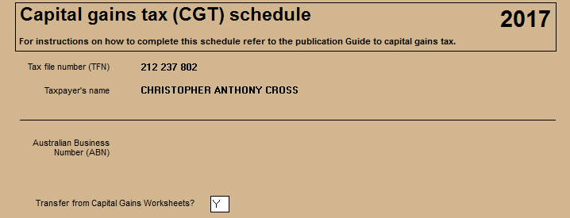

8. Sale of Excess Personal Items on E-Bay

In January 2017, Christopher had a big cleanout of his home in Indooroopilly and decided to throw out lots of unwanted possessions such as clothes, books, old CD's and DVD's as well as a cricket bat, tennis racquet, a bicycle and numerous other personal items. Christopher advises you that he originally acquired all of these items between October and December 2009 for approximately $2,900.

Instead of holding a garage sale at his house, Christopher decided to open up an E-Bay account and sold these items for a total of $1,076 over the course of two weeks.

9. Royalty Income

Some years ago, Christopher wrote a book entitled “Writing your own Will”, which retails for sale at most good Brisbane book retailers for $19.95. For each book sold, Christopher receives a royalty of $5 from the book publisher.

On 26 June 2017, Christopher receives a cheque for $1,240 from the book publisher, representing royalty income in respect of the sale of 248 books during the 2017 income year.
DETAILS RELATING TO DEDUCTIONS

10. Car Expenses

As previously mentioned in Item 2 of this assignment, Christopher is frequently called upon to use his own motor vehicle to visit his clients and to make regular court appearances.

Christopher owns a Lexus IS Prestige sedan which he purchased on 2 February 2016 for $74,326. The registration number is AYB219.

Christopher informs you that he has maintained a logbook for a consecutive twelve-week period during the 2016 income year. At the end of the twelve weeks, the logbook revealed that Christopher travelled a total of 7,800 kilometres, of which 2,730 were work-related. Christopher tells you that this pattern of use is still relevant for the current year.

At 30 June 2016, the odometer shows a total of 9,690 kilometres representing the total distance travelled for the 150 days from 2 February 2016 to 30 June 2016.

At 30 June 2017, Christopher advises you that the closing odometer reading of the car was 25,281 kilometres and that there was no significant or material change in business usage during the 2017 financial year from the prior year.

Christopher personally paid the following expenses in relation to his car for the 2017 income year:

$

- Registration 780
- RACQ membership fees 82
- Comprehensive insurance 1,135
- Petrol and oil 4,940
- Car washing 320
- Purchase of car deodorizers 42
- Replacing the windscreen (a small stone flicked up and cracked it) 830
- Bridge tolls and parking fees (all work-related) – refer note below 216

Christopher advises you that he has kept receipts for all of the above expenses.

Christopher was fully reimbursed by his employer for the bridge tolls and parking fees totalling $216 relating to trips on the way to court appearances.

Assume that Christopher wishes to maximise any car deduction claimed.

Note: There are 150 days from 2 February 2016 (being the date of purchase) to 30 June 2016. This is the total number of days of car ownership in the prior income tax year.

As 2016 was a leap year, there were 366 days in the 2016 financial year.

Hint: For the above item, please complete the “Other Vehicles & Travel” worksheet in HandiTax. As HandiTax does not automatically transfer the eventual claim to Label D1 in the tax return, students will need to remember to retype the claim and the total amount claimed at Label D1 in Christopher’s tax return.

11. Travel Expenses

On 12 February 2017, Christopher travels to London to attend the annual International legal conference held by the International Law Society. The purpose of this conference is to update practising solicitors on the latest legal trends, cases and evidence collection methods affecting lawyers and their clients.

Christopher believes that the conference will prove to be very useful for keeping him up-to-date on aspects of the law that he practices, which will ultimately assist him in his job and with his clients. Christopher personally paid all of the following costs relating to the conference.

Christopher personally paid all of the following costs (expressed in Australian dollars) relating to the conference:

$

- business class economy airfare from Brisbane to London and back * 8,140
- 3 nights accommodation at the Sofitel St James Hotel in London 1,760
- law conference registration fee 1,520
- meals for three days while attending the conference 186
- meal and drink bought at Singapore airport
(which was a two-hour stop over en route to London) 32
- taxi fares to and from airports 208
- phone calls home to Jessica and the kids 24
- sightseeing tour of London 118
- purchase of a jacket ** 214

* It comes to your attention that Christopher has chosen to fly business class from Brisbane to London and back. Based on your research, you discover that the full British Airways economy airfare from Brisbane to London and back at that time was only $2,246.

** Christopher tells your group that he forgot to pack anything warm for his trip. However, upon arrival in London, Christopher is caught off-guard by a sudden change of cold weather in the UK. Christopher promptly heads off to Harrods and purchases a dark navy blue jacket which he wears to the conference each day.

Christopher advises you that he has kept receipts for all of the above expenses and has kept the appropriate travel diary for taxation purposes.

Note: For the purposes of all of the expenses outlined in Item 9 above, please complete the “Other Vehicles & Travel” worksheet in HandiTax. Once again, HandiTax does not automatically transfer the eventual claim to Label D2 Work-Related Travel Expenses in Alan's tax return. Arguably, some of these expenses may be claimed at Item D5. However, for the purposes of this assignment, if students consider any of the above amounts tax-deductible, please include the relevant amounts at Label D2 of the tax return . In other words, do not include these items at any other label of his tax return.

12. Completion of a Master of Laws at QUT

For the past three years, Christopher has been enrolled on a part-time basis completing a Master of Laws at QUT. This course supplements his work as a solicitor with McMahon & Tate. In Semester 2, 2016 he successfully passed his final two units in the course.

Christopher incurred the following education-related expenses during the 2017 income year:

$

- Post-graduate tuition fees 5,152
- Student union fees 280
- Text books purchased for study purposes (all individually less than $300) 417
- Cab fares from work to QUT to attend classes 92
- Cab fares from QUT to home after classes 178

13. Hire of Academic gown at his Graduation

In December 2016, Christopher graduated from his Master of Laws and attended his graduation ceremony at the Queensland Performing Arts Complex. Christopher paid $98 to hire the academic gown which he is required to wear at the graduation ceremony.

Important Tip Relating to Entering Information for Item 14 into HandiTax

HandiTax has a “Work Related Expenses” worksheet. This worksheet asks the preparer to enter more details for any deductions claimed between Labels D1 to D5. However, students are advised NOT to use this worksheet.

Instead, please claim any deduction (where appropriate) for information shown at Items 14(a) to 14 (f) below directly into the relevant labels in HandiTax.

14. Other Expenses

(a) Mobile Telephone Expenses

Christopher owns his own mobile telephone. His mobile telephone call costs for the 2017 income year totalled $1,870.

According to an analysis of Christopher's mobile telephone statements over a three-month period, Christopher reliably estimates that 60% of these calls were work-related. Assume that Christopher did not take any annual leave during the 2017 income year, hence, he worked for the full 12 months of the year.

(b) Breakfast Meetings with Clients

Christopher often wakes up between 5:00 am and 6:00 am each morning. He makes a habit of catching up with his clients for breakfast once a week or so at the Brisbane Marriott between 7:00 am and 8:00 am for one hour.

Christopher uses this time to discuss a range of legal issues with his clients and to gather information and evidence about pending legal cases he is working on.

Christopher pays for the breakfast himself (he is not reimbursed by McMahon & Tate). During the 2017 income year, Christopher spent a total of $1,744 on food and beverages for himself and clients. Christopher reliably estimates that approximately half of this amount was spent on himself, and the other half on clients.

(c) Subscriptions and Memberships

Christopher paid the following subscriptions and professional memberships during the 2017 income year:

$

- Commercial Law Monthly – law magazine 920
- 12 month subscription to Time magazine (for personal interest) 135
- Queensland Law Society’s annual membership renewal fee 1,640
- Qantas Airport Lounge 12-month annual membership 480

Christopher has been a member of The Qantas Club since 2002. On 1 January 2017, Christopher renewed his annual Qantas airport lounge membership because he travels extensively for work purposes and finds it convenient to use the Qantas airport lounge (particularly the business facilities) each time before boarding his flight.

Note: For the purposes of the tax return, if students consider that any of the items listed in the four bullet points above are tax-deductible, please include the relevant amounts at Label D5 of the tax return (ie. 'other work-related expenses'). In other words, do not include these items at any other label of his tax return.

(d) Home Internet Access Fees

Christopher pays $75 per month to an internet service provider to connect to the internet at his home in Indooroopilly. This provides him with a total allowance of 200GB worth of data uploads and downloads per month.

Based on a three-month diary that Christopher has maintained, Christopher estimates that he uses an average of 70% of this data allowance accessing the firm’s intranet, downloading client files, and checking his work e-mails. The remaining 30% of internet usage is attributed to his two children who use the internet to play video games, watch video clips, research for school homework and assignments and send e-mails and messages to their friends.

During the 2017 income year, Christopher paid $900 to the ISP representing 12 monthly payments of $75 each. Assume that Christopher did not take any annual leave during the 2017 income year, hence, he worked for the full 12 months of the year.

(e) Home Office Expenses

Although he spends most of his day working from the offices at McMahon & Tate and out at clients premises, Christopher finds it convenient to occasionally work from home. He has set aside a small room in his house at Indooroopilly, which he uses for the purposes of catching up on work, writing and editing stories and checking e-mails.

When you ask Christopher to provide you with his electricity invoices so that a proportionate claim can be made for home office expenses, he advises that he has not kept any of these invoices.

However, Christopher provides you with a diary which he has kept for four weeks during the 2017 income year, detailing the total number of hours he has worked at home. From this diary, Christopher has been able to estimate that he has worked a total of 520 hours from his home during the 2017 income year.

(f) Concessional and Non-Concessional Personal Superannuation Contributions

Christopher advises you that apart from the compulsory 9.5% superannuation contributions made by his employer, McMahon & Tate into his ING Direct superannuation fund, during the 2017 income year he also made pre-tax salary sacrifice (ie. concessional) superannuation contributions of $11,400 into his complying superannuation fund.

This amount has correctly been reported by his employer on his 2017 PAYG Payment Summary as a “reportable employer superannuation contribution” (see Item 1).

In addition to these pre-tax superannuation contributions, Christopher also advises you that he made after-tax (ie. non-concessional) superannuation contributions of $7,000 into his ING Direct superannuation fund during the 2017 income year.

All of the relevant paperwork has been processed by the fund and Christopher has been advised of these contributions. All of Christopher’s pre-tax and post-tax cash superannuation contributions were received by his superannuation fund prior to 30 June 2017.

Details relating to the superannuation fund are outlined below:

Name of Superannuation Fund: ING Direct Superannuation
Fund’s Australian Business Number: 13 355 603 448
Fund’s Tax File Number: 804 188 050
Christopher’s Account Number: 10631052

Important Tip Relating to Entering Information for Item 15 into HandiTax

Please enter the details for any claims relating to the insurances (ie. item 15 below) directly into the relevant label in HandiTax.

15. Tax Agent's Fees and GIC Charge

On 12 May 2017, Christopher paid the invoice which he received from his previous registered tax agent in Taringa for the preparation and lodgment of his 2016 income tax return. The tax agent's fee was $650.

Christopher also informs you that as his tax agent lodged his 2016 income tax return more than four weeks late, the Australian Taxation Office charged Christopher the general interest charge (GIC) of $62. Christopher paid this amount on 24 June 2017.

Important Tip Relating to Entering Information for Item 16 into HandiTax

Please enter the details for any claims relating to the below possible deductions (ie. from the listing provided in Item 16 below) directly into Label D9 in HandiTax.

16. Gifts and Donations

During the 2017 income year, Christopher made the following payments:

$

- Diabetes Australia 175
- Hepatitis Queensland Inc. 60
- Breast Cancer Australia 140
- Queensland University of Technology Art Museum (gift fund) 75
- Sri Lanka Disaster Relief Fund 100
- Peregian Beach Surf Lifesaving Club Inc. 120
- Purchase of a ticket to a gala charity ball at the Brisbane Sofitel
on 27 July 2016 Beyond Blue Limited to raise monies
for people who suffer from depression 200
- Donation made on the night to Beyond Blue Limited 50
DETAILS RELATING TO REBATES AND TAX OFFSETS

17. Spouse Details - Jessica Cross

Christopher’s wife, Jessica, quit her full-time job with Suncorp-Metway one year ago and enrolled full-time in a Masters of Business Administration (MBA) at QUT Gardens Point. Jessica also has a small part-time job working six hours per week at a local Indooroopilly coffee shop.

Jessica’s assessable income for the 2017 income year consisted of gross wages totalling $9,278 (this amount includes PAYG withholding tax of $1,140 deducted) and interest income of $48. Jessica also received a fully franked dividend of $336 from Woolworths Ltd during the 2017 income year.

Jessica has no other assessable or exempt income, no reportable fringe benefits, and no reportable employer superannuation contributions.

Jessica incurred allowable deductions of $206 in relation to her salary and wage income.

18. Private Health Insurance Policy Details

On 11 August 2016, Christopher takes out private health insurance for the entire family with Medibank Private (MBP). This covers him and his family for the 324 days from 11 August 2016 to 30 June 2017 inclusive.

His combined policy (“C”) covers all family members and is the most comprehensive health policy available providing both private patient hospital cover and ancillary cover for all members of his immediate family. On 11th day of each month, Christopher pays his monthly premium for this family policy.

Christopher provides you with the private health insurance statement that he receives from Medibank Private in respect of the 2017 financial year. The key details from Christopher’s private health insurance statement are summarised below.

MBP Membership Number | Your Premiums eligible for Australian Government rebate | Your Australian Government rebate received | Benefit Code | Other Adult  Beneficiaries for the Policy
27746531 | $1,739 | $484 | 30 | Jessica Cross
27746531 | $679 | $182 | 31 | Jessica Cross

Christopher advises you that he wishes to claim his share of the rebate entitlement (which is shown above) in relation to his policy in his income tax return.

His wife, Jessica, also received the same statement from Medibank Private (with the same membership number) and will claim her rebate entitlement (which are the same figures that relate to Christopher, as above) in her own income tax return.

Hence, please use the "C" tax claim code at Item M2 in Christopher's tax return

ADDITIONAL INFORMATION

For the purposes of this assignment, students should note the following:

- Christopher is not registered for GST. Hence do not adjust any of the figures contained in this assignment for the effects of GST. All figures shown in this assignment are the figures you should use if you determine they should be entered into HandiTax.

- Christopher has been lodging tax returns since he was 18 years of aged and expects to continue to lodge future Australian income tax returns.

- Christopher does not intend to use the electronic funds transfer (EFT) in HandiTax to receive his tax refund (if applicable). Therefore, ignore the section at the bottom of the front cover screen in HandiTax prompting you to enter Christopher’s financial institution details, including his BSB, account numbers and name of his bank account.

- Christopher and Jessica are not eligible for any Family Tax Benefit (Part B) payment and neither person received any paid parental leave payments during the 2017 income year.

- Christopher does not have any outstanding HECS/HELP debt, nor does he have a financial supplement debt or any post-graduate FEE-HELP debt whatsoever.

- Christopher has kept all receipts substantiating all of his expenses.

- Christopher did not receive any tax-free government pensions or benefits and did not receive or derive any foreign employment income (also known as target foreign income).

- The franking percentage shown in the final column of the table at Item 4 Dividends only relates to franked dividends. An unfranked dividend carries no franking credits. Where there is both a franked and an unfranked dividend, this means that the company has paid two (2) separate dividends to shareholders during the 2017 income year – a franked dividend (franked to the relevant franking percentage) and an unfranked dividend.

- In the case of depreciating assets, Christopher wants to maximise his deductions at all times.

- As outlined in Note 6 on page 25, for any depreciable rental property items, Christopher wants you to use the effective lives as set out in Table A of Taxation Ruling TR 2017/2 (refer to Residential Property Operators 67110) where relevant.

- For any other depreciable asset contained in this case study, Christopher wants you to use the effective lives as set out in Table B of Taxation Ruling TR 2017/2 where relevant.

- For motor vehicles, please note that there has been a recent change in the depreciation cost limit as shown below:

- The depreciation car cost limit for the 2016 income year was $57,466.
- The depreciation car cost limit for the 2017 income year is $57,581.

- Christopher wants to use the diminishing value depreciation method for all depreciating assets under Division 40.

- In terms of any Division 43 capital allowances claim relating to the rental property, only the prime cost method is available.

- Any Division 40 claim for depreciation relating to the rental property is to be entered into the depreciation worksheet in HandiTax. The total depreciation claim can then be transferred to the rental property schedule (by coding it to Item 3 at the top of the screen). You will need to enter the address of the rental property at the top of the screen so that the system can transfer the depreciation amount.

- Any Division 43 claim in relation to the rental property is to be entered directly into the rental property schedule. Pressing the function key “F5” will reveal all of the various deduction codes that can be used to enter data into the rental property schedule. The code to enter a claim under Division 43 is “R” for “Capital Works – Special Building Write-off”.

- Christopher wishes to minimise his 2017 taxable income wherever legally possible. Hence, your group should calculate all alternatives allowed under the income tax provisions offering a choice (eg. car expenses, capital gains etc). Your group should therefore choose that option which provides Christopher with the greatest tax benefit (ie. one which results in the lowest amount of assessable income and/or one that results in the highest allowable deduction being claimed).

- Enter all amounts into HandiTax based on whether the program allows for inclusion of cents or whole dollars. In some instances (eg. dividends, franking credits, TFN withholding tax, foreign tax credits, etc.), the program requires that cents be included. However, other amounts (eg. assessable income and allowable deductions) require whole dollar amounts be entered. In this case, round all amounts to the nearest whole dollar.

- All calculations relating to the decline in the value of depreciating assets and borrowing costs should be made on a daily basis and rounded to the nearest whole dollar.

- If you need to calculate the number of days, the ATO has a useful online calculator which performs such calculations, being:

https://www.ato.gov.au/Calculators-and-tools/Host/?anchor=CalculateDays&anchor=CalculateDays#CalculateDays/questions

AYB 219 TAXATION LAW
GROUP CONTRIBUTION SHEET

We, the undersigned, have formed one group from the following tutorial class and agree that each member of the group has made the below outlined contributions to this tax project:

TUTOR NAME: ________________________________________________

TUTORIAL TIME: ________________________________________________

Student Number | Student Name | Signature | % Contribution
TOTAL CONTRIBUTION: |  |  | 100%

Never sign your name before the percentage contribution has been agreed upon by all of the group members. In other words, never sign a blank contribution sheet.

Notes:

It would be hoped, and expected, that an equal contribution would be the norm. For example, if there are 4 members in the group and everybody has made an equal contribution, 25% will be entered beside each person’s name.

In this case, if the group gets a mark of 15 out of 20 for the project, then each person in the group will receive this mark of 15. However, if each person has not made an equal contribution, then differing percentages that reflect each person’s contribution should be entered. For example, if there were four people in the group, and it was agreed that two students contributed 30% each whilst the remaining two students contributed 20% each and the group was given a mark of 15 out of 20, the 30% students would receive a mark of 15 out of 20 and the 20% students would get a mark of 10 out of 20 (being two-thirds of the marks awarded to the two students who contributed the 30% as they have done less work compared to others).

If you do not submit this signed group contribution sheet – each member of the group will incur a (10) mark penalty.
AYB 219 TAXATION LAW
GROUP INTEGRITY DECLARATION

We, the undersigned, hereby declare that we have read, accepted and agree to all of the statements in the Declaration below:

- We have complied with all the unit coordinator's instructions for this assessment.

- We understand that plagiarism involves using another person (or persons) ideas or work as one’s own, as explained in the QUT Manual of Policies and Procedures at C5.3 which is available at: http://www.mopp.qut.edu.au/C/C_05_03.jsp.

- We understand that it is a breach of academic integrity to assist, or allow another person (or persons) to use and/or copy our work.

- We declare that this work is entirely our own, and no part of it has been copied from any other person’s (or persons’) words or ideas.

- We declare that no part of this assessment has been written for us or supplied to us by any other person or persons outside of the below listed group members.

- We give permission for our assessment to be reproduced (copied), communicated, compared with other sources and stored (including electronically) in order to detect plagiarism and agree that plagiarism detection software can be used.

- We declare that all group members have contributed to the assignment and the following group contribution percentages are accepted by all members of the group.

Student Number | Student Name | Original Student Signature

If any member of the group does not sign and/or submit the group integrity declaration, your assignment will not be marked and will automatically be awarded a mark of zero out of 20 for the project.

Furthermore, it is not acceptable for any member of the group to sign on behalf of another group member. This is akin to forgery. This constitutes academic misconduct and each member of the group will automatically awarded a mark of zero. The case will also be referred to the QUT major academic misconduct committee.

AYB 219 TAXATION LAW

GROUP PROJECT CRITERIA SHEET – PARTS A and B (20%)

STUDENTS DO NOT NEED TO PRINT AND/OR SUBMIT THIS PAGE (REFERENCE ONLY)

Students will be provided with a separate mark for Part A and Part B and can use that information to reference this sheet.

CRITERIA | 7  12.75 – 15 | 6  11.25 – 12.75 | 5  9.75 – 11.25 | 4  7.50 – 9.75 | <4  0 – 7.5 | Total %
Knowledge and Technological Skills (KS1.2)  - Ability to accurately complete a tax return using HandiTax. A total of 15 numbers will be marked in Christopher’s income tax return. Part A is worth 15%.  - Furthermore, to get the 1 mark, each amount must be entered at the correct label in the tax return. | Complete accuracy in calculation of the tax return and entry of items into HandiTax | A few mistakes in calculation of the tax return and/or entry of items into HandiTax | Some mistakes in calculation of the tax return and/or entry of items into HandiTax | Several mistakes in calculation of the tax return and/or entry of items into HandiTax | A large number of mistakes in calculation of the tax return and entry of items into HandiTax | / 15
CRITERIA | 7  4.25 - 5 | 6  3.75– 4.0 | 5  3.25 – 3.5 | 4  2.5– 3.0 | <4  0 – 2.25
Teamwork and Self (TS4.2)  - Ability to effectively explain how the group researched the two tax issues identified in the assignment by reference to appropriate sections, cases, taxation rulings, tax determinations and ATO Interpretative Decisions etc. | Complete accuracy in quoting appropriate legislative references, cases, tax rulings, tax determinations and ATO Interpretative Decisions for the two issues. | Mostly accurate in quoting appropriate legislative references, cases, tax rulings, tax determinations and ATO Interpretative Decisions for the two issues. | Some accuracy in quoting appropriate legislative references, cases, tax rulings, tax determinations and ATO Interpretative Decisions for the two issues. | Little accuracy in quoting appropriate legislative references, cases, tax rulings, tax determinations and ATO Interpretative Decisions for the two issues. | Virtually no accuracy in quoting appropriate legislative references, cases, tax rulings, tax determinations and ATO Interpretative Decisions for the two issues. | / 5
TOTAL: |  |  |  |  |  | / 20

AYB 219 TAXATION LAW

PART C: PROFESSIONAL APPROACH (SATISFACTORY/UNSATISFACTORY)

STUDENTS DO NOT NEED TO PRINT AND/OR SUBMIT THIS PAGE (THIS IS FOR MARKERS ONLY)

CRITERIA | MAXIMUM PENALTIES TO BE APPLIED  (The maximum amount of penalties that can apply is to reduce the student's overall mark to zero out of 20) | DEDUCT FROM MARK OUT OF 20 IF UNSATISFACTORY  (Maximum deduction is the amount of marks awarded for each part)
Meets all of the submission requirements of the assignment as per the instructions | Unsatisfactory Satisfactory  Not forming a group of 3 or 4 students from the same tutorial □ □  Not using HandiTax to complete Christopher’s tax return □ □  Not submitting or signing the group contribution sheet □ □  Not signing and/or not submitting the Group Integrity Declaration □ □ | - 20 marks  - 15 marks  - 10 marks  - 20 marks
TOTAL PENALTIES APPLIED:

FINAL MARK OUT OF 20: |  | / 20

